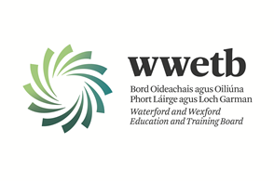

WWETB is delighted to announce the opening of Wexford College of Further Education based in Wexford Town.

Applications are invited from suitably qualified persons for the following role:

**ASSISTANT PRINCIPAL OFFICER**

**PERMANENT POSITION**

Full details on the above roles can be found on our website: [www.wwetb.ie/about/organisation/human-resources/vacancies/other-vacancies](http://www.wwetb.ie/about/organisation/human-resources/vacancies/other-vacancies)

Closing Date: 19th July 2023

Shortlisting may apply.

Canvassing by or on behalf of the candidate will automatically disqualify.

Late applications will not be accepted.

WWETB is an equal opportunities employer.