Corporate Procurement Plan (CPP)
ETB Template

Version 2: Issued 20th January 2020

Corporate Procurement Pack Contents:
- Corporate Procurement Plan Template
- Public Procurement Guidelines for Goods and Services 2019
- Education Brochure (Frameworks & Contracts 2018 for Education)
- Letters of Engagement: Bespoke Competition & Mini Competition
- Bespoke competitions detail
- PSRs process flow map
- OGP Category listings
- EPS flyer
- Overview of OGP services brochure
- E-invoicing information
- OGP Facilities Management brochure
- ETBI Strategic Vision 2016-2020
- Guide to ETBI Procurement Resources

Document Control

Document Location
This template document is available to download from the ETBI website www.etbi.ie

Approvals/ For noting
- Corporate Procurement Plan requires the following approvals/ noting:
Name | Approval / For noting | Date approved/ noted
Chief Executive | For Approval
Finance & Audit Committee | For noting
ETB Board | For noting

- Appendix 1 – Multi-Annual Procurement Plan (MAPP)
Completed MAPP to ETBI by 1st September annually – contact procurement@etbi.ie for details
Contact Name | Department | Completion Due date | Date submitted to ETBI
Therese Ennis  Administrative Officer | Procurement Dept. | 1st September 2019
Therese Ennis  Administrative Officer | Procurement Dept. | 1st October 2020
Therese Ennis  Administrative Officer | Procurement Dept. | 1st October 2021
Therese Ennis  Administrative Officer | Procurement Dept. | 1st September 2022

Foreword
On behalf of Education and Training Boards Ireland, I am delighted that ETBI has been involved with WWETB in updating the ETB Corporate Procurement Plan template launched in April 2019. The Code of Practice for the Governance of ETBs (CL 0002/2019) requires ETBs to confirm that a Corporate Procurement Plan (CPP) has been developed and is being implemented in ETBs.
The plan sets aims and objectives for improving on an incremental basis the procurement outcomes for the ETB. It also shows the measures to support the aims of the plan. ETB planning through this Multi-Annual Procurement Plan (MAPP) gives an insight for the board into the capacity of the ETB to remain compliant. I am glad that the guidance produced through the focus group and involving many of stakeholders in ETBs and in the Department has improved WWETB’s response in this plan.
Paddy Lavelle, General Secretary, ETBI

Foreword
Procurement is a key element of the Government’s Public Service Reform Programme. Education spends approximately €1 billion on goods and services annually and it is essential that this money is spent in a way that achieves maximum value for money, adheres to government policy, national guidelines and EU directives for procurement, while providing a sustainable delivery of services for the taxpayer.
The Education Procurement Service (EPS), designated by the Department of Education as Skills as Education Sector procurement hub, has developed an excellent relationship with the ETB Sector through the ETBI PSR Unit and through the procurement projects it has delivered in collaboration with ETBs.
In addition to being a requirement under the Code of Practice for the Governance of ETBs (CL 0002/2019). the Corporate Procurement Plan is an essential link in the provision of sustainable, fit for purpose, contracts and frameworks. The CPP template developed by the Education Procurement Service (EPS) and Education and Training Boards Ireland (ETBI) for ETBs, sets out the Board’s strategic approach to procurement. The guidelines and supporting documentation in the Corporate Procurement Pack, provide guidance for buyers on the engagement process.
An essential element of the CPP is the planning of the Board’s future procurement requirements. This will be facilitated by annually producing a three-year rolling Multi-Annual Procurement Plan or “MAPP”. The education sector aggregated MAPP will provide the Office of Government Procurement (OGP) with a detailed list of education’s defined future requirements over a three-year period.
The linking of education’s requirements to the development of OGP sourcing strategies will provide buyers with contracts and framework agreements tailored to meet educations specific needs.
By following the guidance set out in this document you are facilitating your ETB’s compliance with the procurement aspect of the Code of Governance and achieving best value for money for the tax payer.
Philip Gurnett, EPS Director & Head of Sourcing Education

Introduction by WWETB Chief Executive

On behalf of Waterford and Wexford Education and Training Board I am pleased to introduce the Procurement Plan for our ETB.
The Procurement Plan and Multi-Annual Procurement Plan (MAPP) in-depth spend analysis will assist in developing a strategic category of purchases management structure and approach for WWETB. The ‘MAPP’ will provide an in-depth knowledge of what we spend our budgets on, how many suppliers are in the categories of items being purchased, provide analysis of the ‘power of supplier’ versus us as a ‘buyer’ and enable WWETB to manage various suppliers to deliver lower costs/better value to our schools, centres and offices.
The potential of a Procurement Plan, the ‘MAPP’ spend analysis and a category of purchases management strategy is to spend money more efficiently and effectively, This is achieved by strategically managing similar areas of spend, developing expertise in managing/negotiating/building relationships with suppliers to enhance value to WWETB for the benefit of our learners and staff. Value will be measured among other areas by ensuring value in the areas of cost, quality, delivery, flexibility and innovation. .
WWETB takes its obligations with regard to procurement seriously and welcomes the structure that is being applied at national level to support ETBs in this regard.

Kevin Lewis, Chief Executive, Waterford and Wexford ETB

Table of Contents
1. Introduction 1
1.1. [Insert name of ETB] Procurement Mission Statement, Values and Goals 1
2. Objectives 2
2.1. Corporate Procurement Plan Objectives 2
3. Structure of Procurement within the ETB 4
3.1.1. Structure of Procurement within [insert name of ETB] 4
3.1.2. Role of Central Procurement Function 4
3.1.3. Role and responsibility of Budget holders 4
3.1.4. Role and responsibility of Other . . . 5
3.1.5. Procurement webpage 5
3.1.6. Systems and Training 5
3.1.7. Key areas of concern / Common issues / Lessons Learned 6
3.1.7.1. Procurement Support Request (PSR)/Supplementary Request for Tender (SRFT) 6
3.1.7.2. Contract Management 6
3.1.7.3. Supplier Relationship Development 6
3.1.7.4. ETB Representation in the National Procurement Model 7
4. Procurement Guidelines 8
5. Corporate Procurement Plan timing, retention and distribution 10
5.1. Corporate Procurement Plan Format 10
5.2. Timing 10
5.3. Retention 10
5.4. Distribution 10
6. The Multi-Annual Procurement Plan 11
6.1. Historical Spending Analysis 11
6.2. Analysis of High Volume / Low Value Purchases (optional exercise) 12
6.3. Review of Future Procurement Requirements 12
6.4. Ongoing evaluation of procurement requirements 13
7. Setting ETB Targets and Key Performance Measures 13
Appendices 15
Appendix 1 Multi Annual Procurement Plan Template 16
Appendix 2 Structure of Procurement within ETBs 17
Appendix 3 Updated Annual ETB Key Performance Indicators 19

Introduction

Waterford and Wexford Education and Training Board (WWETB) Procurement Mission Statement, Values and Goals
Our Vision
We aim to become leaders in public procurement through collaborative partnerships with all stakeholders.

Mission Statement
WWETB is committed to operate its procurement under the national procurement model agreed by government, and the principles of corporate governance outlined in the Code of Practice for the Governance of ETBs (CL 0002/2019). This includes use of central and sectoral procurement frameworks and contracts which offer value for money and efficiencies.
In instances where the national procurement model does not have an appropriate mechanism in place for a particular purchase (framework/drawdown), it is the intention of WWETB to comply with the relevant Public procurement guidelines available from the OGP website and sectorally agreed policies and procedures available from the ETBI website
We aim to engage with all stakeholders with a view to adding value to the WWETB through procurement
Our Values

Goals
- To ensure probity and compliance for the procurement of all goods and services
- To guide stakeholders on the use of procurement processes
- To achieve VFM for our ETB and stakeholders
- To achieve excellence in Contract Management

Objectives

Corporate Procurement Plan Objectives
The CPP is a key tool in facilitating the national procurement model in identifying procurement priorities.
Through the OGP and the four key sector procurement functions (Health, Defence, Education and Local Government), the Public Service speaks with "one voice" to the market for each category of expenditure, eliminating duplication and taking advantage of the scale of public procurement to best effect. This move is in line with best practice in the public and private sector and is part of the continuing reform programme being driven by the Department of Public Expenditure and Reform.
The objectives of WWETB CPP and how they will be achieved are set out in the table below:
Objective | These objectives will be achieved in several ways including
- achieve efficiencies and cost reduction through the procurement process.  - achieve the ETB strategy by aligning objectives and procurement requirements.  - increase the proportion of spend with contracted suppliers drawn from national frameworks.  - ensure compliance with all relevant policies and procedures.  - increase SME participation in public procurement WWETB tender competitions and where possible EPS and OGP frameworks;  - encourage and support Green Public Procurement (GPP). | - by taking a strategic approach to procurement.  - by ensuring compliance with all relevant policies and procedures.  - by WWETB procurement personnel engaging with the OGP for their procurement solutions; and  - by informing budget holders of the framework agreements and contracts that are available.  - hosting Supplier Workshops in assisting how to register on e-tenders and providing general information of requirements for tenders. Providing feedback to OGP re current frameworks also.  - Utilising Dynamic Purchasing Frameworks and Panels encourage SME participation and value for money.  - sourcing products/services that make good economic and environmental sense and comply with EU regulations. Assign marks under award criteria for green initiatives where appropriate.
- enhance leadership, governance, awareness, and skills within the procurement function.  - support an efficient procurement function across the organisation. | - by providing appropriate and periodic training to budget holders on procurement policies, procedures and best practice; and  - by engaging budget holders with the development and implementation of the Corporate Procurement Planning process.
- deliver a common, corporate process of strategic sourcing, supplier relationship development and contract management that supports the national procurement model. | - by establishing and assigning clear roles and responsibilities.  - by completing the Multi-Annual Procurement Plan (MAPP) (Appendix 1) and sharing it with ETBI.  - by complying with the processes set out in the national procurement model.  - by developing supplier relationships and monitoring the quality and delivery of goods and services; and  - by reference to guidance in sections 3 and 4.
- Implement a category management approach to procurement across the WWETB; | - by aligning (where possible) the general ledger and the category management approach to procurement; and  - by adopting a consistent approach to procurement and the raising of purchase requisitions and purchase orders on the finance system;
- support the Department of Public Expenditure and Reform (DPER) by implementing their strategies such as the national Procurement model to increase procurement efficiencies and e-invoicing to further enhance efficiencies and value for money. | - by utilising the procurement solutions and guidance put in place.  - by implementing a multi-annual procurement plan (refer Appendix 1).  - by implementing e-invoicing; and  - by sharing feedback with the OGP on areas of potential improvement.

Structure of Procurement within the ETB
Definitions of the three Procurement structures outlined as follows:
- a structure chart setting out how procurement is managed within ETB sector:
  - Centralised – all procurement is managed through a central procurement function within an ETB.
  - Devolved – all procurement is managed by the relevant budget holder; and
  - Hybrid - procurement up to €25,000 value is managed by the relevant budget holders with procurement over €25000 being managed centrally.
WWETB presently has a hybrid procurement structure.
The Procurement Manager and team are responsible for procuring all products/services over €25,000 which involves publishing a number of tenders each year, preparing specifications, publishing and evaluating same.
Budget holders in schools/centres are required to notify Procurement Team of purchases over €15,000 where team will consider whether a tender process rather than quotation is required. The procurement team are working towards Procurement Workplan of tenders and projects identified for current calendar year.
Procurement Manager must prepare Corporate Procurement Plan and prepare MAPP spend analysis, Contract Register and identify non-compliance for C&AG and internal auditors each year. The Procurement Team assists in spend analysis where key tender projects are identified to complete.
The Procurement Team must contract manage existing suppliers under OGP/EPS Frameworks and WWETB competitions. The Procurement Team must host supplier engagement workshops to assist potential suppliers in tendering for competitions. The Procurement Team must hold workshops with budget holders and admin staff involved in purchasing goods/services for schools and centres on Procurement thresholds, updates on contracted suppliers etc.
Budget Holders have authority to incur expenditure on behalf of WWETB within the limits of their notified budgets and the thresholds (as per WWETB Procurement Policy). They have day to day responsibility and accountability for ensuring that the Procurement Policies and Procedures are applied to all purchases of goods and services within their defined authority. They must use OGP National Frameworks/and other Central Contracted Suppliers of WWETB where available. Procurement handbook issued by Procurement Department outlines current OGP Frameworks and WWETB contracted suppliers for information purposes for budget holders.
All expenditure over €15,000 requires notification to Procurement Team as to whether tender competition is required. All expenditure over €25,000 must be notified to Procurement Team for tender competition.
Under SAP creditors system (Training Centre Creditors system) Stores Section/Finance Dept are required to retain supporting documentation for quotes as per procurement thresholds in Procurement Policy.
For schools/centres under the P2P creditors system Budget holders must retain supporting documentation for quotes as per procurement thresholds and upload supporting documentation on creditors system.
The role of the Procurement Manager and that of budget holders is detailed in the WWETB Procurement Policy (updated September 2021).

Structure of Procurement within WWETB
Hybrid structure for WWETB
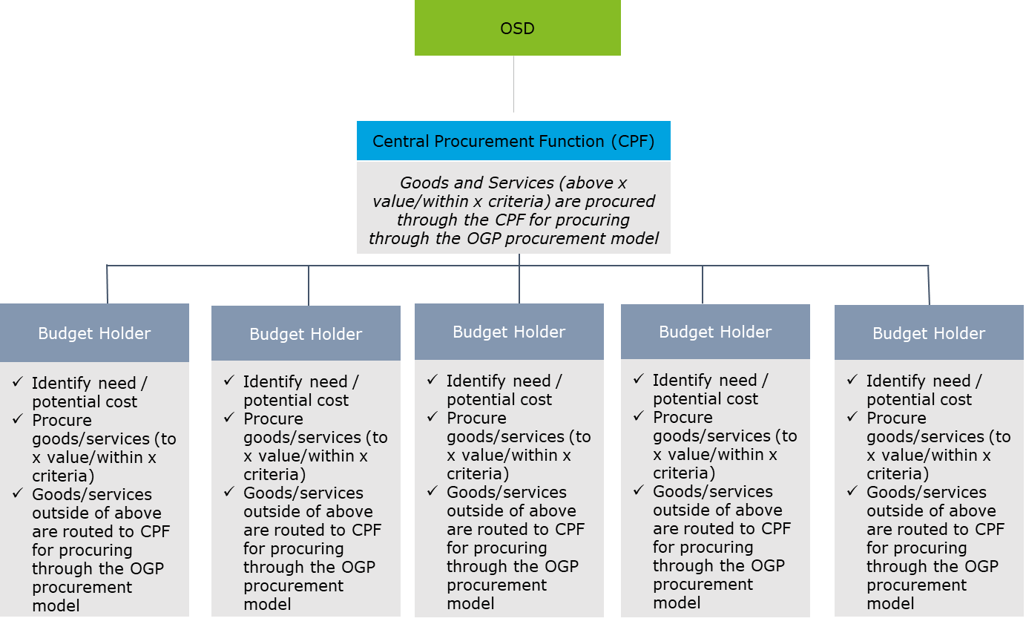
Organisation Chart:
The Procurement Team is managed by a Procurement Officer (Administrative Officer Grade VII) who reports directly to APO Corporate Services. The Procurement team has a Grade VI (Senior Staff Officer) and Grade V (Staff Officer) for Training Centre and one Clerical Officer (part time role in Communications Dept also). Administrative support is provided by a clerical officer in the IT Department (1.0 WTE) supporting IT procurement, IT admin support and general administration office duties.

Role of Central Procurement Function
The Procurement Manager and team are responsible for procuring all products/services over €25,000 which involves publishing a number of tenders each year, preparing specifications, publishing and evaluating same.
Budget holders in schools/centres are required to notify Procurement Team of purchases over €15,000 where team will consider whether a tender process rather than quotation is required. The procurement team are working towards Procurement Workplan of tenders and projects identified for current calendar year.
Procurement Manager must prepare Corporate Procurement Plan and prepare MAPP spend analysis, Contract Register and identify non-compliance for C&AG and internal auditors each year. The Procurement Team assists in spend analysis where key tender projects are identified to complete.

Role and responsibility of Budget holders
The role of the Procurement Manager and that of Budget Holders is detailed above and further information is in the WWETB Procurement Policy (updated September 2021).

It is the responsibility of the budget holder:
- to develop the key specification and identification of the qualitative criteria
- and each person involved in procurement to keep up to date on changes to procurement guidelines/thresholds, regulations, circulars and to implement them ensuring compliance with public procurement guidelines.
- to utilise the national procurement model and the frameworks where available for all procurement spend.
- to retain all supporting procurement documentation (e.g., quotes, tenders).
- Of key importance regarding tenders is the development of the key specification and identification of the qualitative criteria by the budget holder.

It is the responsibility of the budget holder:
- and each person involved in procurement to keep up to date on changes to procurement guidelines/thresholds, regulations, circulars and to implement them ensuring compliance with public procurement guidelines.
- to utilise the national procurement model and the frameworks where available for all procurement spend.
- to retain all supporting procurement documentation (e.g., quotes, tenders).

Role and responsibility of Others
- The Chief Executive is the Accounting Officer for WWETB.
The Director of Organisation Support and Development is responsible for the Governance and Management of the ETB’s administration and oversees the management of WWETB’s resources across the Human Resources, Finance and Corporate Services (including Procurement and ICT functions).
- WWETB management and ultimately the Board should ensure that there is an appropriate focus on good practice in purchasing and that procedures are in place to ensure compliance with procurement policy and guidelines. It is the responsibility of the Board to satisfy itself that Executive Management is fully conversant with the current value thresholds for the application of EU and National Procurement Rules and that the requirements for public procurement are adhered to. Where local procurement is necessary, competitive tendering should be standard procedure in the procurement of ETBs. The Board is ultimately responsible for ensuring that the Chief Executive has instituted an adequate and appropriate system of internal control, including risk management and corporate governance, in WWETB. The work of the Audit and Risk Committee will assist the Board in this function.

Procurement webpage
Procurement Policy and documents to assist Suppliers in registering/submitting tenders available are posted on the WWETB website. A Procurement update which outlines for a range of products/services OGP/EPS frameworks utilised by WWETB and WWETB contracted suppliers from WWETB tender competitions is distributed by email to all schools and centres and on the staff hub under the Procurement Section.

Systems and Training
- A review of the systems in place to support the operation of procurement within the ETB.
Contract Management System:
IT systems required include a contract management system (CMS) which would also support the ‘contracts database/listing for all contracts/payments in excess of €25,000’, the DPER Circular 02/2016. Contract Management System for the Education Sector is presently being pilot tested in other ETBs. WWETB procurement staff assisted in reviewing requirements of the system before pilot phase. It is envisaged that once pilot testing is complete that WWETB will use the system to assist in contract management with existing suppliers. Contract Management system will retain contracts, tender information, review meetings, scorecards for service delivery etc.
P2P purchase system - Compliance verification:
Recent module introduced on existing creditors system to display facility where budget holders/key admin staff can order from WWETB contracted suppliers on the creditors system from catalogues. Approved suppliers have star rating. Where purchases/services do not have contracted supplier, creditors system requires appropriate evidence of quotations sought as per procurement thresholds prior to purchase order approval.
- A review of the systems in place to support the operation of procurement within the WWETB. IT systems required to include a contract management system (CMS). This would also support the ‘contracts database/listing for all contracts/payments in excess of €25,000’, the DPER Circular 02/2016 and e-Invoicing .

- Training and staff development in good practice procurement methodologies will continue for both the Procurement Team and those personnel [Budget Holders] with procurement functions within departments, in order to strengthen the level of competencies and skills of procurement practitioners.
This may include the following:
  - How to operate under the national procurement model.
  - How to develop your goods/service specification.
  - How to manage disclosures of interest and potential conflicts.
  - What award and evaluation criteria to select?
  - How to evaluate tenders, what techniques could be applied including whole life costing; and
  - How to engage in the procurement process in a transparent, fair and equitable manner.
  - Yearly workshops on Procurement Policy guidelines, contracted suppliers, new processes/systems introduced.
  - Focus groups with Budget Holders/key admin staff regarding issues/suggestions regarding supplier product/service delivery.

- The Procurement Department will continue to raise awareness of the complex regulatory framework associated with public procurement in addition to providing training to personnel with responsibility for procurement within departments.
- The Central Procurement Function (CPF) will continue to raise awareness of the complex regulatory framework associated with public procurement in addition to providing training to personnel with responsibility for procurement within departments.

Key areas of concern / Common issues / Lessons Learned
The sections below are areas of importance that have caused concern and we would like to draw these to your attention.

Procurement Support Request (PSR)/Supplementary Request for Tender (SRFT)
- ETBs should complete the PSR/SRFT process and communicate with the OGP Customer Service Helpdesk in a timely basis [refer to the OGP Client proposition], this commences the procurement process.

- The responsibility for sourcing goods/services is with the OGP or the sector Hub other than where PSRs are returned for self-procurement where the responsibility will revert to the ETB to procure.

Contract Management
- Whilst there is a contract template available (contact OGP Customer Service Helpdesk), responsibility for creating, signing and management of the contract rests with the ETB, this includes the identification of key performance indicators (KPIs) that should go into the contract.

- As a rule, contracts with suppliers should be utilised where possible, to develop efficiencies in procurement. When considering procurement, the long term (3 or 4 years) and aggregation for the supply of the goods/services should be considered rather than addressing the immediate supply need.

- When utilising an OGP Framework Agreement or an OGP drawdown solution, a contract needs to be put in place with the supplier and the responsibility for this rests with the ETB. The OGP Customer Service Helpdesk can advise on the procedure to follow; and

- Ongoing monitoring of the contract by budget holders is important to ensure agreed services and performance levels are delivered and rates are being applied by the supplier.

Supplier Relationship Development
- Strong relationship management with suppliers is vital to ensure the smooth and efficient management of contracts. Management of supplier relationship forms an important part of the contract management process and best practice dictates that it should be operative for all contracts especially where the nature of the goods or services supplied are recurrent.

- Meeting with the supplier will facilitate both parties to set out their requirements and expectations to ensure the required goods and services are provided as and when required. If not already formally documented as part of the tender or service level agreement (SLA) process, they should be documented to facilitate ongoing monitoring of the supplier delivery of the goods/service contract.

- Periodic meetings with the supplier will provide both parties with an opportunity to raise issues to enhance the quality of service being provided. These should be documented and shared with the supplier and should include any agreed actions to be taken. They will also assist in building a relationship with the supplier.

- At least annually, a formal review of performance management should be undertaken against the criteria set out in the tender document and/or SLA to evaluate the quality, service and value for money being obtained. The output of the performance review should support the decision to continue the contract (where appropriate) or to initiate a new tender process where appropriate.

- Where contracts are part of a Framework Agreement or a Drawdown solution put in place through the OGP, it is also important that output from monitoring the contract delivery is made known to the OGP through the Customer Service Helpdesk.

ETB Representation in the National Procurement Model
- When requested by the OGP/EPS/ ETBI, ETBs have a responsibility to provide representation:
  - to category councils on behalf of education to develop category strategy; and
  - to sourcing teams to evaluate potential framework bidders.

Procurement Guidelines
Set out below is a list of reference documents to assist you with your procurement. [where ETBs have their own procurement policy and procedures, they should also be referenced here after ensuring that they complement the principles set out in this document.]
Guidance Source | Detail
Circulars | Department Circulars are issued relating to procurement by the Department of Public Expenditure and Reform and previously the Department of Finance. These circulars are also available through the ETenders website below.
ETenders | This website is a central facility for all public sector contracting authorities to advertise procurement opportunities and award notices.
Office of Government Procurement | This website provides access to the Buyers Zone which lists the framework agreements and the drawdown arrangements that are in place and which should be used where appropriate.
Public procurement guidelines | This guideline should be followed where the OGP does not have a procurement mechanism in place for the purchase being made. The latest version of this document can be found in both the OGP website and the ETenders websites. This document has several valuable resources included. The table of contents for the Guidelines are set out below:  - Key Principles  - Encouraging SME Participation  - Environmental, Social and Labour Provisions  - Main Phases of Public Procurement  - Pre-tendering phase  - Below Threshold – National Guidelines  - Above Threshold – EU Rules  - Framework Agreements  - Electronic Procurement  - Monitoring and Reporting  - Freedom of Information  - Contacts  - Glossary  - Frequently Asked Questions  - Key Documents / Websites  - EU Thresholds  - Model Letters for below Threshold  - Light-Touch Regime  - OJEU Time Limits in the 2016 Regulations  - Model Letters for Above EU Threshold  - Checklist for Procurement and Contract File  - Disclosure of records – Information Commissioner
National Public Procurement Policy Framework | The National Public Procurement Policy Framework (2018) consists of 5 strands:  1) Legislation (Directives, Regulations)  2) Government Policy (Circulars etc.)  3) Capital Works Management Framework for Public Works  4) General Procurement Guidelines for Goods and Services  5) More detailed technical guidelines, template documentation and information notes as issued periodically by the Policy Unit of the OGP
ETB Procurement Policy & best practice guides | Sectorally agreed policy and templates are available via the ETBI website
Code of Practice for the Governance of ETBs | Section 8 sets out standards for governance of procurement
Capital Works Management Framework and Dept of Education & Skills Guidance | The Capital Works Management Framework (CWMF) is a structure that has been developed to deliver the Government’s objectives in relation to public sector construction procurement reform. However, as the Department of Education and Skills are the main funding body for building works to ETB schools, the DoES have taken the CWMF documents and tailored them to suit school building (Works) projects

It is the responsibility of each person involved in procurement to keep up to date on changes to procurement guidelines/thresholds, regulations, circulars and to implement them ensuring compliance with public procurement guidelines.

Corporate Procurement Plan timing, retention and distribution

Corporate Procurement Plan Format
The Corporate Procurement Plan (CPP) document will be in two parts as follows:
The CPP The CPP will set out the ETBs mission, values and objectives in respect of procurement and its commitment to compliance with the national procurement model agreed by government. The plan will set out how the ETB plans to achieve these and will set out the roles and responsibilities of staff involved in the procurement process.
Appendix The Multi-Annual Procurement Plan will have the analysis of anticipated procurement requirements by year/category and spend. The appendix should be sent to ETBI for sectoral collation and onward submission to EPS in order to inform analysis of future education sector procurement requirements.

Timing
The Corporate Procurement Plan and the Multi-Annual Procurement Plan should be completed and submitted to ETBI no later than 1st September 2019. The Multi-Annual Procurement Plan should be submitted to ETBI by no later than 1st September of each year thereafter. ETBI will aggregate requirements across the ETB Sector and provide EPS with a detailed list of the future requirements over a three-year period. The timing of the Multi-Annual Procurement Plan will facilitate the completion of ‘Start of Year’ ICT related expenditure requirements, under DPER Circular 02/2016.

Retention
The Corporate Procurement Plan once completed should be retained where staff have online access to it.

Distribution
To achieve maximum value and benefit from the Corporate Procurement Plan, once it is completed, the appendices to the Plan should be distributed to the following:
- Internally
  - All budget holders; and
  - All staff involved in procurement.
- Externally
  - PSR Manager, ETBI

Once the information is collated by ETBI, it will be made available to the EPS for sectoral planning and operational purposes including onward submission to the OGP.
On request (during a review/audit etc.), the Corporate Procurement Plan and appendices will be made available to ETBI, DES and the C&AG for a compliance and governance oversight perspective. b

The Multi-Annual Procurement Plan
To inform the Multi-Annual Procurement Plan (MAPP) (Appendix 1) of the ETB, several tools should be applied such as a review of the historical spending profile, identification of high volume/low value procurement transactions, a review of future procurement requirements aligned to the annual budget and procurement in relation to the longer-term strategic plan of the ETB.
It is acknowledged that the process to develop the MAPP will take an investment of time in year 1 as collating the data for the foundation year is critical to the value that can be obtained from the plan in future years.
During the year, organisational priorities may change resulting in changes to procurement priorities. These changes should be maintained in the MAPP to ensure it remains relevant and up to date.
All items with a projected cumulative spend of €25,000 over the 3-year period should be included in the MAPP. If spend is approaching the €25,000 or if in doubt of the value of spend, it is suggested that the item be included in the MAPP.
In addition to the above, circular 02/2016 indicates that ICT related spend take into account the whole of life cost and must estimate any potential cost for any associated or follow-on projects.

Historical Spending Analysis
The purpose of the spend analysis is to:
- Inform the drafting of the MAPP
- Support the high-level strategies for the identified categories of spend
- Identify opportunities for improvement in terms of saving costs
- Identify opportunities for working in a more efficient manner
- Identify a number of Key Performance Indicators that can be used to monitor review the impact of implementing the MAPP
To inform the drafting of the MAPP, analyse a minimum of 1 year’s historical spend records to identify:
- Categories of spend; and the
- Amount of spend by category.
The identification by category and category spend can be undertaken initially by reference to the General Ledger. Once this is completed, a more detailed review on the categories/product group will be required to identify product code descriptions (if not already established) facilitating the identification of various purchases. We set out below an example of a Product Group and Product Code Descriptions.
  - Example:
Product Group: | AUDIOVISUAL/MULTIMEDIA/EVENTS | COMPUTING, IT, TELECOMS
Product Code Description: | AV EQUIPMENT | DESKTOP PRINTERS
Name of product | Projector | -

The output of the above analysis will identify the purchases that have been made over the last year by product group, product code description and name of product and this information should be populated into the template in Appendix 1. When populating the amount, please ensure that the figures do not include VAT.
Taking the information now populated in Appendix 1, the following should be undertaken:
- Establish how the goods/services are procured (e.g., OGP Framework, OGP Drawdown, Mini-competition, Sectoral procurement, ETB own arrangement);
- Identify purchases of key importance either by difficulty to acquire, risk or criticality.
- Identify the incumbent suppliers providing the goods/services.
- Identify the contract renewal date.
- Identify where appropriate who is responsible for each procurement / contract renewal

Analysis of High Volume / Low Value Purchases (optional exercise)
By identifying purchases that are of low value but high volume across the ETB, it may highlight potential areas where procurement could be more efficient. The purpose of this analysis is to identify if there is a more efficient way to procure those goods and services. The steps are as follows:
- Extract a report identifying all purchase orders by product group, product code description and supplier.
- By product group, product code description, identify the number of purchase orders and the total spend by supplier.
- Populate the details into the spreadsheet in Appendix 1 including the number of POs raised.

Review of Future Procurement Requirements
Having completed the historical analysis, the ETB SMT should be provided with the draft MAPP and asked based on the completed budget for their functional areas to identify the future procurement requirements for their areas. These procurement requirements should be aligned to the annual budget for the coming year, projected procurement requirements for a further 2 years in addition to being aligned to the ETB Strategic Plan as follows:
- Using the past analysis of spend by product group, amend to reflect projected procurement requirements for the next three years.
- Identify purchases that were ‘once off’ or that do not require renewal.
- Identify any new Goods / Services to be procured over the next three years either on a recurring basis or purchases of a once off basis
- Identify purchases of key importance either by difficulty to acquire, risk or criticality.
- The anticipated cost per annum of the Goods / Services to be procured; and
- The month and year the Goods / Services will be required if not already a recurring procurement requirement, and document if there is a timeline that must be met.
Once this information is collated from each organisational pillar, it should then be collated on behalf of the ETB.

Ongoing evaluation of procurement requirements
At present WWETB is reviewing aggregate spend of suppliers/categories annually to identify where procurement thresholds may have been breached or suppliers nearing threshold, this analysis determines key tender projects to be identified as part of Workplan for Procurement Department for next calendar year.
The Procurement Team will consider the possibility of reviewing spend on a quarterly basis to identify possible breaches of thresholds that may warrant a tender process. Procurement Team in consultation with Finance Department will review possibility of trigger on Financial Creditors system where supplier nearing procurement thresholds.

Setting ETB Targets and Key Performance Measures
Targets and Key Performance Indicators should align WWETB with the national procurement model agreed by government and the objectives outlined at 2.1. It is also an opportunity to align procurement objectives with the WWETB’s own strategic objectives. When setting targets and KPIs, please note that several tools can be used when developing objectives such as the SMART goal model. This model is designed to ensure that objectives are
S – Specific.
M – Measurable.
A – Achievable.
R – Relevant; and
T - Timely.
WWETB KPIs to include:
- Timely submission of MAPP to ETBI by 1st September of each year for sectoral collation.
- Improvements in compliance (e.g., number of/ % of >€25K spends identified through MAPP that are now comprehended by procurement process).
- Effective Contract Management through annual review meetings with suppliers (and more where warranted) and scorecards issued to schools/centres to monitor service delivery per school term.
- Engaging stakeholders with procurement:
- Number of briefing sessions on procurement to non-procurement personnel
- Procurement as an agenda item on all SMT meetings in both in head/sub-offices and in schools and centre
- Initiatives to engage SMEs in ETB procurement / number of SMEs responding to ETB tenders/ Number of winning ETB tenders/ Number of SMEs engaging in ETB-run procurements.
- Supplier Workshops to assist SMEs to register and apply for potential competitions on Etenders.
Meeting WWETB Strategic Goals/Priorities/Actions as follows:
Goal 2: Development of Organisation Services: This will be achieved by ensuring we provide the highest quality leadership, executive and administrative supports to a motivated and highly skilled workforce enabling a high quality teaching and learning experience for learners and students.
Strategic Priority 2.3 Ongoing policy development and high standards of governance & compliance.
Strategic Action: 2.3.1 Continue to prioritise the work of implementing robust governance across the organisation to achieve compliance with DES CL18/15 (Code of Practice for Governance of ETBs) and to meet the audit and reporting requirements (C& AG, internal audit etc).
Strategic Action: 2.3.3 Establish and implement a procurement plan, an associated contracts database for the organisation and a structured contract management system to ensure value for money and compliance with national procurement guidelines.

Appendices

Appendix 1 Multi- Annual Procurement Plan
Appendix 2 Structure of Procurement within ETBs
Appendix 3 Updated KPIs

Appendix 1 Multi Annual Procurement Plan Template

This Multi-Annual Procurement Plan (MAPP) template should be completed and updated on an annual basis. The Plan should be based on projected procurement for a rolling three-year period. All items with a projected cumulative spend of €25,000 over the 3-year period should be included in the MAPP. If spend is approaching the €25,000 or if in doubt of the value of spend, it is suggested that the item be included in the MAPP. The Plan once completed should be submitted to ETBI for sectoral collation no later than 1 September each year. Also note that there may be instances where the volume of procurement transactions is high, but the value is less that €25k and placing such procurement under a Framework may provide efficiencies throughout the Public Sector. In addition to the above, please note that circular 02/2016 indicates that ICT related spend take into account the whole of life cost and must estimate any potential cost for any associated or follow-on projects. When completing this schedule if guidance is required, please refer to your ETB Corporate Procurement Plan in the first instance. For guidance on the category of spend, please contact the OGP Customer Services Support Helpdesk. Please note that ETBs may add additional columns to this spreadsheet for internal monitoring purposes, however, only these columns (below and in the accompanying template) are required to be sent to ETBI for collating. The MS Excel template for this schedule will be available on the procurement section of the ETBI website or by contacting procurement@etbi.ie
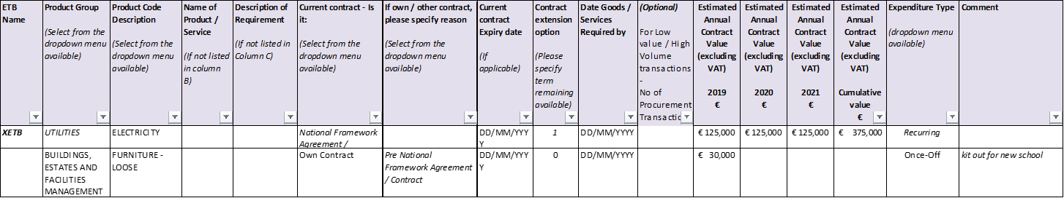
For queries relating to the completion of the Multi Annual Procurement Plan, please contact: eps.mail@ul.ie ; procurement@etbi.ie
* When populating the amount, please ensure that the estimated figures do not include VAT.

Appendix 2 Structure of Procurement within ETBs

Set out below are examples of Procurement structures within Public Sector Bodies:
- Centralised Procurement Structure;
- Devolved Procurement Structure; and
- Hybrid Procurement Structure.
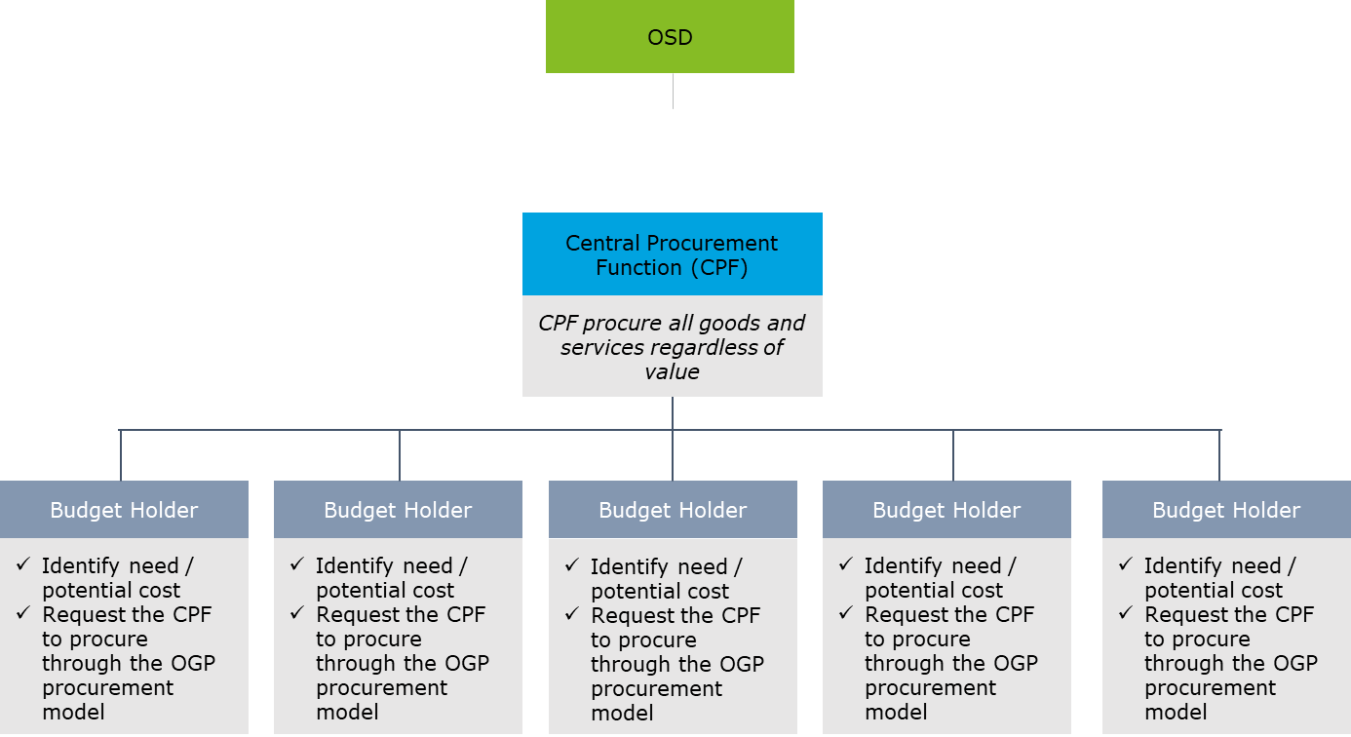

Corporate Services/ Finance
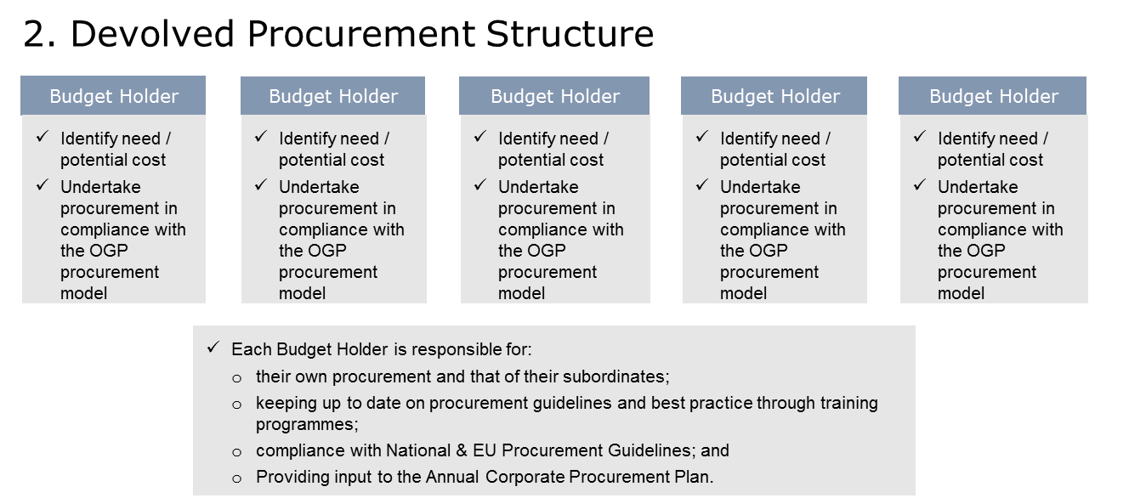

Corporate Services/ Finance

Appendix 3 Updated Annual ETB Key Performance Indicators

Key Performance Indicator | Action required | Responsibility | Timeframe | Achieved? | Date
- Timely submission of MAPP to ETBI by 1st September of each year for sectoral collation. | Timely submission of MAPP to ETBI by 1st October 2021 | Therese Ennis | 1st October 2020
- Improvements in compliance (e.g. number of/ % of >€25K spends identified through MAPP that are now comprehended by procurement process). | Reduction in non- compliance expenditure by 10 % in 2020. | Therese Ennis/Gina McGrath | 31st December 2021
- Effective Contract Management through annual review meetings with suppliers (and more where warranted) and scorecards issued to schools/centres to monitor service delivery per school term. | Holding contract management meetings – one per company identified (of key services/products). This is particularly important for contract mobilisation. With the Contract Management System is available, WWETB will utilise this system. | Therese Ennis/Susan Power | 31st December 2021
- Engaging stakeholders with procurement:  - Number of briefing sessions on procurement to non-procurement personnel  - Procurement as an agenda item on all SMT meetings in both in head/sub-offices and in schools and centre  - Initiatives to engage SMEs in ETB procurement / number of SMEs responding to ETB tenders/ No of winning ETB tenders Number of SMEs engaging in ETB-run procurements.  - Supplier Workshops to assist SMEs to register and apply for potential competitions on etenders. | Briefing sessions for November for staff – Management and Admin.  Supplier guidance documents available on website on how to register on etenders and preparing a TRD.  Video for suppliers on how to register on etenders and preparing TRD issued where we are running frameworks and proving details to all potential existing suppliers. | Therese Ennis/Gina McGrath | 31st December 2021

The requirement to develop and implement a Corporate Procurement Plan is set out in the Code of Practice for the Governance of ETBs (CL 0002/2019).
Public procurement Guidelines for Goods and Services July 2017
Arrangement for Digital and ICT–related Expenditure in the Civil and Public Service
Public procurement Guidelines for Goods and Services July 2017
Arrangement for Digital and ICT–related Expenditure in the Civil and Public Service
European eInvoicing Directive (2014/55/EU)
These can be located on the OGP website or through the OGP Customer Service Helpdesk
Recommended best practice is to include historical analysis of 3 years. However, the CPP focus group note the varying capacity of current ETB FMS in the Sector to yield detailed spend analysis

