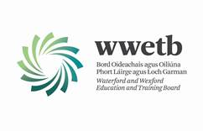

Protected Disclosures Annual Report 2021

The Protected Disclosure Act 2014 Section 22 requires that every public body shall prepare and publish a report on matters on protected disclosures made to it no later than 30th June of each year for the preceding year.

Matters are as follows:-

- the number of protected disclosures made to the public body –

One disclosure was made to WWETB in accordance with the Protected Disclosure Policy

- the action (if any) taken in response to those protected disclosures –

An initial assessment of the information received was carried out by the Protected Disclosures Officer (PDO). The PDO concluded that no further action or investigation was warranted. There was a subsequent request (within the allowed five days) to have the initial assessment reviewed. This review was carried out and concluded that no further action or investigation was warranted. This brought the assessment to a conclusion, with no investigation resulting from receiving the disclosure.

- such other information relating to those protected disclosures and the action taken as may be requested by the Minister from time to time –

The assessment has concluded, no investigation was warranted and the file is now closed.

