GUIDANCE FOR SUPPLIERS

GUIDANCE FOR
SUPPLIERS REGISTERING ON E-TENDERS
VIA
WWW.ETENDERS.GOV.IE
REGISTERING ON

WWW.ETENDERS.GOV.IE

Contents
Introduction ....................................................................................................................... 3
Steps to Register ............................................................................................................... 4
GENERAL COMPANY INFORMATION ......................................................................... 5
COMPANY CONTACT INFORMATION ......................................................................... 6
COMPANY ADMINISTRATOR INFORMATION............................................................. 7
COMPANY ADMINISTRATOR CREDENTIALS............................................................. 8
ACCEPT THE TERMS AND CONDITIONS ................................................................... 8
TO MANAGE BUSINESS ALERTS................................................................................ 9
TO REGISTER RELEVANT CPV CODES ..................................................................... 9

WHAT ARE CPV CODES? .......................................................................................... 10
Call the Helpdesk ............................................................................................................ 10

Introduction

Procurement’ is the overarching function that describes the activities and processes to acquire goods and services from an external source. As distinct from “purchasing” procurement involves all the activities involved in establishing requirements, market research, approach, supplier / tender evaluation, negotiation and award of contracts through to contract management.
Public Bodies (Contracting Authorities) such as Education and Training Boards (ETBs) must ensure that procurement is carried out in accordance with National and European Union Public Procurement Regulations & Directives, Legislation, Policy and Guidelines. There is an onus on public bodies to ensure that the public procurement function is discharged ethically, honestly and fairly in a manner that secures best value for money.
‘Public Procurement’ refers to the process by which public bodies purchase works, goods or services from suppliers’ which they have selected for this purpose. It ranges from the purchase of routine goods or services to large scale contracts for infrastructural projects and involves a wide and diverse range of contracting authorities.

Public Bodies are obliged to publicly tender all requirements on the Irish Government website www.etenders.gov.ie over certain thresholds, in addition to advertising in the Official Journal of the European Union (OJEU) for larger value contracts.

The eTenders website is the national system operated in Ireland. It is a fully electronic confidential tool supporting the advertising and tender transactions for all Irish Public Bodies as well as those in receipt of public funding.

www.etenders.gov.ie is the primary tool used by Public Bodies in Ireland to advertise their requirements for contracts for supplies, works and services.

E-tenders is also being used by Public Bodies for quotations and in the case of mini-competitions under framework agreements. The process for quotations and mini- competitions is similar with the following critical differences:

• In the case of quotations, the Buyer has discretion in who it chooses to invite to submit a quotation.
• In the case of mini-competitions, the Buyer must invite those who have been formally admitted to the framework agreement on foot of a previously advertised competition.

Further information on procurement methods and procurement thresholds are set out in the
“Guidance for Suppliers responding to Tenders via eTenders”.

It is essential therefore that all suppliers are registered on the eTenders system in order to ensure they don’t miss out on quotation and tender opportunities.

Steps to Register

There are a number of steps to be completed to ensure a comprehensive profile is created on the etenders website.

Step 1 Log on to www.etenders.gov.ie

Step 2 Click on the Supplier Company Registration field

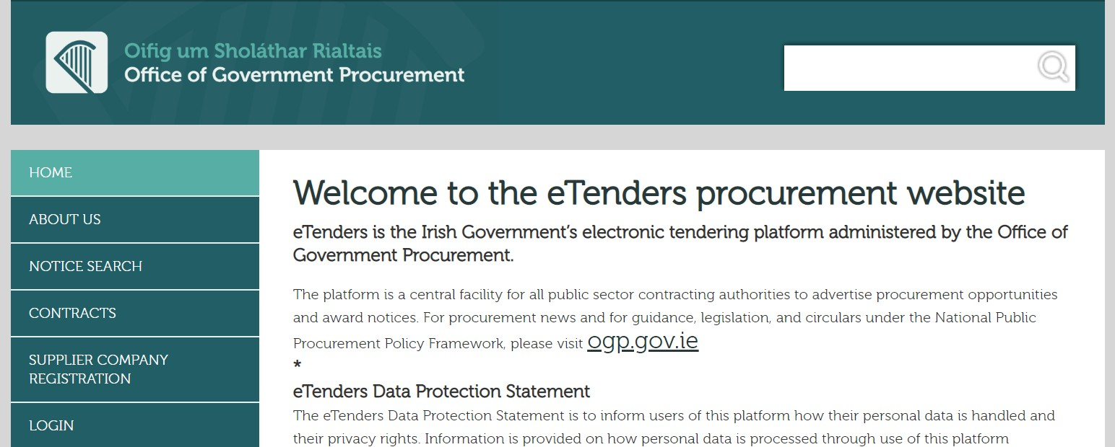

Step 3 Complete the relevant fields:

GENERAL COMPANY INFORMATION

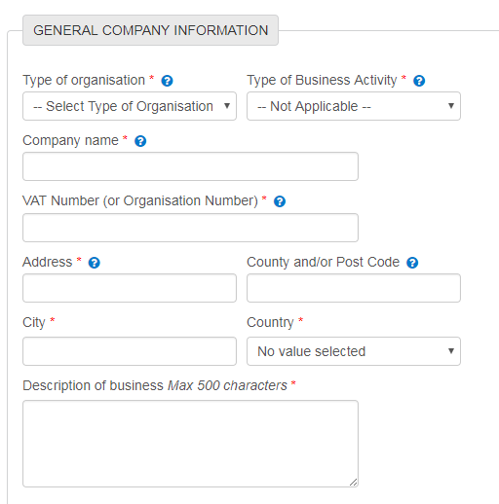Complete all relevant fields as detailed below:

• Type of organisation – pick from Private Company, Public Limited Company, Sole Trader, Partnership, Charity Organisation, Representative Body or Public Interest / Non-Supplier.

• Type of business activity
• Company name – enter formal business name
• VAT number – if no VAT number, enter PPS number.
• Address – Country / Post Code / City / Country
• Description of business – enter pertinent information quickly identifying the type of supplies, works and services provided by the organisation.

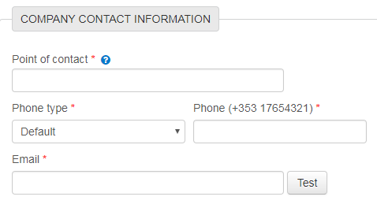COMPANY CONTACT INFORMATION

• Point of Contact
• Phone type
• Phone number
• Email

Note #1: this point of contact is the primary person contacted for opportunities on eTenders. Additional contact points can be added once the profile is established.

COMPANY ADMINISTRATOR INFORMATION

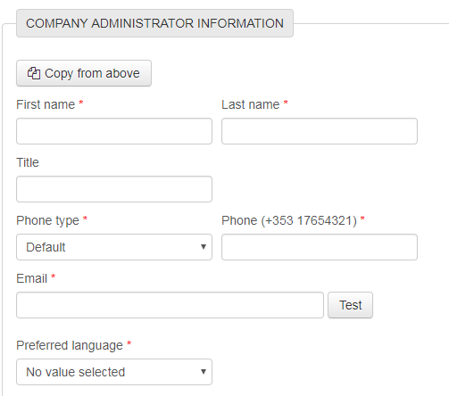

Complete the following fields:

• First Name
• Last Name
• Title
• Phone type
• Phone number
• Email
• Preferred language

COMPANY ADMINISTRATOR CREDENTIALS

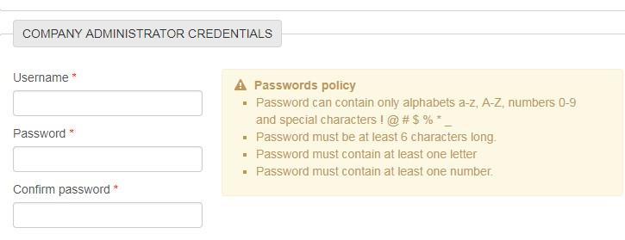Complete the following fields:

• Username
• Password
• Confirm password

You can add multiple email addresses to the system for email alerts.
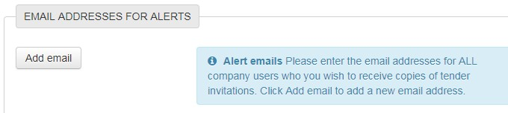

ACCEPT THE TERMS AND CONDITIONS

• Accept terms and conditions

Press SAVE
eTenders will contact you within a few days to confirm your registration and access to the system.

TO MANAGE BUSINESS ALERTS

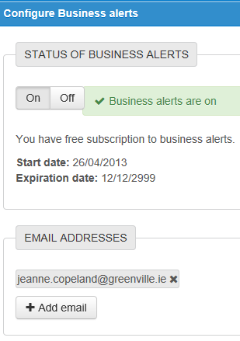Make sure the Business Alerts button is turned on and the relevant CPV Codes for the business have been selected.

Add all relevant email addresses for other colleagues to receive the Business Alerts.

Make sure to turn on Business Alerts and that the relevant CPV Codes have been selected, this is critical to ensure opportunities are not missed.

Additional email addresses can be added for other colleagues to receive the Business
Alerts.

TO REGISTER RELEVANT CPV CODES Once registered ensure that the profile is complete and add the CPV codes (common procurement vocabulary) that are relevant to business. By completing these, the organisation will then receive regular email notifications, daily if applicable, on contract opportunities relevant to the business. Additional CPV codes can be added at any time.

To access this field, please log in - click on the Administration Tab on the top of the log-in screen.

Scroll down to the Current Service Subscriptions section and click on Manage Business
Alerts field.

WHAT ARE CPV CODES?

CPV Codes – the Common Procurement Vocabulary. This a special EU procurement coding for supplies, works and services to enable multi-lingual translation and interpretation of tender opportunities throughout the EU – it is used by Contracting Authorities to classify requirements consistently and to help suppliers find contract notices of interest to them.
By registering the relevant CPV Codes of interest on your profile on eTenders you are
ensuring that don’t miss out on tender opportunities. There is no limit to the number of CPV
codes which you select.

The codes are structured as follows:

Supplies start at | 01000000 – 44000000 and 48000000
Services start at | 50000000 – 99000000
Works are classified under Section | 45000000 only.

On the CPV Codes section, click on Add CPV. There may be multiple codes that suit the business so spend time considering and selecting as many codes as are relevant. (the -9; -0 digits are check digits – it is the first 8 digits that dictate the category).
Examples of CPVs:
5011000-9 Repair and maintenance services of motor vehicles and associated equipment.
50116600-7 Repair and maintenance services of starter motors
3922000-4 Catering Supplies
39310000-8 Catering Equipment
55520000-1 Catering Services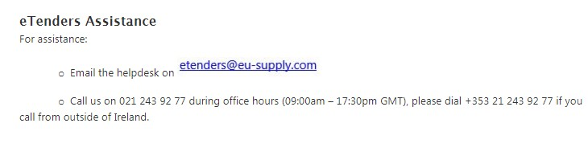

Call the Helpdesk

Guidance for Schools on Good Procurement Practices, (SPU; Jan 2017) Click here for link
Office of Government Procurement Public Procurement Guidelines for Goods and Services Click here for link

