GUIDANCE FOR
SUPPLIERS RESPONDING TO TENDERS
VIA
WWW.ETENDERS.GOV.IE

WWETB’s Procurement Team
procurementteam@wwetb.ie

Contents
Introduction 3
Guidance on Accessing eTenders 7
Guidance on using Messaging / Question and Answer Facility 9
Guidance on Submitting the Formal Response 10
WWETB PROCUREMENT 12

Introduction

‘Procurement’ is the overarching function that describes the activities and processes to acquire goods and services from an external source. As distinct from “purchasing” procurement involves all the activities involved in establishing requirements, market research, approach, supplier / tender evaluation, negotiation and award of contracts through to contract management.
Public Bodies (Contracting Authorities) such as Education and Training Boards (ETBs) must ensure that procurement is carried out in accordance with National and European Union Public Procurement Regulations & Directives, Legislation, Policy and Guidelines. There is an onus on public bodies to ensure that the public procurement function is discharged ethically, honestly and fairly in a manner that secures best value for money.
‘Public Procurement’ refers to the process by which public bodies purchase works, goods or services from suppliers’ which they have selected for this purpose. It ranges from the purchase of routine goods or services to large scale contracts for infrastructural projects and involves a wide and diverse range of contracting authorities.

A ‘Public Contract’ is a contract for the provision of works, supplies or services to a contracting authority. It includes all procurements, not just those which are undertaken on the basis of a full tendering process and formal signing of a contract.
‘Tender’ and ‘Tendering’ is used to describe the procedures for above National Threshold procurements (€25k supplies and services; €50k works) and ‘quotations’ refers to the procedures used for below National Threshold procurements.
Goods/Supplies: the purchase, lease or rental of a good or product (e.g.. vehicles, IT, stationery)
Service: provision of services such as canteen, cleaning services, legal, professional etc.
Work: building / civil engineering design and execution
Framework Agreement: an agreement between one or more contracting authorities and one or more suppliers which establishes some or all of the terms on which contracts for supplies, works or services can be entered into during the period of the agreement without further advertisement.
WATERFORD AND WEXFORD ETB PROCUREMENT THRESHOLDS:
Threshold | Procedure | Publish on ETenders? | Publish on OJEU?
€0 - €500 | Proceed with PO | While publication not required, consider using E-Tenders ‘Quick Quote’ function
€500-€5,000 | One or more competitive quotation(s) - if verbal, document same.
€5,000-€15,000 | Seek 3 written quotations by specified closing date
€15,000-€25,000 | Seek 5 written quotations by specified closing date. Follow clear process e.g.. specification, evaluate, notify.
€25,000-€125,000  €125,000- €215,000 | Open Procedure (single stage no prequalification)  Choice of Procedure (e.g.. open, restricted, competitive dialogue)
€215,000+ | Choice of Procedure
> €750,000 | Title III Services
< €50,000 | Minimum of 5 written quotations | While publication not required, consider using E-Tenders is considered best practice
€50,000- €2,500,000 | Open procedure
€2,500,000-€5,382,000 | Large/ complex projects: Restricted Procedure. Smaller/ straight forward projects: Open Procedure
€5,382,000+ | Restricted Procedure

Public Bodies are obliged to publicly tender all requirements on the Irish Government website www.etenders.gov.ie over certain thresholds, in addition to advertising in the Official Journal of the European Union (OJEU) for larger value contracts.

The etenders website is the national system operated in Ireland. It is a fully electronic confidential tool supporting the advertising and tender transactions for all Irish Public Bodies as well as those in receipt of public funding.

There are essentially 5 categories of procurement methods:

• Quotations – where the Contracting Authority has discretion over who to invite to submit a quotation (as per above thresholds).
• National Tenders – where the Contracting Authority must advertise its requirements on the Irish Government website www.etenders.gov.ie and comply with strict rules and protocols on tendering.
• EU Tenders – where the Contracting Authority must advertise its requirements in the European Journal in addition to www.etenders.gov.ie. The notice will also appear on the OJEU making it accessible to all EU Member States in addition to other countries signatory to various EU trade deals such as the European Economic Area and the Government Procurement Agreement of the World Trade Organisation. The official OJEU website is www.ted.europa.eu. The rules of EU tendering are defined by EU legislation, namely Directive 2014/24/EU as transposed into Irish law by Statutory Instrument 284 of 2016.
In addition to the 3 methods outlined above, Contracting Authorities may also

• Award contracts via mini-competitions under Framework Agreements established by the Office of Government Procurement (OGP), Education Procurement Service or collaborative groups of organisations such as a number of ETBs .
• They may also use framework agreements set up by their own organisations.
It is Government policy to use centralised contracts and this is reiterated in the Code of Practice for the Governance of ETBs Where a National or Sectoral Contract or Framework exists for the supply of goods and services or works the contract will already have been subject to the necessary level of competition and should be used, once suitable to ETB requirements. In the case of a Single Party Framework it is not necessary to obtain further competitive quotations and orders may be placed directly with the supplier. In the case of Multi Party Supplier Frameworks it will be necessary to conduct a 'mini-competition'. Where a central procurement framework or contract is not used, a value for money justification, approved by the Director of OSD, should be kept on file for audit purposes.

In the case of mini-competitions, these are not publicly visible, however the establishing framework would have been advertised on www.etenders.gov.ie / OJEU.

The final method may involve the establishment of panels or Dynamic Purchasing Systems (DPS) – these are lists of qualified economic operators. They are constantly open for access for economic operators to apply on www.etenders.gov.ie / OJEU. The establishment is subject to public advertising; however, the contracts being awarded under the Panels/DPSs are not.

Please note the following:
*Title III Services as defined in the Directives include training and education, social and related services, catering and hotel services, security services, etc.

**Concession Contracts are contracts based upon two fundamental aspects – remuneration and risk. The remuneration is paid for by those using the service / work and the risk (being a significant element of the risk involved) must be taken by the concessionaire. A typical service concession is a bank ATM machine or a coffee shop at a public building/facility. A typical works concession is a toll road.

This Guidance Document aims to explain the process involved for economic operators responding to quotations, tenders or mini-competitions via the www.etenders.gov.ie website.
Timescales for competitions published on Etenders and OJEU:
Procedure | Receipt of Expression of Interest | Receipt of Tenders | +Standstill | +allow time for
NATIONAL (Non-OJEU tenders) |  |  |  | - Preparing specification  - Evaluation of tenders  - Contract finalisation  - Supply & delivery
National – Open (recommended) | N/A | 21 days | 7
National – Restricted (recommended) | 21 days | 21 days | 7
EUROPEAN (OJEU tenders)
Open – e sending notices/docs available | N/A | 35 days | 14
Open – e sending & receiving tenders | N/A | 30 days | 14
Open – PIN | N/A | 15 days | 14
Restricted – e sending notices/docs available | 30 days | 30 days | 14
Restricted – e sending & receiving tenders | 30 days | 25 days | 14
Restricted - PIN | 15 days | 10 days | 14

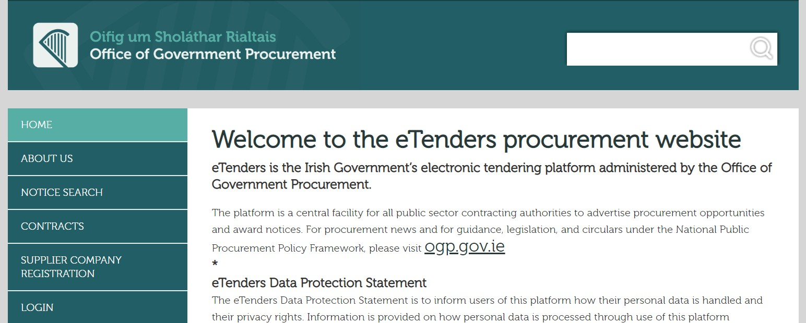

Guidance on Accessing eTenders

Log on to www.etenders.gov.ie

STEP | ACTION
TO GET THE DOCUMENTS FROM WWW.ETENDERS.GOV.IE
Step 1 | Locate the competition under System ID number if known, or via email link from etenders or by searching by the Contracting Authority. This is accessed via the website Notice Search function
System Id | Tender reference | Tender name | Publication date | Response deadline (Irish time) | Procedure | Authority | Countries
153675 | V19/5 | Contract for Emergency Breakdown, Bi-annual Repair and maintenance and supply of parts for the “rolling stock” training units and vehicles for Waterford Training Centre. | 04/07/2019 | 25/07/2019 15:00 | 1. Open Procedure (NON OJEU) | Waterford & Wexford Education & Training Board | Ireland

Step 2 | Click on the hyperlink under the Tender Name  RFT 153675 - V19/5 - Contract for Emergency Breakdown, Bi-annual Repair and maintenance and supply of parts for the “rolling stock” training units and vehicles for Waterford Training Centre  https://irl.eu-supply.com/app/rfq/edittransaction.asp?TID=153675
Step 3 | Check the Button the top left
Step 4 | Enter username and password
Step 5 | Click the button on the top left
Step 6 | Click on the Access Documents Section
Step 7 | Download all the documents – read carefully and ensure you comply with all rules for tender submissions

Guidance on using Messaging / Question and Answer Facility

Note #1: Please note that in public tenders, where questions are asked by tenderers i.e. clarifications sought, the answers are anonymised are issued to all interested parties.

STEP | ACTION
TO ASK QUESTIONS ON WWW.ETENDERS.GOV.IE
Step 1 | Click on the Messaging Tab
 | 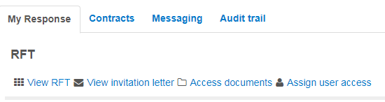
Step 2 | Click on the New Message button
Step 3 | Complete the message including subject, content and press Send.

Guidance on Submitting the Formal Response

STEP | ACTION
TO SUBMIT A TENDER RESPONSE ON WWW.ETENDERS.GOV.IE
Step 1 | LOGIN
Step 2 | On the HOME screen under My Request for Tenders, click on the Tender  Competition using the blue hyperlinked text.
Step 3 | Step 3 Go to the My Response Section and respond to the sections as follows:
Step 4 | My Response  If it asks for Additional Response Documents – just upload the response documents ensuring they are properly named under the  Attach Documents button.  Make sure the documents are:  • Named with easily identifiable titles including organisation name;  • Indexed;  • Page numbered;
Step 5 | The Percent Complete will turn green when documents are uploaded.
Step 6 | When you are ready to submit, press the blue Submit response button:
Step 7 | A request is made for the username and password again – this must be completed to fulfil the submission obligation.

Note #1: Please note that once uploaded it is possible to cancel the submission and re- upload if required, once the closing date and time has not passed.

Note #2: The maximum file size is 2.14Gb. There is no limit on the number of documents which can be uploaded in a tender response, unless limited by the instructions from the buyers.

Note #3: It is recommended to minimise the number of documents submitted where possible. Please ensure all documents are named correctly and logically so that the Contracting Authority can easily determine what the file contains.

Note #4: Please leave sufficient time to upload the documents taking account of the size /
number of files to be uploaded, and the broadband speed and capacity in the local area. It is possible to log in and practice uploading in advance.
• Don’t press submit if practicing;
• Make sure to delete any test documents.

Note#5: Please note the system will time out after 1 hour, so if it is taking longer, save and exit and start again.

Note#6: If you run into difficulty, please contact the eTenders Helpdesk at 021 2439277 or email them at etenders@eu-supply.com.

WWETB PROCUREMENT

WWETB is committed to maximising value for money in all goods and services procured and ensuring compliance with all national and EU regulations.
A key principle of procurement is that goods and services should be appropriate and sourced at the best possible cost to meet the needs to the buyer in terms of quality and quantity, time and location.
WWETB utilises OGP frameworks where suitable for its needs.
Procurement transactions and decisions must in all respects be fair, equitable and ensure value for money. Procurement practices are subject to audit and scrutiny under the Comptroller and Auditor General (Amendment) Act 1993 and Department Circulars and procurement guidelines.
Waterford and Wexford ETB encourage SME participation in public procurement as per Circular 10/14. Some competitions may be sub-divided into lots to facilitate access by SMEs, both quantitatively (the size of the lots may better correspond to the productive capacity of the SME) and qualitatively (the content of the lots may correspond more closely to the specialised sector of the SME). It may also be sub-divided by geographical area.
Waterford and Wexford ETB encourage and support Green Public Procurement (GPP): A process whereby public and semi-public authorities meet their needs for goods, services, works and utilities by choosing solutions that have a reduced impact on the environment throughout their life-cycle, as compared to alternative products/solutions.” Sourcing products/services that make good economic and environmental sense and comply with EU regulations e.g. timber products EU regulations. It raises the concepts of life-cycle analysis (LCA) and life-cycle costing (LCC) are at the heart of GPP, and require buyers and suppliers to consider not just the up-front purchase costs of a given solution, but its total economic and environmental cost.

Guidance for Schools on Good Procurement Practices, (SPU; Jan 2017) Click here for link
Office of Government Procurement Public Procurement Guidelines for Goods and Services Click here for link
S.I. No. 284 of 2016 European Union (Award of Public Authority Contracts) Regulations 2016 Click here for link
All thresholds exclude VAT
Via eTenders
As per DPER Public procurement Guidelines for Goods and Services (July 2017) (Page 35) “contracts for goods and services with an estimated value of less than €5,000 (exclusive of VAT) can be purchased on the basis of verbal quotes from one or more competitive suppliers (best practice is to seek a minimum of 3 quotes confirmed by e-mail)
EY Threshold as of January 2018. EU thresholds are updated every 2 years – current thresholds available here
Particularly relevant for services such as e.g. security, training and restaurant services. See here for regime applied (page 178) and here for list of services/ CPV codes it applies to (Annex XIV)
For details of timeframes that apply to below EU Threshold works-specific procurements go to www.education.ie
In exceptional circumstances – a shorter time limit of 15 days is allowed “where a state of urgency duly substantiated by the contracting authorities renders the minimum impracticable”
Circular 40/02: Public Procurement Guidelines – revision of existing procedures for approval of certain contracts in the Central Government sector. Other Guidelines include National Public Procurement Policy Network (Jan 2018) and Public Procurement Guidelines for Goods and Services.
Circular 10/14: Initiatives to assist SMEs in Public Procurement (16th April 2014).
Green Tenders – An Action Plan on Green Public Procurement 2014 (Green Procurement Guidance for the Public Sector

