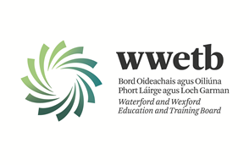

Applications are invited from suitably qualified persons for the following vacancy:

ADULT LITERACY ORGANISER

1 YEAR FIXED-TERM CONTRACT COVERING A CAREER BREAK (JANUARY 2023 – JANUARY 2024)

LOCATION: BUNCLODY FET CENTRE/NORTH WEXFORD

All appointments are to WWETB Scheme

Completed applications should be returned to arrive no later than 4:00pm on 23/01/2023 to vacancies@wwetb.ie

Short Listing may apply.
Canvassing by or on behalf of the candidate will automatically disqualify.
Late applications will not be accepted.

WWETB is an equal opportunities employer.

