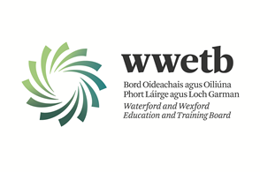

Applications are invited from suitably qualified persons for the following vacancy:

BUS DRIVERS
(to form a panel of suitably qualified Bus Drivers)

INITIAL LOCATION: DUNGARVAN, WATERFORD

Essential:
Class D1 Driving Licence (minimum requirement)
Driver Certificate of Professional Competence (CPC)

Drivers will be subject to successful completion of Garda Vetting process prior to being engaged by
WWETB. Drivers will be engaged as the need arises and payment will be at the rate agreed by WWETB, on a claim form basis.

Please apply by email with covering letter and up to date C.V. to vacancies@wwetb.ie
Closing date for receipt of applications is 4.00pm Friday 20th January 2023.

Short Listing may apply.
Canvassing by or on behalf of the candidate will automatically disqualify.
Late applications will not be accepted.

WWETB is an equal opportunities employer.

