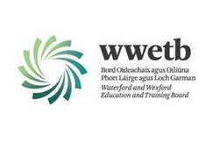
WATERFORD & WEXFORD EDUCATION & TRAINING BOARD
Bord Oideachais & Oiliúna Port Láirge & Loch Garman

Applications are invited from suitably qualified persons for the following vacancy:

ADULT EDUCATOR IN COMMUNITY EDUCATION
LOCATIONS: BUNCLODY FURTHER EDUCATION AND TRAINING CENTRE
TEMPORARY POST

Application form and full details for the above positions may be obtained from https://www.wwetb.ie/about/organisation/human-resources/vacancies/

Closing date for receipt of applications is Thursday 30th March 2023.

Shortlisting may apply.
Canvassing by or on behalf of the candidate will automatically disqualify.
Late applications will not be accepted.
WWETB is an equal opportunities employer

