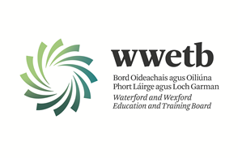

Applications are invited from suitably qualified persons for the following:

CLEANER

BRIDGETOWN COLLEGE

10 HOURS PER WEEK (PERMANENT CONTRACT)

Mon – Thurs: 4-6pm

Fridays: 1-3pm

Application form and Job Description may be obtained from www.wwetb.ie

Completed applications should be emailed to vacancies@wwetb.ie by 28/03/2023 at 4.00pm

Shortlisting may apply.
Canvassing by or on behalf of the candidate will automatically disqualify.
Late applications will not be accepted.

WWETB is an equal opportunities employer.

For any questions relating to this role please contact the recruitment team in WWETB at
053- 9123799

