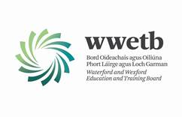

Protected Disclosures Annual Report 2022

The Protected Disclosure Act 2014 Section 22 requires that every public body shall prepare and publish a report on matters on protected disclosures made to it no later than 30th June of each year for the preceding year.

Matters are as follows:-

- the number of protected disclosures made to the public body –

No disclosure was made to WWETB in accordance with the Protected Disclosure Policy

- the action (if any) taken in response to those protected disclosures –

No action required

- such other information relating to those protected disclosures and the action taken as may be requested by the Minister from time to time –

No action required

