2018 QUALITY IMPROVEMENT PLAN
PROGRESS REPORT

Waterford and Wexford Education and Training Board
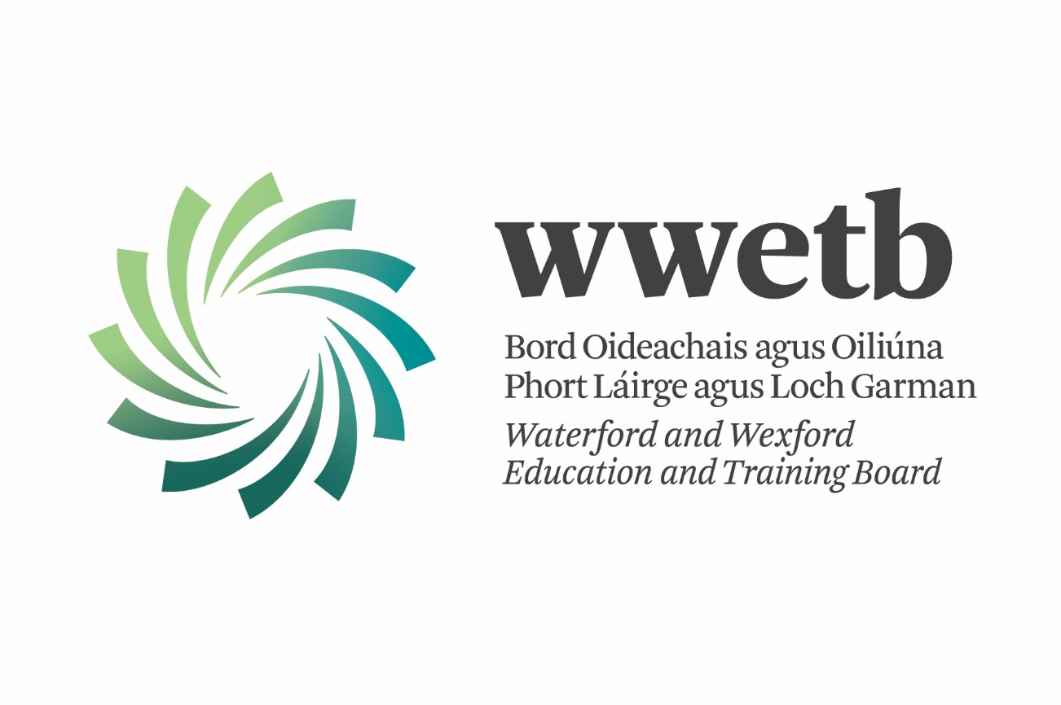

Part 1: Overview of Quality Improvement Activities in 2018

Key Areas of focus in 2018
- Review and enhance FET QA Governance
- Review existing policies and procedures, and amend or create new policies and procedures where needed; with a view towards one overarching Total Quality Assurance Framework.
- Review and ensure the implementation of fair & consistent assessment procedures.
- Review and improve course monitoring procedures.
- Improve Data & Information Systems and Analysis.
- Improve Programme Development process & validation of new Agriculture Programmes.
- Ensure Continuous Professional Development of the QA Team, QA/QQI Coordinators and centre-based staffed involved in the Assessment Process.
Detailed Sub-tasks for each for the above can be found in the 2018 QIP.

Main QA improvement achievements in 2018
WWETB undertook a review of our FET QA Governance which led to a number of changes and enhancements. Our QA Team and FET Governance structures were fully documented. The role, structure and participation on our QA Steering Group (QASG) and Programme Approval Committee (PAC) were reviewed and updated. New terms of reference were approved for both the QASG and PAC.
We have begun the vast process of reviewing existing policies and procedures and to amend or create new policies and procedures where needed; with a view towards one overarching Quality Assurance Framework for WWETB for Further Education and Training.
The new ETBI assessment procedures handbooks were reviewed to consider viability of common assessment procedures across ETB centres. Six of these handbooks were rolled out as working drafts in 2018 and will be further reviewed in 2019.
We identified & collated all existing legacy policies and procedures (both FE & TQAS) from the seven legacy QA agreements WWETB had with FETAC/QQI. We prioritised some policies/procedures to be addressed during 2018 and worked on amending and implementing policies in consultation with centres.
Reviews were undertaken to ensure the implementation of fair & consistent assessment procedures, this included the collation and review off all EA Reports and RAP meetings from 2016/2017. The main findings of this review were outlined to coordinators and FET management at a QA Workshop in September. Review and training around our Interval Verification and External Authentication procedures was carried out.
WWETB did a lot of work on improving our Data & Information Systems and Analysis. In September we launched our QA SharePoint site which includes a controlled access repository for all our programmes, a library of all assessment process documentation and forms, policies and procedure and a shared collaboration library.
We also created a new Data Analytics role and employed a data analytics person on a contract basis. While the benefit of this role to QA has been limited, it has been of huge benefit to the organisation from a data analysis and planning point of view.
A huge amount of work has taken place around our Programme Development and validation processes and work is ongoing on the validation of three new Agriculture Programmes. A lot of excellent learning and development has taken place, but it has been a very challenging process and the outcomes will need to be reviewed for future programme development.
The QA team continues to deliver CPD and Training to programme managers/coordinators, QA/QQI coordinators, teaching staff and centre-based staffed involved in the Assessment Process. This process has been very successful in ensuring consistency of approach in a changing environment for our centres.

Barriers or challenges encountered in implementing the 2018 QIP
The development of a common QA Framework across all WWETB programmes and provision is an extremely complex task and will likely take a number of years.
The amount of time the QA Officer has spent on the Agriculture programme development project has negatively impacted the time available to work on other QIP tasks.
The work involved in developing the three new Agriculture programmes under the new QQI validation policy has proved to be hugely more onerous than expected. This is a pilot project and the development and learning has been extremely successful. However the current process is completely unsustainable and inefficient. It will have a massive impact on the sector going forward unless the necessary structures are put in place.
Certain QA projects and tasks are being worked on centrally through ETBI. WWETB is reliant on the speed at which these projects develop nationally.
While WWETB employed a data analytics person and engaged in a review of EQAVET Indicators, we found it challenging to determine the usefulness of a lot of this data.
There has been a huge amount of change in sector, which is challenging on an ongoing basis.
- Structural changes; both locally and in ETBI and QQI. The amalgamation of FE & T programmes community programmes for example, while making sense from a planning perspective, creates a number of challenges from a QA, programme and certification viewpoint.
- Policy changes; the changes to our governance has resulted in new policy and procedures which need to be implemented in a consultative and managed fashion. The new QQI validation policy has been extremely challenging with regards to new programme development.
- Systems changes; the rollout of the new QA SharePoint while beneficial, results in process change. The updated QBS created some issues and required additional support and training. The retirement of CAMS creates continued uncertainty around the access and management of AISs.
- Personnel changes; WWETB had 12 new or acting programme coordinators / centres managers in the last year, this creates support and training challenges that must be carefully managed.

Key areas of focus for quality improvement in 2019

Review existing policies and procedures and amend or create new policies and procedures where needed; with a view towards one overarching Quality Assurance Framework
- Retire TQAS; Replace the TQAS with WWETBs Assessment Framework
- Review current RPL policy and update where necessary
- Teacher Induction
- Amend/develop and implement identified policies/procedures to include consultation with and communication to centres
- Consider how other Awarding Bodies and non-certified programmes can be included in policies and procedures
Review and ensure the implementation of fair & consistent assessment procedures
- Review Assessment Handbooks launched in 2018
- Review and implement new External Authentication model once this has been agreed nationally
- Complete review of Repeats in WWETB and implement new Repeats Policy
Continued improvement of course monitoring procedures
- Reintroduce monitoring functions and reports for centre visits and briefing
- Ensure admin support is available for the production of RAP reports in 2019
Improve Data & Information Systems and Analysis
- Training of staff on the use of WWETB SharePoint site to include all WWETB policies, procedures, resources and programme descriptors.
- Review grade distributions across our components
- Research meaningful ways of using data indicators for continuous improvement
Programme Development, Validation and Review
- Successfully develop and validate new agriculture programmes
- Updated AISs; implement the AISs updated as part of the AIS review carried out by ETBI
- Review and updated Payroll modules
- Programme review as part of subject specific working groups
Training and CPD of centre managers/coordinators and teaching staff
- Review and plan for the CPD needs of QA Team
- Training of new coordinators and teaching staff
- Subject specific working groups, communities of practice

