2019 QUALITY IMPROVEMENT PLAN
PROGRESS REPORT

Waterford and Wexford Education and Training Board
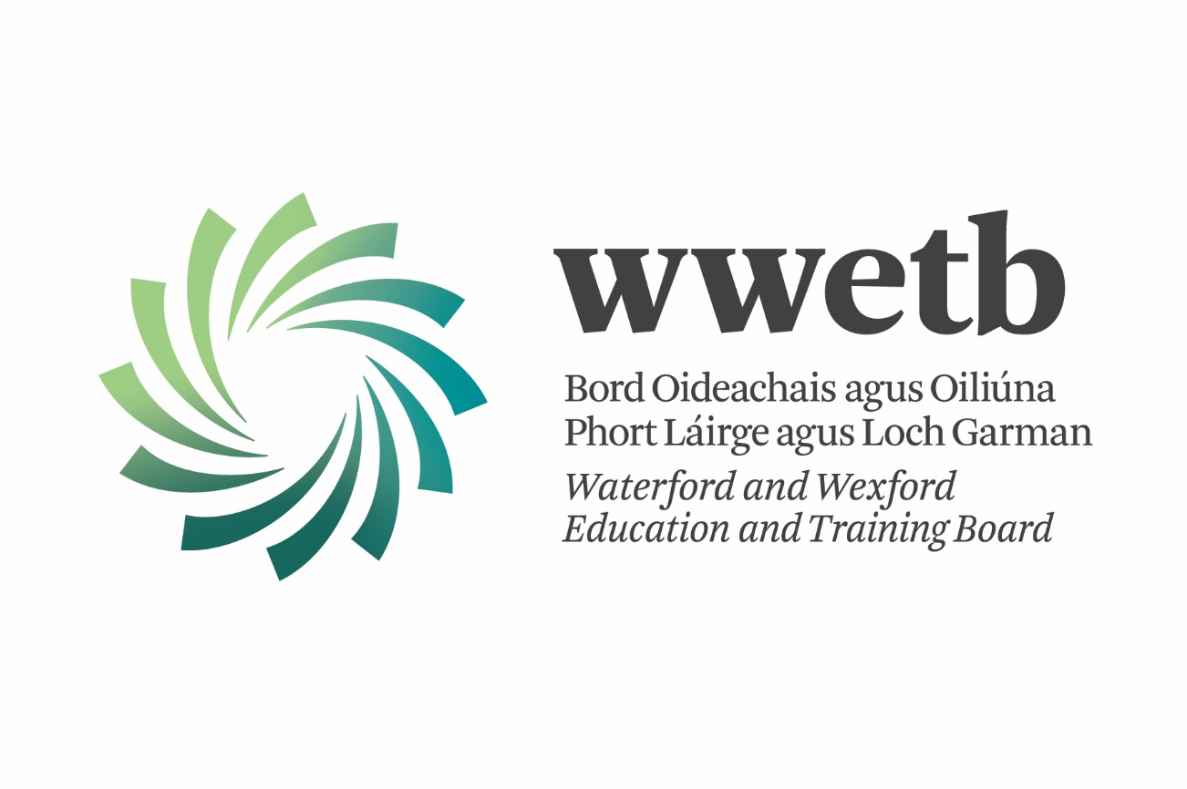

Part 1: Overview of Quality Improvement Activities in 2019

Key Areas of focus in 2019
- Review existing policies and procedures and amend or create new policies and procedures where needed with a view towards one overarching Quality Assurance Framework
- Review and ensure the implementation of fair & consistent assessment procedures.
- Continued improvement of course monitoring procedures
- Improve Data & Information Systems and Analysis
- Improve Programme Development process & validation of new Agriculture Programmes
- Training and CPD of QA Team, centre managers/coordinators, and teaching staff
Detailed Sub-tasks for each for the above can be found in the 2019 QIP.

Main QA improvement achievements in 2019
We are continuing the vast process of reviewing existing policies and procedures and to amend or create new policies and procedures where needed; with a view towards one overarching Quality Assurance Framework for WWETB for Further Education and Training. The TQAS forms relating to the assessment process were retired and replaced by WWETB forms. The few forms allowed closer integration between the FE & T assessment process and a singular common form was identified for use where possible.
The ETBI assessment procedures handbooks were reviewed after the first year of use. This will result in changes to all of these handbooks over the 2019/2020 academic year and the subsequent development of WWETB specific assessment handbooks, which will supersede the ETBI Assessment Procedures handbooks. The WWETB handbooks will be largely consistent with ETBI development handbooks with some required local amendments.
Considerable consultation and development was done on the creation of a consistent Repeats policy for WWETB. This will be finalised and approved in 2020 for September 2020 rollout. Further prioritisation of the policies/procedures to be addressed during 2020 has taken place.
Reviews were undertaken to ensure the implementation of fair & consistent assessment procedures. This included the collation and review off all EA Reports and RAP meetings from 2018 & 2019. The main findings of this review were outlined to coordinators and FET management at a QA Workshop in September. Review and updates around our Internal Verification and External Authentication procedures were carried out.
WWETB put great effort into improving Data & Information Systems and Analysis. The new Data Analytics Consultant has been of huge benefit to the organisation from a data analysis and planning perspective. Work has commenced around a number of projects in this area, including a Data & Information Management Policy; a review of the data consistency across our various business systems, defining the data lifecycle of learner, course, programme and certification data and development of key data indicators.
The successful validation of three new Agriculture Programmes was completed. The learning and outcomes of this project will inform programme development and validation in the ETB sector for many years to come.
The QA team continues to deliver CPD and Training to programme managers/coordinators, QA/QQI coordinators, teaching staff and centre-based staff involved in the Assessment Process. This process has been very successful in ensuring consistency of approach in a changing environment for our centres.

Barriers or challenges encountered in implementing the 2019 QIP
The development of a common QA Framework across all WWETB programmes and provision is an extremely complex task and will likely take a number of years.
The required time commitment on the part of the QA Officer in the development of the Agriculture programme in the first-half of the year, negatively impacted the time available to work on other QIP tasks.
Certain QA projects and tasks are being worked on centrally through ETBI. WWETB is reliant on the speed at which these projects develop nationally.
The amalgamation of FE & T programmes, Community programmes for example, while making sense from a planning perspective, creates a number of challenges from a QA, programme and certification viewpoint. These will be further reviewed in 2020.
The retirement of CAMS creates continued uncertainty around the access and management of AISs.
Personnel changes:
- Within the QA team there were a number of staff changes in 2019, while welcome and required for the long term, it results in some short-term uncertainty and delays.
- WWETB appointed a number new or acting principals, programme coordinators / centres managers in the last year, this creates support and training challenges that must be carefully managed.

Key areas of Focus for Quality Improvement in 2020
The detail of 2020 Quality Improvement Plan is currently under review as a result of the changed priority associated with the COVID19 crisis. It is likely there will be changed priorities and focus for the third and fourth quarters of 2020. A detailed, updated QIP for 2020 will be submitted to QQI as soon as approved by WWETB governance structures. The key areas of focus for 2020 are as follows:

- Plan, develop and implement self-evaluation aspects of the Inaugural Review including review of integrated QA Handbook.
- Review existing policies and procedures and amend or create new policies and procedures where needed; with a view towards one overarching Quality Assurance Framework for WWETB.
- Review and ensure the implementation of fair & consistent assessment procedures.
- Improve Data & Information Systems and Analysis, including a Data & Information Management Policy.
- Develop contingency plans as required during COVID19 crisis.
- Develop policies and procedures around blended learning and extend scope of provision with QQI.
- Review use of AISs and the QA System in use with LTIs and CTCs.
- Training and CPD of QA Team, centre managers/coordinators, and teaching staff.

Note: the ability of the QA team and WWETB FET to work on these areas will be dependent on the ongoing COVID 19 crisis and the impact on business practices and the need for the QA team to focus on issues arising therefrom.
Quality Improvement Objective/Desired Outcome | Key Tasks/Activities | Responsible Person(s) | Timeline | Status | Updated | Revised Timescale
- Review existing policies and procedures and amend or create new policies and procedures where needed; with a view towards one overarching Quality Assurance Framework | 1.1 Retire TQAS; Replace the TQAS with WWETBs Assessment Framework | QA Team  QA Steering Group | Q2-Q4 2019 | Complete | Forms complete by Colin. On Curriculum Drive in “WWETB QA Forms” Folder
 | 1.2 Review current RPL policy and update where necessary | QA Team | Q3 2019 |  | Draft has been developed and awaiting approval | Q4 – 2020
 | 1.3 Review teacher induction process and develop policy | QA Team  QA Steering Group | Q3 2019 |  | All teachers must complete an Assessment process QA briefing.
 | 1.4 Amend/develop and implement identified policies/ procedures to include consultation with and communication to centres | QA Team  QA Steering Group | 2019 |  | All Approved  - Repeats  - Short-Term Extensions  - Compassionate Consideration  Updated and awaiting approval  - Examinations  - Assessment Malpractice  - Secure Storage  - RPL | Work to continue in 2020
 | 1.5 Consider how other Awarding Bodies and non-certified programmes can be included in policies and procedures | QA Team  QA Steering Group | Q3 Q4 2019 |  | Work completed on inclusion in programme approval policies.  Oversight is covered in Training as part of TQAS.  Further work required in FE in 2020 | Work to continue in 2020 regarding oversight of centres with direct agreements
- Review and ensure the implementation of fair & consistent assessment procedures | 2.1 Review Assessment Handbooks launched in 2018 | QA Team | Q3 2019 |  | Complete
 | 2.2 Review and implement new External Authentication model once this has been agreed nationally | QA Team  QA Steering Group | Q3-Q4 2019 |  | Complete  Concern over aggregated T&S payments
 | 2.3 Review current practices around Repeats and in consultation develop a clear policy and procedures on Repeats | QA Team  QA Steering Group | Q3 2019 |  | Complete
- Continued improvement of course monitoring procedures | 3.1 Reintroduce monitoring functions and reports for centre visits and briefing | QA Team | Q2 2019 |  | New monitoring process and form complete. Will be rolled out in 2019.
 | 3.2 Ensure admin support is available for the production of RAP reports in 2019. Provide resources where required. | QA Team & FET Director | Q2 2019
- Improve Data & Information Systems and Analysis | 4.1 Training of staff on the use of WWETB SharePoint site to include all WWETB policies, procedures, resources, and programme descriptors. | QA Team | Q1 –Q4 2019 |  | Complete & ongoing as requested
 | 4.2 Review grade distributions and consistency of standards across our components | QA Team | Q3 – Q4 2019 |  | Further work required in 2020. Alan L to work with Jon Ishaque on further rollout. | Q4 2020
 | 4.3 Research meaningful ways of using data indicators for continuous improvement | QA Team  Data Analytics | Q3 – Q4 2019 |  | Further work required in 2020. Alan L to work with Jon Ishaque on further rollout. | Q4 2020
- Improve Programme Development process & validation of new Agriculture Programmes | 5.1 Successfully develop and validate new agriculture programmes | QA Officer  Centre Coordinators  Programme Writers | Q2 2019 | Complete |  | Q3 2019
 | 5.2 Updated AISs; implement the AISs updated as part of the AIS review carried out by ETBI | QA Team | Q3-Q4 2019 |  | Awaiting decision from ETBI DFET forum on rollout. | Q4 2020
 | 5.3 Review and update Payroll modules | QA Officer  QA Team | Q2-Q3 2019 | Complete | Complete
 | 5.4 Programme reviews as part of subject specific working groups | QA Officer | Q1 – Q4 2019 | Complete | Complete
- Training and CPD of centre managers /coordinators and teaching staff | 6.1 Review and plan for the CPD needs of QA Team. | Unit Manager  QA Team | Q2 2019 | Complete | Training identified
 | 6.2 Training of new coordinators and teaching staff | QA Officer  TSO | Q1 – Q4 2019 | Complete | Further training in 2020
 | 6.3 Subject specific working groups, communities of practice | QA Officer  CPD Coordinator | Q1 – Q4 2019 | Complete | Some have taken place. AOG to talk to Paul Fallon around next groups. Childcare to be created in 2020

This is colour coded to indicate progress. i.e. Green is complete, Yellow is on track, Amber is delayed and Red not started.

