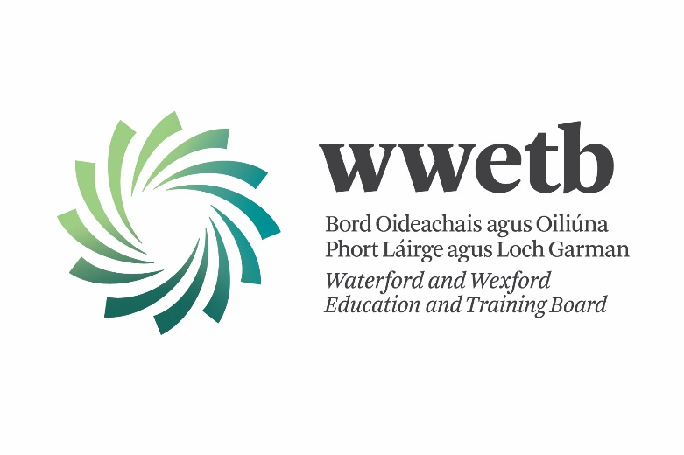

WWETB Appeals Process Handbook

For Colleges, Centres & Programmes using the WWETB Appeals Process in respect of QQI Awards

January 2021

Introduction

WWETB Quality Assurance manages the Appeals Process for all WWETB QQI assessments. The appeals process for 2021 is similar to the process that has pertained in recent years: for 2021, appeals from your college/centre will be processed by the WWETB Appeals Coordinator who is located in the Waterford Training Centre.
This handbook has been produced by WWETB to outline the roles and responsibilities of colleges/centres, learners and the WWETB Appeals Coordinator in the processing of Appeals. An electronic version of this handbook will be forwarded to all WWETB centres, accompanied by an electronic copy of the Learner Appeal Application Form. The handbook is divided into a number of sections:
Section1: WWETB Appeals Process
1. College/Centre Roles & Responsibilities
2. Appeals that may have an implication for CAO offers
3. WWETB Appeals Coordinator Roles & Responsibilities
Section 2: Appeals Documentation
1. Information to Learners
2. Learner Appeal/s Application Form
3. Statement of Appeal Outcome
4. Sample Letters from College/Centre to Learner
Section 3: 2021 Certification Calendar

Section 1: WWETB Appeals Process

1. College/Centre Roles and Responsibilities
1. After the Results Approval Panel (R.A.P.) meeting, the Provisional Statement of Results can be sent to the learners, along with a note outlining their right to appeal and/or the Learner Assessment Appeals Application Form. The College/Centre must insert their closing date for receipt of appeals on the Learner Assessment Appeals Application Form, bearing in mind that the learner must be given a minimum of 10 working days to return the form.
2. The College/centre has prime responsibility for communications with learners. The WWETB Appeals Coordinator will communicate directly with the college/centre and the college/centre directly communicates with learners. The college/centre has the responsibility to ensure the learner does not contact or communicate with the WWETB Appeals Coordinator.
3. Documentation for appeals in respect of minor awards must be accompanied the relevant programme module descriptor. An appeal in respect of a minor award cannot be re-examined without the relevant programme module descriptor.
4. The College/centre is required to check the relevant module descriptor to ensure that all the appropriate assessment evidence produced by the learner is available for the appeal. An appeal in respect of a minor award cannot be re-examined without the relevant assessment evidence.
5. The Appeal fee/s (€30.00 per component/module) must be lodged by the Learner to the WWETB Bank Account. Appeal fees must be referenced with the Learners Name and transferred to WWETB via electronic funds transfer to WWETB’s Bank Account, the details for which are given below:
Bank Name | Bank of Ireland, The Quay, Waterford
Sort Code | 90-61-95
Account Number | 10028234
BIC | BOFI IE 2D
IBAN | IE82BOFI 90619510028234

6. The College/centre must enclose a copy of the Appeal Application along with the following Appeal documentation:
- Note: All documentation will be held locally on site in Waterford Training Centre and returned once the appeal is complete
- Authentication Report by Learner Group by Minor Award Results Sheet
- Appeal Module Descriptor
- Learner Assessment Evidence
- Assessment Briefs & Marking Schemes
- Outline Solutions / Suggested Answers / Marking Scheme
- Learner Feedback
- Any media required, Memory Stick, Disk, Tape etc.
- Original Internal Verification report
- Original External Authentication report (if available)
- In the case of a remote IV & EA process the relevant folders must be either Shared with or zipped and emailed to the Appeal Coordinator
7. All Appeals for CAO applications must be received by the WWETB Appeals Coordinator on or before 4:00pm on 21st June 2021 and all additional appeals must be received by the WWETB Appeals Coordinator on or before 12:00pm on 13th September 2021. Appeals received after this date cannot be processed. For other certification rounds contact the QA Officer in the event of an appeal.
8. The college/centre is advised to personally deliver or use registered post or courier service when sending appeals to the WWETB Appeals Coordinator.
9. Only evidence that has previously been presented by the learner, and has been securely retained in the college/centre following the initial assessment, can be considered as part of an appeal. No new evidence can be submitted.
10. If learner evidence is of such a nature that it cannot readily be forwarded to the WWETB Appeals Coordinator, and a visit to the college/centre by an Appeals Examiner is required, the college/centre will indicate this to the WWETB Appeals Coordinator.
11. The centre/college will be informed by the WWETB Appeals Coordinator regarding the outcome of the appeal by letter or email and the centre/college will then inform the learner of the outcome of their appeal within a reasonable timeframe.
12. Following the completion of the Appeals Process, QQI will be informed by the WWETB Appeals Coordinator of appeal outcomes. QQI will make any required amendments to grades on the QQI Business System.
2. Appeals that may have an implication for CAO offers
The outcome of an appeal may have a significant bearing on whether an applicant through the CAO is offered a place on a Higher Education programme. The CAO operate to extremely strict timelines, and results that are not communicated to them in time will not be included in the point’s calculations, and subsequent candidate place offers. In order to ensure that a learner who has applied through the CAO and who is appealing the marks awarded to them through the WWETB Appeals Process in respect of QQI Awards benefits from any upgraded results awarded through the Appeals Process, applications for appeals in these cases must be received by the WWETB Appeals Coordinator not later than 4:00pm on 21st June 2021.
All appeals by learners who have applied through the CAO for Higher Education programmes should be clearly marked as “CAO APPLICANT”.
3. WWETB Appeals Coordinator Roles & Responsibilities
- The Appeals Process will involve a re-examination of:
- The learner evidence presented for the component/module under appeal
b) The assessment result awarded for the component/module
- An Appeals Examiner will be assigned by the WWETB Appeals Coordinator for the purpose of the appeal. The Appeals Examiner who re-examines a learner appeal will not be the teacher/tutor who made the original assessment decision, or the External Authenticator assigned to the college/centre during the assessment period for that award.
- The WWETB Appeals Coordinator will communicate the outcome of the appeal directly to the college/centre via letter or e-mail and will return all evidence to the college/centre.
- The college/centre will communicate the outcome of the appeal directly to the learner. If an appeal is successful, the €30.00 fee will be refunded to the learner by WWETB, a refund application form will be issued to the learner.
- The WWETB Appeals Coordinator will communicate the outcome of the appeal directly to QQI. In cases where an appeal is successful, QQI will amend the original result on the QQI Business System and will issue a new Certificate directly to the college.
- The WWETB Appeals Coordinator will not communicate directly with learners and will not respond to communications that do not emanate from a college/center.
- WWETB Appeals Coordinators Contact Details:
Michael Maher
Waterford Training Centre,
Waterford Industrial Park,
Cork Road, Waterford.
Tel: 051-862682
E-mail: michaelmaher@wwetb.ie
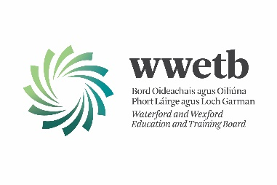

Section 2: Appeals Documentation

This section contains documentation required by learners and colleges/centres in respect of the processing of appeals.

1. Information for Learners
1. For all learners, information on the WWETB Appeals Process and the procedures and deadline for submitting an appeal must be made available to the learner.

2. Learners are entitled to appeal their result/s awarded for individual awards or components.

3. A learner who wishes to make an appeal must complete and submit a Learner Appeal/s Application Form which is available from their college/ centre. Learners must be given a MINIMUM OF 10 WORKING DAYS from receipt of results to return the application form and lodge the appeal fee. The college/centre must determine a date which complies with the minimum notice required and inform the learners of this date. Learners should be informed that Appeals received by the college/centre after this date will not be processed.

4. A fee of €30.00 is payable in respect of each module/component being appealed. This fee is refundable in the case of successful appeals. This fee of €30.00 per appeal must be paid by the learner directly to the WWETB account.

- Learners should be informed that Appeals cannot be processed without the payment of fees.

- Learners must communicate directly with the college/centre and under no circumstances should contact the WWETB Appeals Coordinator.

2. Learner Appeal/s Application Form (separate electronically form included)
1. The Learner Appeal/s Application Form must be available from the college/centre for all learners undertaking assessment.

2. The Learner Application Form is in Word format so that the college/centre can insert their own date by which the learners must submit an application to appeal, ensuring that the minimum requirement of 10 working days notice is adhered to.

3. The Learner Appeals Application form must be signed by learner and by College Principal/Centre Director.

4. The college/centre retains the Learner Application form for their records and should forward a copy of it to the WWETB Appeals Coordinator along with Appeal documentation.

5. An electronic version of this Handbook and the Learner Application Form will be forwarded to WWETB centres from which the Learner Application Form can be made available.

3. Statement of Appeal Outcome from WWETB Appeals Coordinator to College/Centre
1. This statement will be issued by letter or e-mail from the WWETB Appeals Coordinator directly to the college/centre.
2. The college/centre retains the statement for their own records and issues the learner with a separate letter communicating the appeal outcome.
3. The Appeal fee refund will follow in due course from the WWETB directly to the learner. A refund application form will be issued to the learner.
Statement of Appeal Outcome from WWETB Appeals Coordinator to College/Centre
College/Centre Name: Roll No.:
Learner Name:
Learner PPSN:
OUTCOME OF APPEAL
Component Code | Component Title | ORIGINAL GRADE | APPEAL GRADE
QQI have been informed of the appeal outcome and will amend statements of results where the appeal has resulted in the original result being upgraded. QQI will issue the learner with a new Certificate in due course.
The appeal fee of €30.00 will be reimbursed in due course for every component where the appeal resulted in an upgrading.
4. Sample Letters from College/Centre to Learner
1. The college/centre should ensure that they directly communicate with the learner on the outcome of an appeal and are welcome to use the following sample letters:
(a) Sample Successful Letter from College/Centre to Learner
Date, Learner Name, Address
Re: QQI APPEAL/S June 2021
Dear Learner
Your appeal in respect of «Component/Module_Code» has been successful and a grade of «Amended_Grade» has been awarded.
Your statement of results has been amended and QQI will issue you with a new Certificate. Your appeal fee of €30.00 will be reimbursed in due course.
Yours sincerely,

Principal /Centre Coordinator

(b) Sample Letter from Centre to Learner in respect of an Unsuccessful Appeal
Date, Learner Name, Address
Re: QQI APPEAL/S June 2021
Dear Learner
I am writing to you in regard to an appeal submitted for «Component/Module_Code»
This appeal has been unsuccessful and there is no change in grade. Your certificate has been issued with (June 2021 Assessment) Certificates.
Yours sincerely

Principal/Centre Coordinator

Section 3: 2021 Certification Calendar
2021 - QBS SUBMISSION CALENDAR
FOR QQI CERTIFICATION
Certification Round | Final Date on QQI Business System To Close Invalid Entries / Submit Certificate Requests | Final Date for receipt of Appeals by QA Team
Feb-21 | 12th February 2021 | Contact QA Officer in the event of Appeal
Apr-21 | 12th April 2021 | Contact QA Officer in the event of Appeal
Jun-21 | 12th June 2021 | 21st June (Final Date for CAO Appeals)
Aug-21 | 12th August 2021 | Contact QA Officer in the event of Appeal
Oct-21 | 12th October 2021 | Contact QA Officer in the event of Appeal
Dec-20 | 12th December 2021 | Contact QA Officer in the event of Appeal
N.B. All Appeals for CAO applications must be received by the WWETB Appeals Coordinator on or before 4:00pm on 21st June 2021
All results must be internally verified, externally authenticated and approved by Results Approval Panel prior to submission for certification.
Approved results should be flagged on the QBS, where an Appeal of a result has been lodged.

-END-

