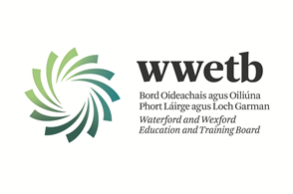

APPRENTICESHIP ELECTRICAL INSTRUCTOR VACANCIES
WATERFORD & WEXFORD

Applications are invited from suitably qualified persons to fill the following vacancies:

APPRENTICESHIP ELECTRICAL INSTRUCTOR
WATERFORD TRAINING CENTRE
PERMANENT POST

All details including Application form and a detailed Job Description can be downloaded from our website:

https://wwetb.ie/about/organisation/human-resources/vacancies

Closing date for applications is 12th October 2023 at 4:00pm

WWETB is an equal opportunities employer
Canvassing will disqualify.
Shortlisting may apply.
Late applications will not be accepted

