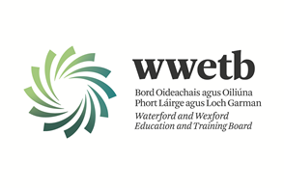

SPECIAL NEEDS ASSISTANT PANEL

**Permanent, Temporary, Full-time and Part-time Panel Positions in WWETB Schools**

Applications are invited from suitably qualified persons for inclusion on a SNA panel for the following schools under the patronage of Waterford and Wexford Education and Training Board (WWETB) in the following locations:

Co. Waterford: Dungarvan College/ Coláiste Dhún Garbhán, St. Declans Community College, St. Pauls Community College, Meánscoil San Nioclás, Waterford College of Further Education.

Co. Wexford: Bridgetown College, Bunclody Community College, Coláiste Abbáin, Coláiste an Átha, Creagh College, Enniscorthy Community College, Gorey Hill School, Kilnamanagh Community National School, Selskar College.

Following interview, a panel of suitable candidates will be formed to fill SNA vacancies which may occur within 12 months from 1st May 2024 – 30th April 2025.

*Essential Requirements:*  
Candidates must have a minimum QQI Level 3 major qualification on the National Framework of Qualifications or a minimum of three grade Ds in Junior Certificate or equivalent.

Previous experience of working in the special educational needs and disabilities sector would be desirable for Gorey Hill School.

Application form and full details may be obtained from <https://www.wwetb.ie/about/organisation/human-resources/vacancies/>

Completed applications should be returned to [vacancies@wwetb.ie](mailto:vacancies@wwetb.ie) by **4:00pm on Friday 29th March 2024.**

WWETB is an equal opportunity employer.

Canvassing will disqualify.

Shortlisting may apply.

Late applications will not be accepted.

