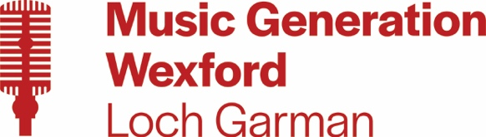

WATERFORD AND WEXFORD EDUCATION AND TRAINING BOARD

ADMINISTRATOR
SPECIFIC PURPOSE CONTRACT (COVERING A MATERNITY LEAVE)
MUSIC GENERATION WEXFORD

WWETB, as Lead Partner for Music Generation Wexford, wishes to recruit an Administrator to assist the Music Generation Development Officer with the organisation, promotion and day-to-day running of Music Generation performance music education programmes in Wexford County. The ideal candidate will have a relevant qualification, a passion for music in all its forms and for its promotion and development.

Details of post and application are available to download from www.wwetb.ie

Notes:
- The closing date for receipt of online applications is 4pm on 10th May 2024
- Late or incomplete applications will not be considered
- Shortlisting may apply
- Garda Vetting will apply
- Canvassing will disqualify

WWETB/County Council is an Equal Opportunities Employer

