**Waterford & Wexford**

**Education & Training Board**

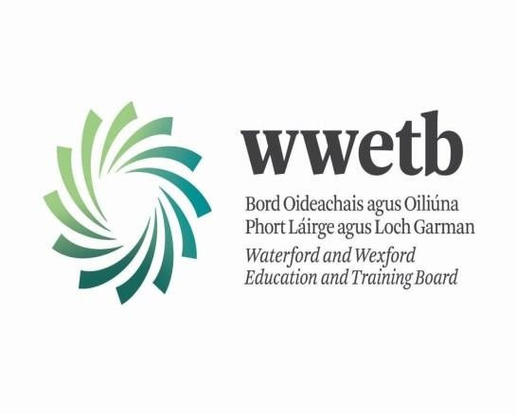

**Annual Report 2015**

## Table of Contents

|  |  |
| --- | --- |
|  | Page |
| Members of Waterford and Wexford ETB | 3 |
| Committees of Waterford and Wexford ETB | 5 |
| Administration Offices of Waterford and Wexford ETB | 6 |
| Overview of Services | 7 |
| Location of Centres with Waterford and Wexford ETB | 8 |
| Financial Summary | 9 |
| Second Level Education | 12 |
| Outdoor Education Centre | 45 |
| Adult Guidance Service | 47 |
| Adult Literacy Programme | 50 |
| Back to Education Initiative | 58 |
| Community Education | 68 |
| English for Speakers of Other Languages | 76 |
| Vocational Training Opportunities Scheme | 77 |
| Youth Work | 95 |
| Youthreach | 101 |
| Training Services | 114 |
| Human Resources | 118 |
| Corporate Services | 119 |
| Appendix 1 | 121 |

**Members of Waterford and Wexford ETB Committee**

On the 1st July 2013, the Committees of City of Waterford VEC, County Waterford VEC and County Wexford VEC amalgamated to form the Board of Waterford and Wexford Education and Training Board.

Waterford and Wexford ETB has 21 members and has a formal schedule of functions reserved to itself. The reserved functions are supported by legislation and include policy, planning and monitoring and the adoption of the annual accounts/reports. The ETB is supported by an “Executive” which is responsible for implementation of plans, day to day management and functions not reserved for the ETB.

ETB members and designated staff are required to provide annual Disclosure of Interests in respect of issues that could materially influence performance of functions. In addition the ETB has adopted a Code of Ethics and this has been provided to all members and staff.

The ETB meets every two months, with a register of attendance being maintained. Members received agenda and papers in advance of meetings. Minutes are maintained and adopted in support of ETB meetings. The Board of Waterford and Wexford ETB were:

Cllr. Malcolm Byrne, Cllr. Ger Carthy, Cllr. Kathleen Codd-Nolan, Ms. Breda Cogley\*, Mr. Geoffrey Collins, Cllr. Tom Cronin, Mr. David Doyle, Mr. John Evoy, Cllr. Mary Farrell, Mr. Mark Fitzgerald, Cllr. Jim Moore, Cllr. Barbara Anne Murphy, Ms. Nessa Murphy, Cllr. Pat Nugent, Ms. Catherine O’Donnell, Cllr. Michael J O’Ryan, Cllr. Fionntán Ó Súilleabháin, Cllr. Lola O’Sullivan, Cllr. Mary Roche, Ms. Mary Ryan\*\*, Ms. Áine Uí Fhoghlú\*\*\*, Mr. John Wall.

The dates of the ETB Committee meetings were as follows:

|  |  |
| --- | --- |
| **Month** | **Date** |
| February 2015 | 10 February 2015 |
| April 2015 | 14 April 2015 |
| June 2015 | 09 June 2015 |
| September 2015 | 08 September 2015 |
| November 2015 | 03 November 2015 |

\*Last meeting June 2015

\*\* From November 2015

\*\*\* From September 2015

### Members Attendance at ETB Meetings 2015

|  |  |  |  |  |  |
| --- | --- | --- | --- | --- | --- |
| **Name** | **10 Feb**  **2015** | **14 April**  **2015** | **09 June**  **2015** | **08 Sept**  **2015** | **03 Nov**  **2015** |
| Byrne, Malcolm | ✓ | ✓ | ✓ | - | ✓ |
| Carthy, Ger | ✓ | - | - | ✓ | ✓ |
| Codd-Nolan, Kathleen | ✓ | ✓ | ✓ | ✓ | ✓ |
| Cogley, Breda | ✓ | ✓ | - |  |  |
| Collins, Geoffrey | ✓ | ✓ | - | ✓ | ✓ |
| Cronin, Tom | ✓ | ✓ | ✓ | ✓ | ✓ |
| Doyle, David | ✓ | ✓ | ✓ | ✓ | ✓ |
| Evoy, John | - | ✓ | ✓ | ✓ | - |
| Farrell, Mary | ✓ | - | ✓ | ✓ | ✓ |
| Fitzgerald, Mark | ✓ | ✓ | ✓ | - | ✓ |
| Moore, Jim | ✓ | ✓ | ✓ | ✓ | ✓ |
| Murphy, Barbara Anne | ✓ | ✓ | ✓ | ✓ | ✓ |
| Murphy, Nessa | ✓ | ✓ | - | ✓ | ✓ |
| Nugent, Pat | ✓ | ✓ | - | ✓ | ✓ |
| O’Donnell, Catherine | - | ✓ | ✓ | - | ✓ |
| O’Ryan, Michael J | ✓ | ✓ | ✓ | - | ✓ |
| Ó Súilleabháin, Fionntán | ✓ | ✓ | ✓ | ✓ | ✓ |
| O’Sullivan, Lola | ✓ | ✓ | ✓ | - | ✓ |
| Roche, Mary | ✓ | ✓ | ✓ | ✓ | ✓ |
| Ryan, Mary\* |  |  |  | - | ✓ |
| Uí Fhoghlú, Áine\*\* |  |  |  | - | ✓ |
| Wall, John | ✓ | ✓ | ✓ | ✓ | - |

\*Ms Mary Ryan, First meeting November 2015

\*\*Ms Áine Uí Fhoghlú, first meeting September 2015, replacement for Ms. Breda Cogley

## Committees of WWETB:

VEC Committees had established a number of sub-committees including Finance and Audit sub- committees and these Committees remained in place for the interim period up to July 2014.

Both these sub committees are composed of Committee/Board members. WWETB Board nominates the Chairperson of these Committees and detailed terms of reference are provided.

### Audit Committee

The Audit Committee is composed of 6 members, all of whom are independent of management. It is responsible for monitoring the Executive in the carrying out of its functions and provides assurances to the Committee as to the adequacy and effectiveness of the internal control processes. It met 4 times during the year. It received reports from management, external and internal audit. Internal audit reports go to the Audit Committee and it is required to meet annually with the external auditor (Comptroller and Auditor General).

Waterford and Wexford ETB Audit Committee:

Mr. Eddie Breen (Chairperson), Cllr. Kathleen Codd-Nolan, Cllr. Ger Carthy, Cllr. Michael J. O’Brien, Ms. Elaine Sheridan, Mr. John Cuddihy.

### Finance Committee

The Finance Committee is composed of 5 members. It has responsibility for reviewing the

income/expenditure of the ETB’s. Minutes of the Finance Committee are received by WWETB for consideration and to assist in providing assurance that the education and service plans are being achieved.

Waterford and Wexford ETB Finance Committee:

Mr. Michael Veale (Chairperson), Mr. Padraig Hall, Ms. Anne Murray, Cllr. Pat Nugent, Mr. David Doyle.

## Administration Offices of Waterford and Wexford ETB

|  |  |  |
| --- | --- | --- |
| **Head Office**: | Ardcavan Business Park  Ardcavan Wexford |  |
| Tel: | 053 9123799 |
| Fax:  Email: Website: | 053 9124109  [info@wwetb.ie](mailto:info@wwetb.ie) [www.waterfordwexford.etb.ie](http://www.waterfordwexford.etb.ie/) |
| **Sub Office**: | Dungarvan Sub Office Dungarvan Shopping Centre Dungarvan  Co Waterford | Waterford Sub Office 30 The Mall Waterford |
| Tel: | 058 41780 | 051 874007 |
| Email: | [infodungarvan@wwetb.ie](mailto:infodungarvan@wwetb.ie) | [infow@wwetb.ie](mailto:infow@wwetb.ie) |
| Website: | [www.waterfordwexford.etb.ie](http://www.wwetb.ie/) | [www.waterfordwexford.etb.ie](http://www.wwetb.ie/) |
| **Training Centre:** | WWETB Training Centre Waterford Industrial Park Cork Road  Waterford |  |
| Tel: Email:  Website: | 051 301500  [info@wwetb.ie](mailto:info@wwetb.ie)  [www.waterfordwexford.etb.ie](http://www.wwetb.ie/) |  |

### Waterford and Wexford ETB Senior Management Team

Eilís Leddy, Chief Executive Officer, Acting Michael O’Brien, Education Officer, Acting

Anne Marie Jones, Human Resource Manager Jim Maher, Finance Officer

Fintan O’Reilly, Head of Corporate Services

## Overview of Services

On 1 July 2014, the FÁS/SOLAS Training Centres in Waterford and Wexford came under the governance of WWETB.

13 Post Primary Schools

7 Youthreach Centres

Waterford

Further Education and Training

and Wexford

ETB

Youth Services

Waterford Training Centre & Wexford Training Centre

## Location of Centres within Waterford and Wexford ETB

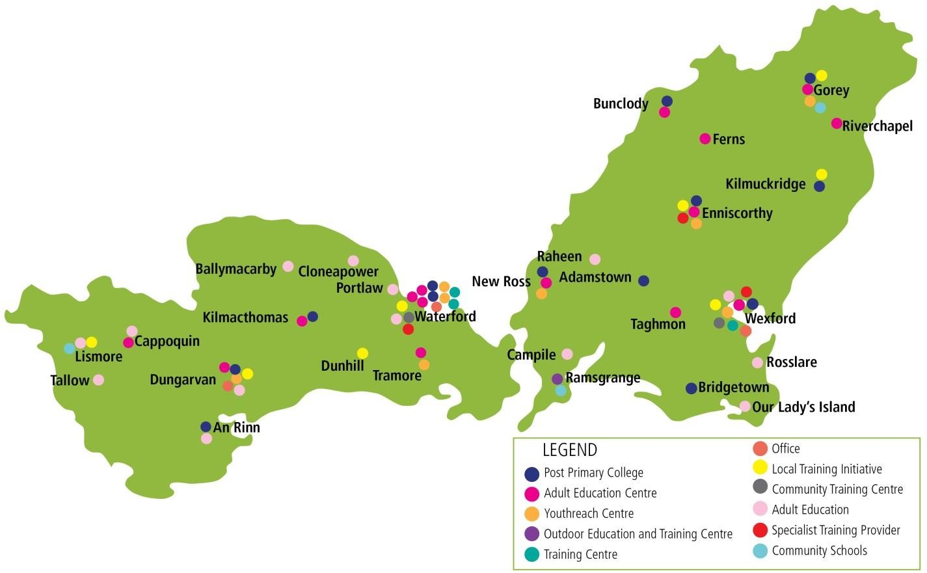

|  |  |  |
| --- | --- | --- |
| **Non-Designated Community**  **Colleges** | **Designated Community**  **Colleges** | **Education & Training Centres** |
| Bridgetown College | Meánscoil San Nioclás | Bunclody |
| Bunclody Vocational College | St Pauls Community College | Cappoquin |
| Coláiste Abbain |  | Dungarvan |
| Coláiste an Átha | **Youthreach Centres** | Enniscorthy |
| Coláiste Cathail Naofa | Dungarvan | Gorey |
| Creagh College | Enniscorthy | Kilmacthomas |
| Enniscorthy Vocational College | Tramore | Lismore |
| Kennedy College | Waterford | New Ross |
| Selskar College | Wexford | Ozanam Street |
| St Declans Community College | Sub La Centre Waterford | Railway Square |
|  |  | Tramore |
|  |  | Waterford |
| **Community Schools where**  **WWETB are joint patrons** | **Shilebaggan OEC** | Wexford |
| Blackwater Community School |  |  |
| Gorey Community School |  |  |
| Ramsgrange Community School |  |  |

**Financial Summary**

Waterford and Wexford ETB annual accounts for the 18 months ended 31 December 2015 have been prepared in a form directed by the Department of Education and Science and have been submitted to them. The accounts have been audited by the Comptroller and Auditor General (C&AG), in accordance with the requirements of Section 7 of the Comptroller and Auditor General (Amendment) Act 1993, who presents a report on the Boards financial stewardship to the Oireachtas.

The following table sets out, in summary form, the receipts and payments for the year ended 31 December 2015.

### Operating Account for the Year Ended 31st December 2015

|  |  |  |
| --- | --- | --- |
|  |  | **2015** |
|  |  | **€** |
| **RECEIPTS** |  |  |
| Schools & Head Office | | 38,364,411 |
| Further Education and Training | | 55,859,561 |
| Student Support Services | | 352,958 |
| Youth Services | | 1,222,248 |
| Agencies & Self Financing Projects | | 3,384,746 |
| Capital Grants | | 4,693,581 |
| Others: | Globalisation Fund | 27,653 |
|  |  | **103,905,158** |
| **PAYMENTS** | | |
| Schools & Head Office | | 38,562,928 |
| Further Education and Training | | 57,383,635 |
| Student Support Services | | 521,973 |
| Youth Services | | 1,277,367 |
| Agencies & Self Financing Projects | | 3,033,404 |
| Capital Grants | | 4,668,399 |
|  |  | **105,447,706** |
| **Cash Surplus/(Deficit) For Period** | | **(1,542,549)** |

**Summary of Receipts**

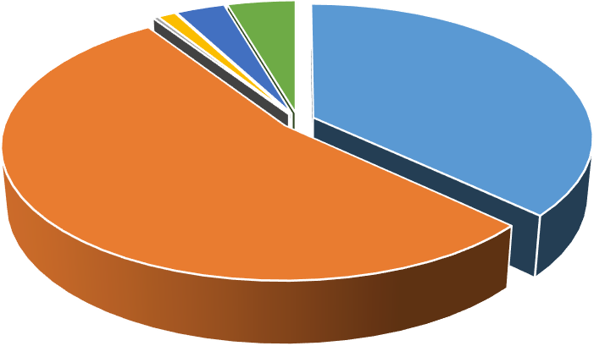

0% 1%

3%

0%

5%

37%

Schools & Head Office

Further Education & Training

Student Support Services

Youth Services

Agencies & Self Financing Projects

54%

Capital Grants

Others

### Summary of Payments

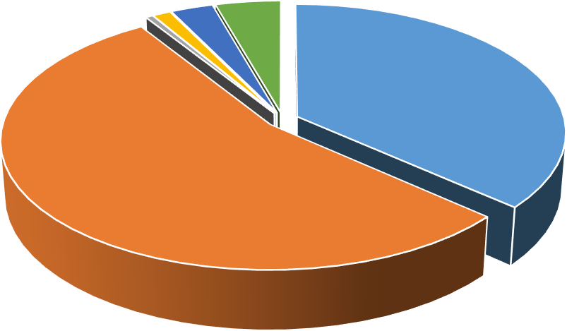

1% 1% 3%

4%

37%

54%

Schools & Head office

Further Education & Training Student Support Services Youth Services

Agencies & Self Financing Projects

Capital Grants

**Board Members Expenses for the Year Ended 31st December 2015**

|  |  |  |  |  |  |
| --- | --- | --- | --- | --- | --- |
| **Board Member** | **Statutory Expenses**  **€** | **Interview Boards**  **€** | **Attendance at Conferences/ Seminars**  **€** | **Other**  **€** | **Total**  **€** |
| Byrne, Malcolm | 544 | 0 | 0 | 83 | 627 |
| Carthy, Ger | 262 | 0 | 0 | 226 | 488 |
| Codd-Nolan, Kathleen | 851 | 304 | 373 | 1,451 | 2,979 |
| Cogley, Breda | 222 | 0 | 0 | 0 | 222 |
| Collins, Geoffrey | 486 | 0 | 0 | 0 | 486 |
| Cronin, Tom | 1,197 | 0 | 0 | 0 | 1,197 |
| Doyle, David | 410 | 0 | 1,131 | 1,783 | 3,324 |
| Evoy, John | 536 | 0 | 493 | 41 | 1,070 |
| Farrell, Mary | 539 | 0 | 0 | 129 | 668 |
| Fitzgerald, Mark | 150 | 0 | 497 | 0 | 647 |
| Moore, Jim | 691 | 136 | 662 | 2,601 | 4,090 |
| Murphy, Barbara Anne | 636 | 0 | 0 | 161 | 797 |
| Murphy, Nessa | 240 | 0 | 0 | 46 | 286 |
| Nugent, Pat | 266 | 484 | 0 | 0 | 750 |
| O’Donnell, Catherine | 324 | 513 | 471 | 1,030 | 2,338 |
| O’Ryan, Michael J | 475 | 0 | 0 | 444 | 919 |
| Ó Súilleabháin, Fionntán | 731 | 0 | 0 | 102 | 833 |
| O’Sullivan, Lola | 257 | 58 | 0 | 167 | 482 |
| Ryan, Mary \* | 0 | 0 | 0 | 0 | 0 |
| Roche, Mary | 234 | 105 | 0 | 122 | 461 |
| Uí Fhoghlú, Áine\*\* | 102 | 107 | 0 | 0 | 209 |
| Wall, John | 336 | 279 | 393 | 24 | 1,032 |
| **TOTAL** | **9,489** | **1,986** | **4,020** | **8,410** | **23,905** |

\*First Meeting November 2015

\*\*First Meeting September 2015

## Second Level Education

There are thirteen Waterford & Wexford ETB second level schools across the Counties of Waterford and Wexford. They offer a comprehensive range of day school courses to Junior Certificate, and Leaving Certificate, including Leaving Certificate Applied and Leaving Certificate Vocational Programme. The colleges are non-denominational and co-educational and offer a learner centred environment.



Coláiste

Abbain

Creagh

College

Bridgetown

College

Meanscoil

San Nioclás

Bunclody

VC

WCFE

WWETB

Enniscorthy

VC

St Declans

CC

Coláiste an

Átha

Coláiste

Chathail Naofa

Selskar

College

Kennedy

College

### Enrolments at 30 September 2015

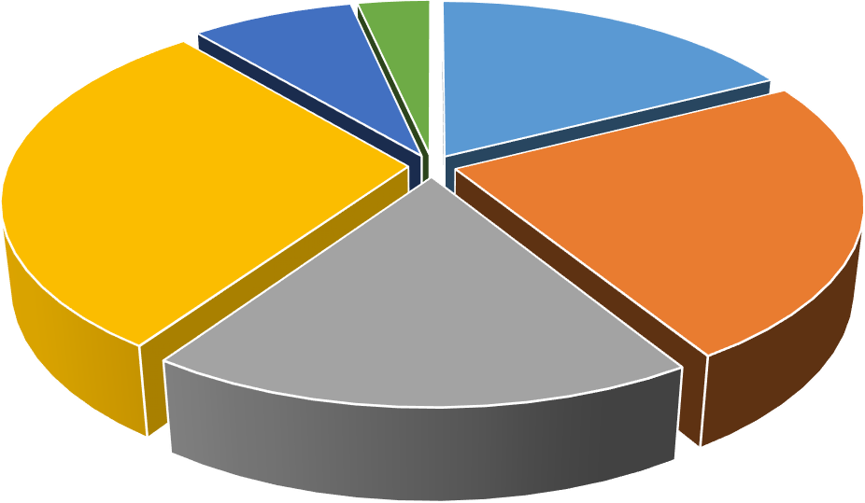

LCVP

8%

LCAP

3%

JCSP

18%

PLC

29%

Junior Cert

24%

Leaving Cert

18%

|  |  |  |  |  |  |  |  |
| --- | --- | --- | --- | --- | --- | --- | --- |
| **College** | **JCSP** | **Junior** | **Leaving** | **PLC** | **LCVP** | **LCAP** | **Total** |
| **Bridgetown** | 73 | 244 | 82 | 15 | 131 | 36 | 581 |
| **Bunclody** | 108 | 0 | 14 | 70 | 54 | 0 | 246 |
| **Coláiste Abbain** | 101 | 0 | 42 | 39 | 0 | 0 | 182 |
| **Coláiste an Átha** | 128 | 43 | 25 | 52 | 62 | 12 | 322 |
| **Coláiste Chathail Naofa** | 84 | 0 | 1 | 215 | 45 | 15 | 360 |
| **Creagh College** | 0 | 330 | 159 | 0 | 0 | 0 | 489 |
| **Enniscorthy VC** | 102 | 208 | 120 | 246 | 47 | 50 | 773 |
| **Kennedy College** | 81 | 5 | 44 | 106 | 0 | 17 | 253 |
| **Meánscoil San Nioclás** | 55 | 0 | 69 | 0 | 0 | 0 | 124 |
| **St Declans CC** | 67 | 274 | 310 | 0 | 0 | 19 | 670 |
| **St Pauls CC** | 97 | 137 | 148 | 51 | 34 | 22 | 489 |
| **Selskar College** | 111 | 122 | 42 | 137 | 71 | 27 | 510 |
| **WCFE** | 0 | 0 | 0 | 754 | 0 | 0 | 754 |

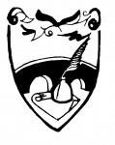**Bridgetown College**

Principal: Ms Fionnuala Greene Deputy Principal: Mr Adrian Power

Address: Bridgetown, Co Wexford Tel: 053-9135257

Email: [Bridgetownvocationalcollege@wwetb.ie](mailto:Bridgetownvocationalcollege@wwetb.ie) Website: [www.bridgetownvocationalcollege.ie](http://www.bridgetownvocationalcollege.ie/)

**Teacher Allocation for 2014/2015:** Full Time Day Courses 51.55 WTE Teachers

10.00 SNA

**Teacher Allocation for 2015/2016:** Full Time Day Courses 51.34 WTE Teachers

10.00 SNA

### Mission Statement

*Bridgetown College aims to provide a holistic educational experience meeting the diverse needs of the community in a positive learning environment.*

*We encourage all students to realise their full potential and develop a sense of self-worth by promoting mutual respect, co-operation and tolerance.*

### Introduction:

Bridgetown College is situated in the village of Bridgetown, in the heart of South, Co Wexford. The college has 40 classrooms including specialist rooms for Art, Home Economics, Metalwork, Craftwork, Computer Aided Design and Woodwork. Students have access to three laboratories, three computer rooms, a library, a large gymnasium and a canteen. The college also has an Autistic Spectrum Disorder (ASD) unit. The college is multi-denominational, co-educational and non-selective in its intake, supported by the Board of Management and the Parents’ Association. It caters for a catchment area stretching from Wellingtonbridge to Rosslare Harbour, and from the sea to Forth Mountain. The college ethos promotes respect, seeks to promote the development of the potential of each individual and aims to generate moral and social responsibility.

### Subjects Offered:

Subjects offered include Irish, English, Maths, History, Geography, Science, Religious Education, CSPE, Social Health and Physical Education, French, Art, Craft & Design, Technical Graphics, Materials Technology (Wood), Metalwork, Home Economics, Business Studies, Theatre & Stage, Music.

### Extra-Curricular Activities:

Students enjoy a wide range of extra-curricular activities thanks to staff who give generously of their time and talents. Extra-curricular activities provided include athletics, basketball, camogie, equestrian events, football, hurling, handball, outdoor education, rugby and soccer. Students produce a newspaper entitled “The Bridge” and they are encouraged to participate in competitions in the following areas: art, public speaking, enterprise and essay writing. Each year a variety of musical productions are staged and many students participate in our choir and orchestra.

### Highlights of 2015 include:

* **College Name**

Following consultation with staff, students, parents, the Board of Management and WWETB, the College name was changed in June from *Bridgetown Vocational College* to *Bridgetown College.*

### CPD

* + Transition Year
  + NBSS
  + VSware: Student Management System

### HSCL Initiatives

* + One Book One Theme, a family based reading project.
  + Art Classes for Parents: A six-week programme for parents was held in the Stella Maris Centre in Kilmore Quay.
  + We were awarded the Amber Flag in recognition of initiatives that promoted positive mental health and awareness of mental health issues.
  + Cyclone Bullying Workshop for students: activities and talks took place on World Health Day.
  + Up 2 U: Beat FM ran a workshop for students on cyberbullying.
  + Students created a Well Being Wall with advice and suggestions from students.

### School Improvement:

* + The Transition Year Programme was introduced as a post JC Option
  + A whole-school Numeracy Plan was developed and implemented.
  + The NBSS Strategy Team simplified school rules. The Board of Management then ratified the amended Code of Behaviour.
  + Critical Incident Management Plan was ratified
  + Checklist for Annual Review of the Child Protection Policy

### Development of College Facilities

* + Building of the ASD Unit was completed just before Easter
  + A proposal was submitted to WWETB that highlighted the need for additional accommodation and facilities and requested that funding be sought by WWETB to purchase land for development purposes.
  + Painting of the exterior of our oldest building, corridors in the 1984 building and the front wall was completed during the summer.
  + New external doors were installed for health and safety reasons
  + Wexford County Council completed works to improve parking arrangements in the bus park.
  + New arrangements for emergency evacuations were put in place following completion of the ASD Unit.

### Board of Management

A new Board of management was formed in June. In October, presentations were made to outgoing members, Mrs. Georgina Rothwell, Mrs. Ita Hannigan, and Mr. Ray Kent.

### Bunclody Vocational CollegeBunclody Vocational College

Principal: Mr James Murphy

Deputy Principal: Ms Sandra O’Toole

Address: Irish Street, Bunclody, Co Wexford Tel: 053-9377590

Email: [bunclodyvocationalcollege@wwetb.ie](mailto:bunclodyvocationalcollege@wwetb.ie) Website: [www.bunclody.ie](http://www.bunclody.ie/)

|  |  |  |
| --- | --- | --- |
| **Teacher Allocation for 2014/2015:** Full Time Day Courses | 21.33 | WTE Teachers |
|  | 3.00 | SNA |
| **Teacher Allocation for 2015/2016:** Full Time Day Courses | 21.79 | WTE Teachers |
|  | 3.00 | SNA |

**Mission Statement**

*We endeavor to provide a quality education to all our students in a caring, disciplined and respectful environment. We aim to prepare students for life and responsible citizenship and motivate them towards the achievement of their full potential.*

### Introduction:

Bunclody Vocational College is a co-educational school delivering educational excellence to the people of Bunclody and its surrounding areas for the past sixty years. The school is committed to high quality education and their mission is based on meeting the needs of all students in their care. An extensive programme of Junior and Leaving Certificate subjects are offered as well as a broad adult education programme.

The low pupil-teacher ratio is one of the many advantages to be gained from attending the school. This allows for small focused classes and all students are encouraged to take as many higher level subjects as possible.

### Subjects Offered:

Subjects offered at Junior Cycle include: Art, English, Maths, Environmental and Social Studies, Gaeilge, Geography, Materials Technology (Wood), History, Science, Art, CSPE, Business Studies, Materials Technology (Metal), French, Home Economics, Religion, SPHE, Technical Graphics, Technology and PE.

Subjects offered at Senior Cycle include: English, Gaeilge, Maths, Accounting/Business, Biology, Construction Studies, Home Economics, Engineering, French, History, Engineering, Art, Careers, DCG, LCVP, Geography, Religion, PE.

### Extra-Curricular Activities:

Students are encouraged to participate in activities outside of the classroom. These include sports, drama, charity work, projects and competitions.

Throughout the year students take part in charity walks, bag packing, non-uniform days, selling badges etc. to raise funds for local charities and also for the Lourdes trip. These charities include the Lions Club, the St Vincent de Paul and the Irish Wheelchair Association.

All students are encouraged to participate in sports. A number of students also make the weekly trip to Butterfly Farm to learn how to horse ride. Many of the students are part of football, basketball, soccer and hurling teams.

In conjunction with the English curriculum, drama workshops are held regularly and students attend plays and performance outside the school. Students take part in their own productions which are televised in the school. There are free music lessons on Wednesday afternoons.

### Highlights of 2015 include:

* Involvement in a research project with UCD focusing on the use of Assistive Technology in the classroom.
* Literacy SIP Plan developed this year.
* Progression link developed with Waterford Institute of Technology and Carlow Institute of Technology for our PLC graduates.
* Major refurbishment to toilet facilities under the Summer Work Scheme.
* Site cleared to make way for our new PLC campus.
* Our new extension went out to tender this year.
* Students and staff had a most enjoyable History tour to Krakow.
* Schools Business Partnership with Kerry Foods was further developed this year.
* Two students competed in the Young Technologist competition. Bunclody Vocational College was hoping to make it five wins in a row in this competition. One of our finalists came third on this occasion.
* One of our student scooped first place in the LCVP category at the County Enterprise Awards.
* As usual each year students engaged in a number of fundraising campaigns throughout the year. Beneficiaries this year included Bunclody Day Care Unit. Students and staff also generously supported the Christmas Shoebox Appeal.
* Our motivational guest speaker at our annual awards day this year was DJ Carey, legendary Kilkenny hurler.

### CuaTed-WgAAayn4[1]Coláiste Abbain

Principal: Mr Senan Lillis

Deputy Principal: Mr John Nolan

Address: Adamstown, Co Wexford Tel: 053-9240564

Email: [colaisteabbain@wwetb.ie](mailto:colaisteabbain@wwetb.ie) Website: [www.colaisteabbain.ie](http://www.colaisteabbain.ie/)

|  |  |  |  |
| --- | --- | --- | --- |
| **Teacher Allocation for 2014/2015:** | Full Time Day Courses | 14.95 | WTE Teachers |
|  |  | 1.00 | SNA |
| **Teacher Allocation for 2015/2016:** | Full Time Day Courses | 15.36 | WTE Teachers |
|  |  | 2.00 | SNA |

**Mission Statement**

*We endeavor to provide a quality education to all our students in a caring, disciplined and respectful environment. We aim to prepare students for life and responsible citizenship and motivate them towards the achievement of their full potential.*

### Introduction:

Coláiste Abbain is situated in the village of Adamstown in the heart of County Wexford. It was officially opened in May 1937 and it is serving its community and hinterland for 80 years. The college is non-denominational and co-educational and provides 2nd and 3rd level courses.

Coláiste Abbain boasts of excellent academic achievements and its past students have gone on to further education in every 3rd level establishment in Ireland.

### Subjects Offered:

All students study a set of core subjects that include: Irish, English, Maths, History, Geography, Science, Civic Social and Political Education, Social, Personal and Health Education, PE, Computers. Students have a choice from the following additional subjects: Metalwork, Woodwork, Business Studies, Home Economics, French, Music, Art, German and Technical Graphics.

The Leaving Certificate students are divided on the basis of subject choice. All students study a set of core subjects that include: Irish, English, Maths, Career Guidance and PE. They also choose additional subjects from: Engineering, Construction Studies, Home Economics, Business, Geography, Biology, French, Art, Music and Design and Communication Graphics.

LCVP is also offered in the school, where students sit six regular Leaving Certificate subjects and two link modules which are: Preparation for the World of Work and Enterprise.

### Extra-Curricular Activities:

Extra-curricular activities form a vital part of school life and include debating and public speaking, hurling, gaelic football, soccer, basketball, badminton, young entrepreneur, craft fair and fitness classes.

### Crest-300x210Coláiste an Átha

Principal: Ms Elizabeth Martin

Deputy Principal: Mr Raymond Furlong

Address: Kilmuckridge, Gorey, Co Wexford Tel: 053 9130169

Email: [colaisteanatha@wwetb.ie](mailto:colaisteanatha@wwetb.ie) Website: [www.colaisteanatha.ie](http://www.colaisteanatha.ie/)

|  |  |  |  |
| --- | --- | --- | --- |
| **Teacher Allocation for 2014/2015:** | Full Time Day Courses | 25.34 | WTE Teachers |
|  |  | 1.00 | SNA |
| **Teacher Allocation for 2015/2016:** | Full Time Day Courses | 27.03 | WTE Teachers |
|  |  | 2.00 | SNA |

**Mission Statement**

*Coláiste an Átha is dedicated to providing a quality education in a caring and supportive environment where the holistic development of each individual student is nurtured.*

### Introduction:

Coláiste an Átha is a co-educational inter-denominational, post-primary college providing Junior, Leaving and Post Leaving Certificate Programmes. Very dedicated staff, working together as a team delivers an education that prepares students for life. Coláiste an Átha, formerly Kilmuckridge Vocational College, has been in existence since the late 1930’s opening its doors as a typical two roomed rural Vocational School offering in addition Home Economics and Rural Science.

### Subjects Offered:

At Junior Level, the following subjects are offered: Gaeilge, English, Maths, Geography, History, French, German, Spanish, Science, Art, Materials Technology, Woodwork & Metalwork, Construction Studies & Engineering, Technical Graphics & D.C.G, Home Economics, Music and PE. The Junior Certificate School Programme is also on offer in the school.

At Senior Level, the following subjects are offered: Gaeilge, English, Maths, Geography, History, French, German, Spanish, Science, Art, Business, Accounting, LCVP, Materials Technology Woodwork, Construction Studies & Engineering, Technical Graphics & DCG, Home Economics, Music, PE and Business.

LCVP and the Leaving Certificate Applied are also available in the school.

### Extra-Curricular Activities:

Coláiste an Átha provide a wide range of extra-curricular activities including hurling, camogie, soccer, basketball, rugby and athletics.

### Highlights of 2015 include:

* 289 students at second level
* 32 PLC students
* School was awarded the Amber Flag for the promotion of Mental Health and Well Being
* Approval was received for an extension to include a Music room, a Science room and a Deputy Principal’s office

### Logo - Colaiste Chathail NaofaColáiste Chathail Naofa

Principal: Mr Danny Cunningham Deputy Principal: Mr Jason Ryan

Address: Youghal Road, Dungarvan, Co Waterford Tel: 058 41184

Email: [cnn@wwetb.ie](mailto:cnn@wwetb.ie) Website: [www.cnndungarvan.com](http://www.cnndungarvan.com/)

|  |  |  |  |
| --- | --- | --- | --- |
| **Teacher Allocation for 2014/2015:** | Full Time Day Courses | 29.75 | WTE Teachers |
|  |  | 2.25 | SNA |
| **Teacher Allocation for 2015/2016:** | Full Time Day Courses | 30.09 | WTE Teachers |
|  |  | 3.25 | SNA |

### School Mission

Coláiste Chathail Naofa aims to be a centre of excellence in education where all students are encouraged to achieve their full potential in all aspects of their educational and personal development in an environment of care and mutual respect.

### Introduction

Located near Dungarvan town centre, Coláiste Chathail Naofa provides education to Leaving Certificate standard while offering a wide range of Post-Leaving Certificate courses and evening classes. Coláiste Chathail Naofa is named after a local Irish Saint, St. Cathaldus, who was born near Dungarvan Co Waterford. Having spent many years in Ireland, he went on to Italy to become as famous in Italy as St. Patrick is in Ireland.

**Courses offered;** Junior Certificate Schools Programme, Transition Year, Leaving Certificate Applied and Leaving Certificate Vocational Programme.

### Highlights of 2014-2015 include:

**UCC Student Achievement Awards**

These awards have been established to encourage Second Year students to continue their hard work into their Junior Cert year and maximise the number of higher level exams they sit.

### ucc awardsThe JCSP Chess Club Competition

Picture are the recipients of the UCC Plus Student Achievement Awards

We would like to congratulate our Chess Club on their wonderful performance on Tuesday February 10th as they participated in a J.C.S.P. Chess Competition in Terence MacSwiney Community College in Cork City.

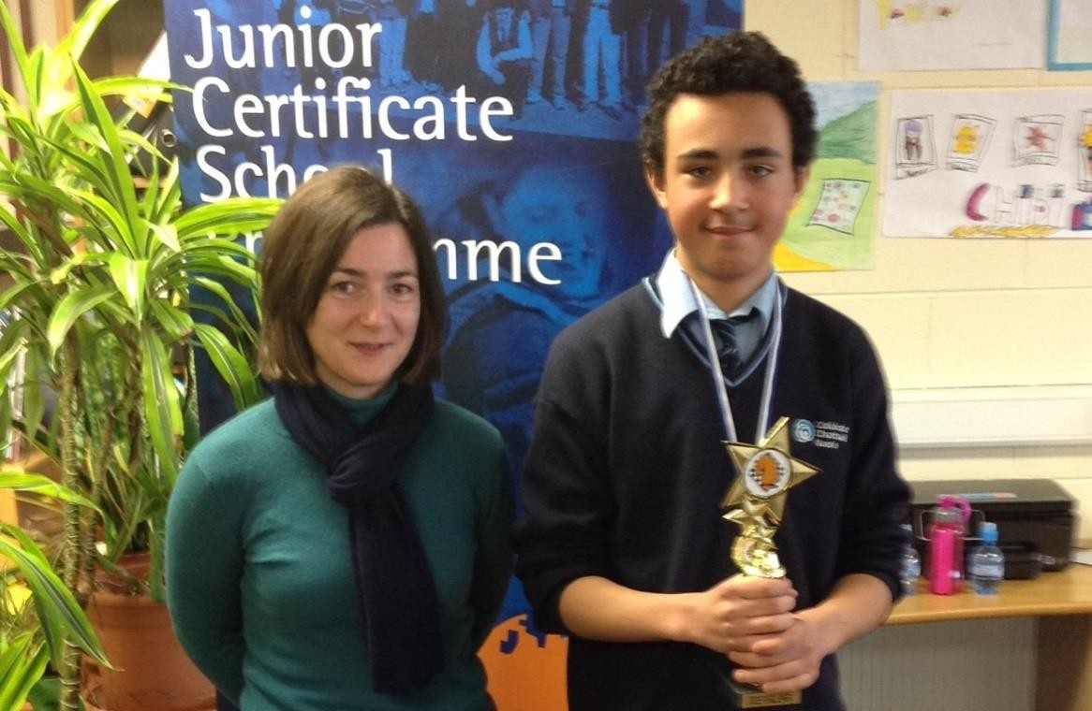

Pictured above is Jessica Whelan School JCSP Librarian and Tadhg Doswell 1st Year who was the overall winner of the chess competition.

### The Ger Howley Cup for overall metalwork student - sponsored by Radley Engineering

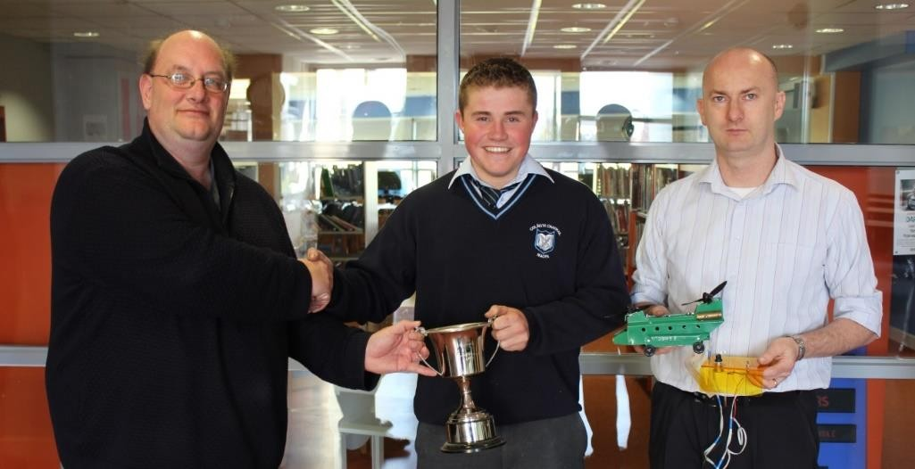

Pictured above is Mr Michael O’Brien, Education Officer of Waterford and Wexford Education and Training Board presenting Bill Brennan with the ‘Ger Howley Cup’ for his overall result in his Junior Certificate Metalwork.

### J.C.S.P. Celebrity Chef

We were delighted to welcome the Celebrity Chef Rachel Allen of Ballymaloe House to Coláiste Chathail Naofa on Thursday April 23rd. 'Celebrity Chef' is a J.C.S.P. Initiative which gives schools the opportunity to invite a famous chef to meet with Junior Certificate students.

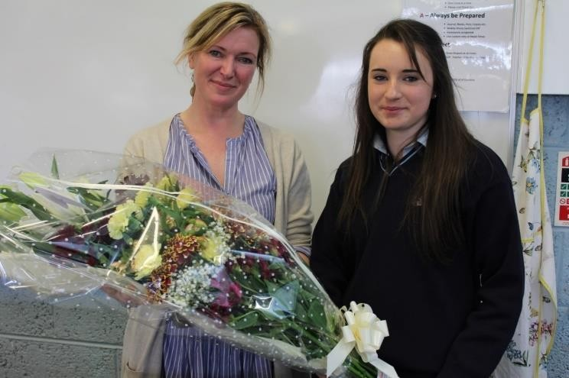

Pictured above is Claddagh Marie Power making a presentation to Rachel Allen of Ballymaloe House

### Main logo RGB col landscapeCreagh College

Principal: Mr Paul Glynn

Deputy Principal: Mr Declan O’Toole

Address: Creagh, Gorey, Co Wexford Tel: 053 9484035

Email: [creaghcollege@wwetb.ie](mailto:creaghcollege@wwetb.ie) Website: [www.creaghcollege.com](http://www.creaghcollege.com/)

|  |  |  |  |
| --- | --- | --- | --- |
| **Teacher Allocation for 2014/2015:** | Full Time Day Courses | 27.37 | WTE Teachers |
|  |  | 3.00 | SNA |
| **Teacher Allocation for 2015/2016:** | Full Time Day Courses | 34.82 | WTE Teachers |
|  |  | 2.50 | SNA |

### Mission Statement:

*Creagh College believes in the provision of positive learning experience that nurtures mutual respect and personal responsibility within a safe, fair and caring environment. We are committed to the pursuit of excellence in all of our activities.*

### Introduction:

Creagh College is a co-educational, multi-denominational post-primary college which is committed to the pursuit of excellence in all activities and to the provision of a teaching and learning environment that caters for the diverse needs of young people in the Gorey area in a safe and respectful environment. Creagh College promotes the development of the whole person and aims to nurture responsible citizenship. Student development is based on principles of respect for self, for others and the environment.

Creagh College moved into their new, permanent home on 28th April 2014. Millions of euro were invested in the new, modern, purpose-built Creagh College Campus which has been designed to motivate and inspire our students.

### Subjects Offered:

For first year, all students study the following compulsory subjects: English, Irish, Mathematics, French or Spanish, Science, SPHE, CSPE and PE. In addition, each student chooses five subjects to study from the following: Art, Craft & Design, Business Studies, Classical Studies, Geography, History, Home Economics, Music, Materials Technology (Wood), Materials Technology (Metal), Religious Education, Technology and Technical Graphics.

At Senior Cycle the college offers: English, Irish, Maths, History, Geography, Accounting, Business Studies, Economics, Biology, Physics, Chemistry, Agricultural Science, Engineering,

Construction Studies, French, Art, Home Economics, Music, DCG, PE, SPHE, Career Guidance, Classics, Spanish

### Extra-curricular Activities

Extra-curricular activities at the college include, debating, chess club, a traditional music club, a quiz club, a green schools committee, a student council and art club. Sport is also encouraged in the school, primarily for physical activity, which is recognized as a component of good health. The sporting extra-curricular activities include, rugby, soccer, Gaelic football and camogie.

### Highlights of 2015 include:

* Introduction of Leaving Cert subjects for the first time (September 2015)
* Continued roll-out of e-learning programme
* New Board of Management appointed

### Enniscorthy Vocational CollegeEnniscorthy Vocational College

Principal: Mr Seamus Murphy Deputy Principal: Dr Iain Wickham

Address: Milehouse Road, Enniscorthy Co Wexford Tel: 053 9234185 Email: [enniscorthyvocationalcollege@wwetb.ie](mailto:enniscorthyvocationalcollege@wwetb.ie) Website: [www.evc.ie](http://www.evc.ie/)

**Teacher Allocation for 2014/2015:** Full Time Day Courses 60.85 WTE Teachers

9.00 SNA

**Teacher Allocation for 2015/2016:** Full Time Day Courses 64.30 WTE Teachers

11.00 SNA

**Mission Statement**

*Enniscorthy Vocational College endeavours to provide a secure and supportive educational environment where all students can experience a quality of education appropriate to their intellectual, physical, personal, social, moral and spiritual needs in a changing world.*

### Introduction:

Enniscorthy Vocational College is a co-educational school under the authority of Waterford and Wexford ETB. The school caters for Second Level students and Further Education students. The schools recent extension has ensured state of the art facilities. These facilities coupled with a vibrant and dedicated staff will ensure the delivery of a top quality education and learning into the future. Teachers are encouraged to adopt a flexible student-centred approach in the delivery of the curriculum. This ensures inclusiveness and the needs of all students are catered for. There is an excellent pastoral care system in the school to assist students during their time there.

### Subjects Offered:

At Junior Level, the following subjects are offered: Irish, English, Mathematics, History, Geography, French, German, Science, Business, Music, Art, Home Economics, Metalwork, Materials Technology (Wood), Technical Graphics, I.T., Religion, P.E and Career Guidance. The Junior Certificate Schools Programme is also offered in the school.

At Senior Level, the following subjects are offered: Irish, English, Mathematics, History, Geography, French, German, Physics, Biology, Agricultural Science, Business, Music, Art, Home

Economics, Construction Studies, Design & Communications Graphics, Metalwork, I.T., Religion,

P.E. and Career Guidance.

The Leaving Certificate Applied and Leaving Certificate Vocational Programmes are also offered in the College.

### Extra-Curricular Activities:

Extra-curricular activities include: hurling, football, soccer, badminton, basketball, debating, music, variety show, school tours, enterprise club, creative writing and the Gaisce awards.



### Kennedy College

Principal: Ms Suzanne Barrett

Deputy Principal: Mr Dominic Hearne

Address: New Ross, Co Wexford Tel: 051 421278

Email: [kennedycollege@wwetb.ie](mailto:kennedycollege@wwetb.ie) Website: [www.kennedycollege.ie](http://www.kennedycollege.ie/)

|  |  |  |  |
| --- | --- | --- | --- |
| **Teacher Allocation for 2014/2015:** | Full Time Day Courses | 21.86 | WTE Teachers |
|  |  | 3.00 | SNA |
| **Teacher Allocation for 2015/2016:** | Full Time Day Courses | 21.81 | WTE Teachers |
|  |  | 3.00 | SNA |

**Mission Statement**

*Kennedy College seeks to offer an inclusive holistic education, where respect and responsibility are fostered. We encourage all students to develop a sense of worth, so they can reach their full potential in order to meet the diverse needs of society.*

### Introduction:

Kennedy College has a long and distinguished tradition of providing high quality education at both second level and Post Leaving Certificate. The college is committed to providing an inclusive, supportive and caring environment for all students. A broad, comprehensive programme is provided to cater for the needs of all students.

The college staff is committed to working closely in partnership with students, parents and the local community to support all students to reach their potential. The college is committed to the promotion of mutual respect in a safe friendly well-disciplined teaching and learning environment.

Kennedy College is a co-educational, inter-denominational college set in a high quality modern school with many supports in place to help all students to achieve their potential.

### Subjects Offered

Irish, and Mathematics are offered at Junior Certificate Level, at Higher, Ordinary and Foundation Level. The following subject options are available at Higher and Ordinary Levels: English, Art, Craft & Design, Business Studies, French, Geography, History, Home Economics, Metalwork, Science, Technical Graphics and Woodwork. CSPE is also taken at Common Level for Junior Certificate examination. Religious Education, Physical Education, Computer Studies and SPHE also form part of the Junior Cycle Timetable.

Leaving Certificate Students have the option to study at Higher and Ordinary levels in all subjects. In addition English Irish and Mathematics can be taken at Foundation level. All students study the following compulsory subjects: English, Mathematics and Irish with the option of four subjects from the following: Art, Biology, Business Studies, Construction Studies, Design and Communication Graphics, Engineering, French, Geography, History and Home Economics. Students also study the non-examination subjects, Health Education, Career Guidance, Computers, Physical Education and Religion.

Kennedy College offers Junior Certificate with the support of the Junior Certificate schools Programme, Leaving Certificate and Leaving Certificate Applied for Senior cycle students.

**PLC courses offered:** Kennedy College have developed a range of Post Leaving certificate courses to suit the demands of the local community and the interests of the students in the community of New Ross. The college offers five courses at QQI level 5 – Early Childhood Care and Education, Community and Health Services, Horticulture, Information Processing and Office Administration; and one course at QQI level 6 in Early Childhood Care and Education. These courses offer students a route to both employment and further education with links with WIT and CIT to support progression to these colleges.

### Extra-Curricular Activities:

Extra-curricular activities include: Gaelic Football, Hurling, Soccer, Rugby, Basketball, Athletics and outdoor education.

### Highlights of 2015 include:

Following a survey of teachers, students, parents and the Board of Management the College changed its name from New Ross Vocational College to Kennedy College in a lovely ceremony in November 2015. Congressman Joe Kennedy (Massachusetts), grandson of US Attorney General Bobby Kennedy and grandnephew of former US President John F Kennedy endorsed the change of name with a moving speech on behalf of the Kennedy family by video link from Boston. The whole school community, along with members of the Board of Management, Parents Association and members of the wider community of New Ross attended the ceremony.

In March four Student Council members attended a ceremony in Waterford hosted by the Thomas Meagher Foundation where they received the Irish Flag from members of the Defence Forces. President Michael D Higgins addressed students from all over Ireland at the event which commemorated the introduction of the Irish flag by Waterford native Thomas Meagher.

Kennedy College was awarded funding from the Department of Education and Skills under the emergency works scheme to install internal fire doors throughout the school, along with new external emergency doors, and new fire escape staircase from the canteen.

The school improvement plan this year focused on numeracy. A team of teachers took part in Forbairt supported by the Centre for school Leadership. They developed the numeracy plan which supports strategies to support the development of numeracy across the curriculum.

The school had a science inspection in September. The feedback on teaching and learning in Science was positive with recommendations for improved planning and student activity.

Although uptake for Science has improved considerably with the introduction of science as a core subject in the school, the practice of offering some students learning support due to their learning issues was criticized.

In October Home School Liaison teacher Vanessa Murphy showcased a transfer programme Next Step at Feilte in the RDS on World Teachers Day. This transfer programme supports the preparation of primary school students for their transfer into secondary school and was developed by the Home School Liaison teachers (primary and post primary) in New Ross.

Throughout the school year a team of teachers from Kennedy College, along with Coláiste Abbain and NBSS developed a first year Induction programme Get Set Go, for the incoming first year students to support them on the transfer from primary to secondary. They produced a comprehensive programme to be used throughout first year which was introduced in September with very positive results. New Ross Credit Union sponsored the workbooks.

The highlight of the school’s academic year was the schools Annual Awards Day in May where students received awards for academic, personal and sporting achievements.

### Logo Meanscoil San NioclasMeánscoil San Nioclás

**Príomhoide**: Séamus Ó Cadhain

**Príomhoide Tánaisteach**: Áine Uí Icí

Seoladh: An Rinn, Dún Garbhán, Co Phort Láirge Fón: 058 46464

Ríomhphost: [meanscoil@wwetb.ie](mailto:meanscoil@wwetb.ie) Suíomh idirlín: [www.meanscoil.com](http://www.meanscoil.com/)

|  |  |  |  |
| --- | --- | --- | --- |
| **Teacher Allocation for 2014/2015:** | Full Time Day Courses | 12.70 | WTE Teachers |
|  |  | 1.00 | SNA |
| **Teacher Allocation for 2015/2016:** | Full Time Day Courses | 12.85 | WTE Teachers |
|  |  | 1.00 | SNA |
| **Ráiteas Misin:** |  |  |  |

‘Sí an aidhm atá againn ná daltaí a ullmhú don saol agus iad a fhorbairt go lán a gcumais. Éascaítear an bóthar intleachtúil, fisiciúil, sóisialta agus spioradálta dóibh.

Cuirtear scoth na múinteoireachta ar fáil agus cothaítear labhairt na Gaeilge agus cur amach ar na traidisiúin Ghaelacha mar chrann taca do gach dalta agus iad á seoladh amach fén domhan mór.

Soláthraimid deiseanna foghlama fad saoil agus gnéithe éagsúla den gcultúr Gaelach i measc muintir na nDéise idir óg agus aosta.

### Curaclam na Scoile

**Teastas Sóisearach**: Gaeilge, Béarla, Mata, Stair, Tíreolaíocht, Eolaíocht, Spáinnis, Ealaín, Staidéar Gnó, Teagasc Críostaí, [Teicneolaíocht Ábhar Adhmad](http://www.meanscoil.com/teic_abhar_adhm/teic_index.htm), [Eacnamaíocht Bhaile](http://www.meanscoil.com/eacbhaile/eacbhaile_home.htm), Gairmthreoir, Amhránaíocht, Ceol, SPHE, agus Polaitíocht.

**Ardteist:** Gaeilge, Béarla, Mata, Stair, Tíreolaíocht, Spáinnis, Bitheolaíocht, Ceimic, Fisic, Staidéar Gnó, Ealaín, [Staidéar Foirgníochta](http://www.meanscoil.com/staidear_foirgniochta/staidear_foirgniochta_home.htm), [Grafaic Dhearaidh agus Chumarsáide](http://www.meanscoil.com/GDC/gdc_index.htm), [Eacnamaíocht](http://www.meanscoil.com/eacbhaile/eacbhaile_at_home.htm) [Bhaile](http://www.meanscoil.com/eacbhaile/eacbhaile_at_home.htm), Gairmthreoir, Amhránaíocht, Ceol agus Teagasc Críostaí.

### Seach-churaclaim:

Foirne Peile agus Iomána, Foireann Camogaíochta, Peil na mBan, Ceol traidisiúnta, Cór, Labhairt Poiblí, Rámhaíocht, Drámaíocht, Rasaíocht trastíre, Club Ealaíne, Club Spáinnise agus Club Fisice.

### Logo Selskar CollegeSelskar College

Principal: Ms Eimear Ryan Deputy Principal: Mr Peter Nagle

Address: Westgate, Wexford Tel: 053 9122753

Email: [selskarcollege@wwetb.ie](mailto:selskarcollege@wwetb.ie) Website: [www.selskarcollege.ie](http://www.selskarcollege.ie/)

|  |  |  |  |
| --- | --- | --- | --- |
| **Teacher Allocation for 2014/2015:** | Full Time Day Courses | 38.96 | WTE Teachers |
|  |  | 7.00 | SNA |
| **Teacher Allocation for 2015/2016:** | Full Time Day Courses | 40.49 | WTE Teachers |
|  |  | 7.00 | SNA |

**Mission Statement**

Teaching and Learning with care and respect, where every person matters.

### Introduction:

Selskar College has put together an educational, pastoral and extra-curricular programme that takes account of the fact that students have many different needs and different ways of learning. There is not just one type of Junior Certificate, but two, there is not just one type of Leaving Certificate, but three. Many of the colleges students progress to Further and Higher Education and to direct employment. A wide range of Further Education Courses are offered for school leavers and mature students. All students should be happy, respected and encouraged to reach their potential and that is taken care of in this school. Through encouraging respect for each other and valuing the opportunities available, we all grow and learn.

### Subjects Offered

The Core Subjects at Junior Certificate level are: Civic, Social & Political Education, Irish, English, Mathematics, Science, Social, Personal & Health Education and Physical Education. Students also choose from the following: Art, Business Studies, French, Geography, History, Technical Graphics, Home Economics, Materials Technology (Wood), Metalwork, Music, Religions Education and Computers.

The Junior Certificate Schools Programme is also offered in the School.

At Senior Level the Leaving Certificate Applied, Leaving Certificate Vocational Programme and Leaving Certificate Applied are on offer.

### Extra-Curricular Activities:

Extra-curricular activities include: basketball, fishing, soccer and outdoor education.

### Highlights of 2015 include:

The college was renamed Selskar College from 1 August 2015 to reflect the varied curriculum on offer. History was reintroduced as a subject, made possible by increasing enrolment.

* An Incidental Inspection took place in January for a number of subjects. No written report is issued but the verbal feedback was very good, with the Inspector stating that the college was “a gem of a school”. Both inspectors commented on the excellent behavior of students, positive relationships between teachers and students and the supportive management team.
* Under the guidance of Mairead Stafford of Ballyelland Pottery, Castlebridge, Second Year students have produced a stunning piece of ceramic art depicting the Wexford town skyline encircled by our missions statement, with the tree of knowledge rooted in both.

|  |  |
| --- | --- |
| Learners with ceramic art |  |

* The college trophy cabinet was unlocked to add more glassware on following a successful night at the Xcel County Enterprise Awards. First Year students took 2 prizes in the Junior category – ‘Best Report’ and a ‘Merit Award’ for sharing profits with the school. The LCA1 girls’ team was awarded for the ‘Best Report’ in the LCA/LCVP category.
* Four teachers are taking part in the TL21 Programme (in association with NUI Maynooth)
* Major works carried out to main building roof and insulating walls during Summer 2015
* Full canteen now operating at the college by Fresh Today (contracted to Wexford Town School Completion Programme). School meals funding for lunch was secured for all Junior Students at the College.
* Student winner 1st prize in the County Council Biodiversity art competition at end 2014/2015 school year and 1st prize in U17 section of Credit Union Art competition
* Selskar College win Leinster title with an impressive 3-12 to 1-1 victory over Portlaosie College in the South Leinster Juvenile football D championship final

### Photo of St Declan's Community CollegeSt Declan’s Community College

Principal: Mr Eugene Power Deputy Principal: Ms Mary Dunbar

Address: Kilmacthomas, Co Waterford Tel: 051 294100

Email: [stdeclanscc@wwetb.ie](mailto:stdeclanscc@wwetb.ie) Website: [www.stdeclans.com](http://www.stdeclans.com/)

|  |  |  |  |
| --- | --- | --- | --- |
| **Teacher Allocation for 2014/2015:** | Full Time Day Courses | 45.48 | WTE Teachers |
|  |  | 3.00 | SNA |
| **Teacher Allocation for 2015/2016:** | Full Time Day Courses | 45.51 | WTE Teachers |
|  |  | 3.00 | SNA |

### Introduction:

St Declan’s Community College is a modern co-educational school under the auspices of

Waterford and Wexford ETB. As it passes the fortieth anniversary of its opening, St Declan’s continues to develop as the focus of second-level education in mid-Waterford.

The size of the student population has increased greatly over the years, and the schools accommodation has expanded to meet student needs. The most recent extension was opened in September 2008. This included an ASD unit. St Declan’s offers its students a highly comprehensive range of subjects to Junior and Leaving Certificate Level. Fourth year is very

well established in St Declan’s, while programmes such as Junior Certificate Schools Programme and Leaving Certificate Applied add further breadth to the Curriculum.

### Subjects Offered

Subjects offered at Junior Certificate Level include Irish, English, Mathematics, French, Religious Education, Art, Craft and Design, Physical Education, History.

The Junior Certificate Schools Programme is also offered in the School.

Subjects offered at Leaving Certificate Level include Irish, French, Economics, English, German, Business Organisation, Religion, Accountancy, Biology, Geography, Music, Chemistry, History, Physics, Maths, Agricultural Science, Home Economics, Art, Craft & Design, Physical Education, Career Guidance, Construction Studies, Engineering Technology, Technical Drawing.

The Leaving Certificate Applied Programme is also offered in the School.

### Extra-Curricular Activities:

Extra-curricular activities include: Hockey, Equestrian Sports, Athletics, Badminton, Football, Hurling, Ladies Football, Camogie, Soccer, Orienteering, Ladies Soccer, Table Tennis, Swimming and Outdoor Pursuits.

### Highlights of 2015 include:

*Academic Awards*

* + Invited to Trinity College, Dublin for Entrance exhibition Award for Doireann McCarthy (over 560 points in Leaving Cert)
  + Invited to UCD for Entrance Scholars Awards Ceremony, high achievement in Leaving Cert, to Michael Behan who achieved 625 points.
  + Michael Behan achieved highest mark in Ireland for German in the Leaving Certificate,
  + WIT Business Award

The following students attended WIT on Tuesday 6 October to receive their

Business Award for attaining Grade A in Business Studies in the 2015 Junior Cert; Billy Power, Rena Behan, Paraic Hallihan, Niamh Mc Keon and Aislinn Keane.

*Sports*

* + Munster champions in senior hurling and All Ireland Hurling Finalists
  + Munster senior Soccer champions

*Transition Year Programme*

* + TYP and Fifth Year science students visited BT Young Scientists Exhibition in RDS
  + Group that won best musical number in the All-Ireland schools theatre awards, performed on Swipe TV and also performed at the Dungarvan Food Festival. A second group from school also performed the the Food Festival
  + TYP concert in March and December
  + Four TYP students participated in Speech and Drama Exams
  + On Thursday 5 November, 50 Transition Year students from St. Declan’s Community College descended on the RDS in Dublin for Web Summit 2015. Whilst there they were treated to a two hour presentation from a variety of budding entrepreneurs, surprisingly only two of which were internet orientated.
  + Forensic Science Workshop
  + Car Safety and Mainteance Workshop

*Pastoral*

* + Aware Seminar – 6th Year students dealing with Mental Health, stress and pressures of teenage years
  + TYP “Saor” Mental Health talk
  + Friendship Awareness Week
  + LGBT week

*Gaeilge*

* + Seó Bóthair – Workshop through Irish for TYP students
  + Seachtain na Gaeilge – various activities, including céilí, Poster competition, drama workshops, social mornings took pace. Thanks to teachers in Irish Department.
  + Caith amach É is a comic sketch show based on the 20 picture sequences for the Leaving Cert Irish Oral

*YSI/COSI*

* + YSI organised a cinema afternoon for all First Years – money raised will go towards Autism assistance and Dogs Ireland.
  + COSI team organised BlueDay to help raise awareness for Autism. Money was collected on the day for use in the Sensory Room in our ASD Unit.

*Awards*

* + Board Gais Energy School Theatre Awards – school won best individual song
  + Competed in all-Ireland Enterprise awards, but unfortunately were not placed. Great product, many queries since then and also appeared on Late-Late Show.

*Parents Council*

* + Dr. Fergus Heffernan gave excellent talk on Understanding the Wellbeing of Teenagers.

*Various school activities*

* + Annual Sponsored Walk – €4000 raised.
  + Trócaire Lenten Fast- €1,505 raised this year
  + The Lions Club presented the school with a plaque for money raised for the Christmas Appeal. €415. On the fundraising day we also collected €417 for south east Simon.
  + Niamh Briggs, Captain of the victorious rugby team visited the school, great role model for all and especially all sports women.
  + Sixth Year Graduation Mass took place on Monday 18 May
  + Awards Ceremony took place on Friday 22 May
  + 120 enrolled in school, Summer camp was attended by over 90 of these. There was a two day induction for them at the start of the school year.
  + Our First Year Mass took place on Wednesday 7 October in Our lady of Mercy Church, Kilmacthomas.
  + The Mentor Programme included a quiz and soccer blitz.
  + Induction for all other years with particular emphasis on TYP and LCA.
  + College Awareness Week ran from November 23 to 27
  + Students Council

Ben O’Donnell was elected Chairperson, Niamh Cahill was elected secretary and Mark Lenihan was appointed PRO.



### St Paul’s Community College

Principal: Ms Noreen Reilly

Deputy Principal: Mr John Keane (November 2015)

Address: Browne’s Road, Waterford Tel: 051 355816

Email: [stpaulscommunitycollege@wwetb.ie](mailto:stpaulscommunitycollege@wwetb.ie) Website: [www.stpaulswaterford.ie](http://www.stpaulswaterford.ie/)

**Teacher Allocation for 2014/2015:** Full Time Day Courses 14.79 WTE Teachers

12.00 SNA

**Teacher Allocation for 2015/2016:** Full Time Day Courses 44.66 WTE Teachers

13.00 SNA

**Mission Statement**

*St Paul’s Community College is a multi-denominational, co-educational school providing and inclusive learning environment for all. We recognise and respect each student as an individual, embracing a variety of learning and teaching styles and aspiring to encourage each student’s unique skills and talents. St Paul’s Community College encourages the involvement of parents through home school contacts and through the involvement in the development and growth of the Parents Council.*

### Introduction:

St Paul’s Community College situated on Browne’s Road, a stretch of road almost a mile in length, which runs from Tycor Road at the Waterworks to the main Waterford/Cork Road opposite Woodlawn Grove housing estate.

The aim of the College is to provide a safe, friendly, well-disciplined teaching and learning environment, where mutual respect is promoted. Each student is also afforded the opportunity to reach their potential in education. The active participation of all members of the school community in the life of St Paul’s Community College is encouraged and this is currently exemplified by a vibrant Parents; Council.

### Subjects Offered

For the Junior Cycle, St Paul’s Community College offers all subjects at Higher and Ordinary level. In addition, Foundation is offered in English, Mathematics and Irish for some student. Subjects offered at Junior Cycle include: Irish, English, Maths, Science, French, CSPE, Geography, History, Business Studies, Home Economics, Music, Art, Technical Graphics, Woodwork and Metalwork.

For the Senior Cycle, the established Leaving Certificate, Leaving Certificate Applied and Leaving Certificate Vocational Programme are offered.

Subjects offered include: Irish, English, Maths, French, Physics, Engineering, History, Business Organisation, Home Economics, German, Biology, Construction Studies, Geography, Economics, Music, Chemistry, Technical Studies, Art, Economic History. Non examination subjects include; Computer Studies, Physical Education, Religion, Career Guidance and Health Education.

### Extra-Curricular Activities:

Extra-curricular activities include: Basketball, Gymnastics, Volley Ball, Indoor Soccer, Indoor Hurling, Circuit Training, Health and Fitness Gym, Handball Alley, Soccer.

### Highlights of 2015 include:

**January**

* + SUAS Project - Paired Reading Project (6 weeks twice a week with adult volunteers)
  + Math teacher brings group to BT Young Scientist & Technology Event.

### February

* + Skydome – Mobile Planetarium visited us again as part of TY activities, Physics Curriculum and Geography
  + Scéal, High Rock Production telling/writing stories “as Gaeilge”, as part of TY Activies
  + Healthy Living Week
  + Chess tournament and WRrap Project - Cross school initiaitive between Dublin, Waterford, Cork JCSP schools “Mind Games” A WRrap about Chess” <https://soundcloud.com/gmcworkshops/jcsp-libraries-mind-games>
  + Make a Book Exhibit – First years resource group – “Type Write” Help guide on writing and typing – Ms. Tobin and JCSP students
  + Kyra Collins – Young People & Law – CSPE Action Project Ms. Power – Third years
  + Ski Trip for Senior Cycle Students to Italy

### March

* + Colm Keegan – Poet Workshop
  + Garry McCarthy Trocaire Project – WRrAP Initiative
  + 18 & 23/3 – ETB Training
  + Baush & Lomb speakers – Ms. Woods (Links with industry
  + Solar Eclipse March 20th Geography and Science collaborate.
  + Junior Achievement Award – 6 week program for Business students in Transition Year
  + CPD ASD Seminar for 3 Teachers.

### April

* + Birth of a Nation Short documentary & Talk on 1916 given by Gerald McCarthy – for Jr & Senior classes
  + Pop up Politics session with journalist Johnny Fallon
  + Leave no Trace Workshop for Transition Year Students on the environment.
  + SciFest 2015 at WIT, three students receive the Discover Science Award
  + Bishop Cullinan’s Visits St. Paul’s as part of “Make a Difference” Program
  + UCC Plus Event Four students were invited to participate in a week long program at UCC where they got experience of life in University.
  + Trip to Ipswich town

### May

* + Trip to Bord Gaisc “To Kill a Mockingbird” for third years part of positive behaviour and revision for Junior Cert Exam.
  + WRaPP – Event National Library May 14th and being invited to culture night in September.
  + Science Trip to European Space Centre in Belgium
  + Sports Day
  + Business Trip to Genzyme
  + Economic Trip to the Central Bank
  + Paul Flynn, Celebrity Chef Visits to give masterclass as part of JCSP Subject Initiatives

### July

* + Summer Reading Program in conjunction with JCSP Library & Waterford School Completion.

### August

* + 3 students who had support from the ASD classroom and received their Junior Cert in 2013, they went on to do their Leaving Cert in June 2015. One student went on to The National Learning Network, another to START (where he continues his learning for life) and the final student to a new life in the Anne Sullivan Foundation, where he joined other deaf people in a new residential setting. These were the first cohort of St Paul’s ASD class students to complete 6 years in our school.

### September

* + Start of School Bank in conjunction with Bank Of Ireland “Make Money Matter” Transition Year Student run bank.
  + New Post Leaving Certificate Course commenced Applied Science & Laboratory Technician
  + Parent Coffee Morning hosted by the principal and Home School Liaison. 6th year parents “Supporting your child in sixth year” First Year Parent Coffee morning in

conjunction with HSCL on transitioning to Secondary School. Second and Third Year Parent Coffee

* + CPD for teachers SESS Workshop on Differentiation
  + Students from St. Paul’s represented the school at Waterford Comhairele na nOg Meeting
  + Celebration of European Day of Languages 26th of September

### October

* + 15 JCSP students brought to meet author Darren Shan as part of the October Children’s book Festival.
  + Group of 30 third year JCSP students brought to see the play Curious Incident of a Dog in the Night Time at Bord Gais which is based on the book by Mark Haddon which is on the Junior Cert Curriculum
  + **Maths Week** October 12 – 16 First Year Students participated in a Lego Work-shop and Maths Dice Program (Mental Arithmetic) Tournament.
  + Europe Direct Public Speaking Soapbox Competition
  + Study skills sessions for all Junior Cert Students and their parents (1-3) given by Amazing Brains.

### November

* + Mon 2nd Nov Study Skills – *Super Generation* for sixth year students paid for by Waterford City Partnership facilitated by WSCP and JCSP Library.
  + Web Summit, Dublin trip for third – sixth year students
  + Caith Amach é for sixth years – oral preparation for Gaeilge.
  + *Sleeping Beauty* for First & Second Year JCSP girls ties into Dance Program as part of P.E. Curriculum. Also incorporated into Fairytale unit with Second Year in art and English creative writing.
  + Reptile Zoo as part of Science week.
  + College Awareness Week 23 – 29th November Trip to WIT with Second Year Students.
  + Trip to *Bord Gais* to see Lord of the Flies

### December

* + December 10 Niall De Burca – visited the school. All first years got to listen to stories.
  + Christmas Reading for Teachers - to encourage teachers to model reading JCSP Library project purchased/borrowed/picked a book for every member of the staff.

### wcfe-new-logo 4Waterford College of Further Education

Principal: Mr Gerard Morgan

Deputy Principal: Mr Michael Normoyle

|  |  |  |  |  |
| --- | --- | --- | --- | --- |
| Address: | Parnell Road Waterford | | Tel: 051 874053 | |
| Email: | [info@wcfe.ie](mailto:info@wcfe.ie) | | Website: [www.wcfe.ie](http://www.wcfe.ie/) | |
| **Teacher Allocation for 2014/2015:** | | Full Time Day Courses | | 42.84 WTE Teachers |
| **Teacher Allocation for 2015/2016:** | | Full Time Day Courses | | 42.95 WTE Teachers |

### Introduction:

Located in the heart of Waterford City, WCFE offers the largest range of Further Education Courses in the South East. Over the past eleven years, the College has increased its enrollment from 275 to 865 day time and in excess of 500 night time students, in the current academic

year. This reflects the College’s excellent reputation for providing high quality courses leading directly to employment or third-level education. Our state of the art facilities and motivated teaching staff allow us to provide you with the opportunity to pursue your personal and academic goals. We welcome students of all ages, abilities and nationalities and promise to provide you with a learning environment which is both innovative and supportive.

WCFE graduates enjoy professional qualifications certified and accredited by national and internationally recognised examining and professional bodies.

### Courses Offered

Full time day courses include: Advanced Art and Photography, Photographic Studies, Art & Design Portfolio, Advanced Certificate in Photography, Beauty Therapy, Holistic Therapies, Business Studies, Business Studies with Digital Marketing, Advanced Certificate in Business, Advanced Certificate in Childcare, Childcare, Special Needs Assistant, Applied Social Studies, Computer Systems and Networks, Multimedia, Construction Technology, Electronic Technology, Hairdressing, Advanced Certificate in Media Production, Journalism and photography, Sound Engineering and Music Technology, Nursing Studies, Healthcare Support, Fitness and Health, Sport Therapy and Injury Management, Sport, Physical Fitness and Massage, Sport and Recreation, Hospitality Operations, Tourism and Travel Industry Studies.

VTOS is also offered in the College.

Adult Education Day Courses include; Art, Photography, French Conversation, English Literature and Creative Writing.

Evening Courses include; **Childcare:** Level 5 Understanding Special Needs, The Emotional Life of the Child.**Education:**Training Delivery and Evaluation, Returning to Education Foundation Course.

**Business:** Level 4 Bookkeeping and Accounts, Introduction to Management for Beginners, Level 5 Payroll Manual and Computerised, Level 5 Start your own Business. **Beauty/Hairdessing** Introduction to Hairdressing, Introduction to Barbering, Introduction to Massage and Complimentary Therapy, Introduction to Beauty Therapy, Style and Image.

**IT.** IT for Beginners, Introduction to Web Design, Introduction to Graphic Design, CAD, Introduction to Software Development. **Photography** Basic Digital Photo Imaging.

**Counselling/Psychotherapy/Psychology** Introduction to Psychotherapy with Counselling Skills, Introduction to CBT, Introduction to Psychology, Healing through Play – A psychotherapeutic Approach. Art Therapy. **Other Courses**: Archaeology 1 and 2, Spanish, French, German, Italian, Sign Language, Strength and Fitness, Sports Massage, Philosophy, Guitar, Woodturning, Art, Painting, Textiles, Flower Arranging, Gardening, Cooking, Cake Craft, English Literature, Creative Writing.

### Highlights of 2015 include:

* + WCFE student, Andrea Donoghue, wins a Medallion of Excellence in Beauty Therapy in the World Skills Competition in Sao Paulo, Brazil.

## Outdoor Education Centre

### Shielbaggan Outdoor Education Centre

Co-Ordinator: Mr Colin Gibbon

Address: Ramsgrange, The Hook, Co Wexford Tel: 051 389550

Email: [info@shielbagganoec.com](mailto:info@shielbagganoec.com) Website: [www.shielbagganoec.com](http://www.wcfe.ie/)

### Background Information:

Shielbaggan Outdoor Education and Training Centre (SOETC) has been providing outdoor education for over 25 years and is situated at the base of the Hook peninsula.

SOETC provides outdoor education through adventure sport, on land and sea, primarily for young people but also for adults. The location amongst some of the best beaches in Ireland and the favourable weather in the “Sunny South East” makes SOETC the ideal location to bring a group to come and improve your skills.

At SOETC we are proud to provide quality outdoor programmes for a diverse range of clients. Employing some of the most highly qualified instructors we work to tailor courses to clients needs. Whilst SOETC works primarily with groups from Education and Youth work we also provide courses for individuals as well as specialist courses for both instructor training and the emergency services.

### Activities Offered

Activities Offered in the Centre include Caving, Rock Climbing and Abseiling, Kayaking and Canoeing, Archery, Sea Kayaking, Orienteering, Team Building, Hillwalking, Surfing, Coasteering and High Ropes.

### Training Courses Offered

A number of Training Courses are offered in the Centre, which include: River Safety and Rescue, Coasteering, Sea Kayaking, First Aid Courses and Powerboat Courses.

**Centre Usage 2015**

|  |  |
| --- | --- |
| **Users** | **No. of Students** |
| Schoolgoers/Students – Irish | 5319 |
| Schoolgoers/Students – Foreign | 7 |
| Adult | 780 |
| Youth & Special Needs Groups | 1091 |
| Training Courses | 181 |
| Misc. | 1558 |
| **TOTAL** | 8936 |

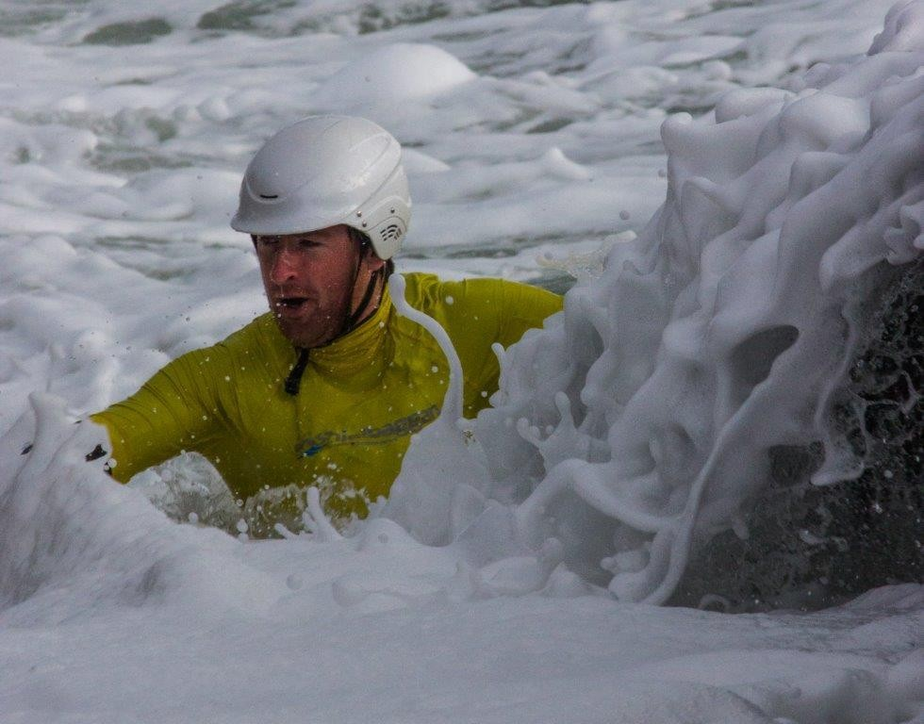

## Adult Guidance Service

### Adult Education Officer: Michael Kirwan Mission Statement

*An opportunity to look at your present situation and plan for the future.*

### Introduction:

The Adult Guidance service is a free, confidential service that provides information on adult education and training opportunities as well as one-to-one guidance to support people in making informed educational, career and life choices.

The Service provides Guidance counselling and information services to individual clients and to groups, and referral services to other agencies, as appropriate. Support and advice in the field of guidance and counselling to staff in adult education centres, and support in the development of an integrated curriculum of learning, guidance and progression.

There are a wide variety of choices available to clients, which include: Adult Literacy Service, Apprenticeships and Training Courses, Back to Education Initiative, Community Education, Distance Learning, English for Speakers of other languages, Evening Courses, Higher/Third Level, Momentum Skills, Post Leaving Certificate, Private Training Providers, Skillnet, Springboard, Vocational Training Opportunities Scheme and Work Place Learning.



Adult Literacy

Services

Workplace

Learning

Apprenticeships

& Training Courses

Vocational

Training Opportunities Scheme

Back to

Education Inititative

Higher/Third

Level

Community

Education

Education and

Learning Opportunities

Skillnet

Distance

Learning

Post Leaving

Certficate

Evening Courses

Private Training

Providers

English for

Speakers of Other Languages

Momentum

Skills

### Wexford

Guidance Counsellor: Grace Finlay Information Officer: Mary Ruth Tobin

Address: WWETB, Ardcavan Business Park, Ardcavan, Wexford Tel: 053 9152067

Email: [adultguidance@wwetb.ie](mailto:adultguidance@wwetb.ie) Website: [www.wwaegs.ie](http://www.wwaegs.ie/)

### 2015 Participant/Staff Figures

|  |  |  |  |  |  |  |
| --- | --- | --- | --- | --- | --- | --- |
| **Participant Numbers** | | |  | **Staff Numbers – Paid** | | |
| **Male** | 524 | 38% | **Male** | - | % |
| **Female** | 856 | 62% | **Female** | 2 | 100% |
| **TOTAL** | 1380 |  | **TOTAL** | 2 |  |

**Highlights for 2015**

* Worked on a new website for Waterford & Wexford AEGS which is a joint project between the guidance services within Waterford & Wexford AEGS. This website is an information resource for clients to access information on course provision, adult education, employment and career pathways. Supported guidance services within WWETB with regard to data entry and identified any technical issues to improve the functionality of the website.
* Worked with the Adult Guidance Co-ordinator in Co. Waterford to plan and co-facilitate an ‘Adult Guidance’ tutor workshop for WWETB tutors in Co. Wexford as part of the Tutor Support Programme.
* Worked with ETB staff in the new Wexford Education Centre; a shared space that provides a great opportunity for the Adult Eduational Guidance Service to work more closely with learners in Wexford town.
* Represented the Adult Educational Guidance Association of Ireland as regional representative of the Association by attending regional meetings as well as meetings of the Executive to bring forward issues of concern for members and share best practice in developing systems to deal with current changes relating to guidance and information provision.

## Adult Literacy Programme

### Adult Education Officer: Michael Kirwan

Waterford and Wexford ETB’s Adult Literacy Programme provides a free and confidential service for adults seeking help to improve their literacy/numeracy skills.

### Waterford City Adult Literacy Service

Adult Literacy Organiser: Joann Power

Address: Adult Literacy Service, Unit 1A, Railway Square, Waterford Tel: 051 854444

Email: [joannpower@wwetb.ie](mailto:joannpower@wwetb.ie) Website: [www.waterfordwexford.etb.ie](http://www.waterfordwexford.etb.ie/)

### Introduction:

The Adult Literacy Programme provides adults with a chance to learn basic skills which may be needed for employment, further study and for use in their daily lives. There are opportunities to develop a range of skills in areas such as reading, writing, spelling, numeracy, form filling, letter writing, computer literacy and personal development.

The tuition is free of charge and may be offered on a one to one basis or in a group setting depending on individual needs. Students can choose what they want to learn (by identifying their interests and needs) and they can work at their own pace.

### Courses Offered

A range of accredited courses at QQI Level 1 to 3 are available. Other programmes include; Intensive Tuition in Core Skills, Workplace Programmes and Family Learning Programmes.

The Intensive Tuition in Core Skills develops core skills in reading, writing, communications, maths and computers. Participants study in small groups for six hours a week for a 14-week block. This course is a good starting point for adults who left school early and wish to get back into education.

The Workplace Programmes provide core skills needed for the modern workplace. Participants develop their communication, maths and ICT skills in a small group setting.

The Family Learning Programmes recognise that parents are the primary teachers of their children. They provide support for parents/guardians and are an opportunity to discover the fun of learning together.

The Adult Literacy Service provides free and confidential group classes and one-to-one tuition for adults who wish to improve their reading, writing, spellings, maths or basic computer skills.

Classes are part-time and are provided by trained tutors in a friendly and informal atmosphere.

In addition to offering help with reading, writing, spelling and maths/sums, we also offer help and support with preparing for health and safety, driver theory and driving tests. All courses and activities are specifically designed to meet the needs of adult basic learners, for example an introduction to computers. Progression routes include QQI accreditation at Levels 1, 2 , 3 and 4.

If someone missed out in school, got left behind or just feel they need to improve their skills and gain confidence, they are entitled to a second chance.

### Highlights for 2015

* + International Adult Literacy Day (DCU) September 2015 ‘Delivering Adult Literacy and Numeracy Tuition
  + Plain English Conference, Dublin
  + ESF Audit
  + Launch of ‘Love to Write’
  + Promotional DVD for Adult Literacy
  + Managing Risk in the Education and Training Centre WWETB and IPB
  + Launch of ‘Return to Learning’ Competition
  + ‘Analysis of PIACC’, Dublin
  + Took on two TUS workers
  + PLSS Briefing
  + ALOA Forum, Cavan
  + FET Conference ETBi Building individual empowerment, social cohesion and economic prosperity in the 21st century.
  + Annual Awards Ceremony
  + Health Literacy Training provided to staff both within and outside the ETB
  + ESS Training (portal)
  + ALOA Regional meetings
  + Dignity at work training (WWETB) Venue – Training Centre
  + Teacher Education Qualification placements in the Adult Literacy Service
  + BKSB Training for staff
  + Aontas – Celebration of the publication of ‘Return to Learning – My Story’
  + FARR Training
  + Review and printing of tutor booklet
  + 0365 Training
  + QQI – The assessment process training for staff in conjunction with the QQI Coordinator
  + Perspectives on Professionalism in the FET sector – NCI, Dublin
  + Data Protection Training
  + The Creditors Portal training – Usage and Coding
  + Presentation to Level 9 students in WIT ‘Adult Literacy Provision in Waterford City’
  + Learner Educational Trip to Dublin – 1916 Commemorations
  + ‘Dealing with Trauma – the Syrian Refugees’ – Clonea Strand Hotel
  + ALOA AGM
  + Health Literacy Group – Consultation with the hospital in Waterford as part of their course
  + Competence Based Interview Training (WWETB)
  + U Casadh Assessments – Ex-prisoner project
  + Print of all leaflets (Modern Printers)
  + Caribbean Cruise – The Play (Raised €1100 for the hospice)
  + CID Meeting for management (HR WWETB)
  + Assessment in the Training Centre (Plumbers)
  + Internal and External Verification (QQI) June 7th and 8th
  + Shortlisting for interviews
  + Interviews
  + New Skills for Work, Family Literacy and Traveller Education Leaflets developed

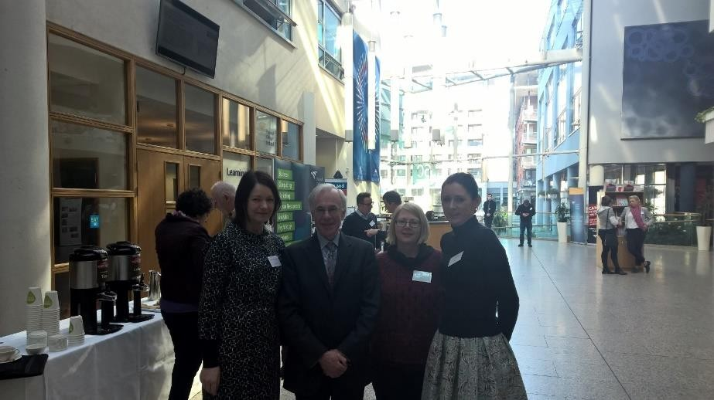

Perspectives on FE - NCI

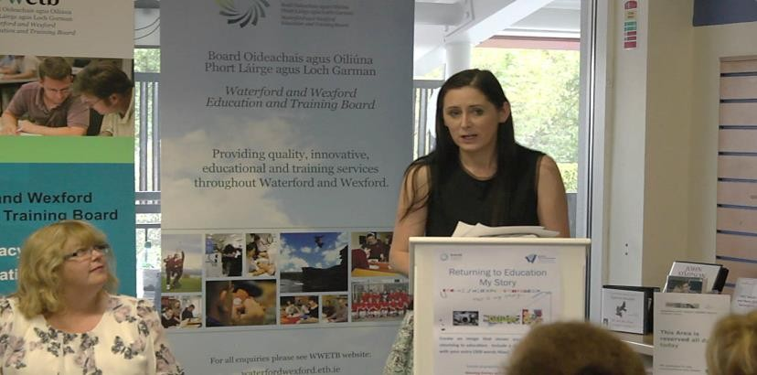

Launch of ‘Love to Write, maths trail and competition (September 2015)

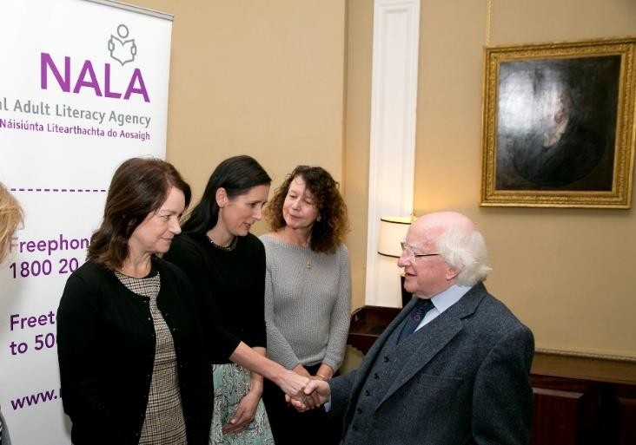

Adult Literacy Awareness Week 2015

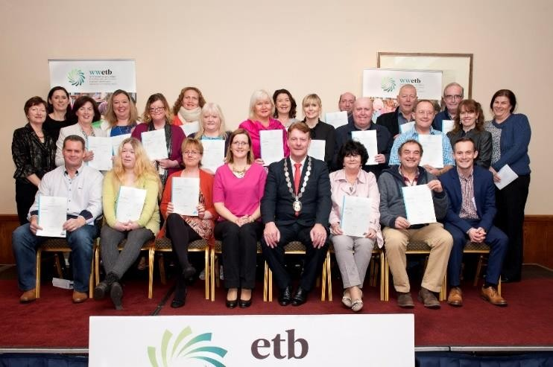

Awards Night (November 2015)

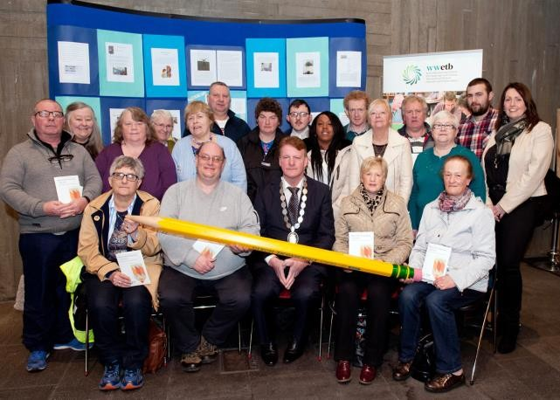

Return to Learning – My Story (AONTAS)

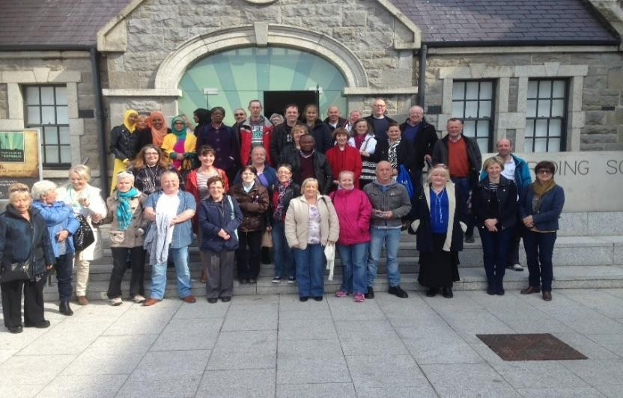

1916 Commemorations- trip to Dublin

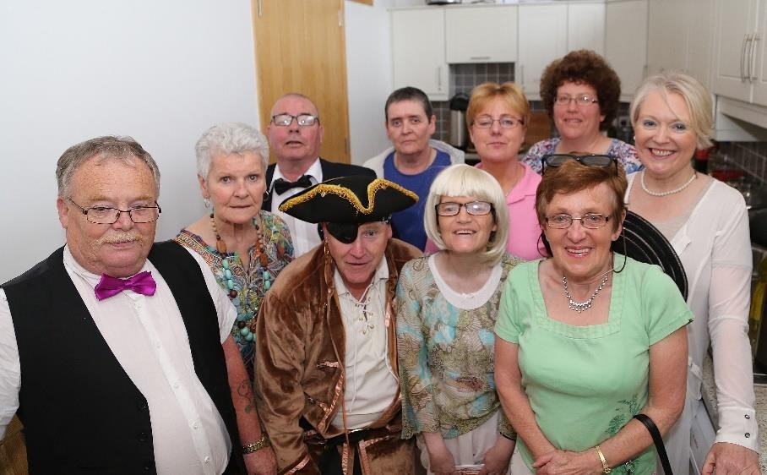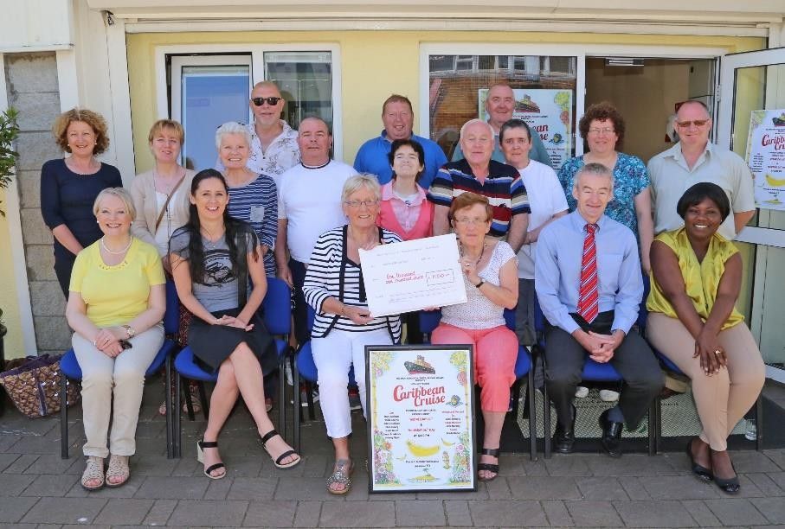

Drama Group and tutor Carol Doherty – Caribbean Cruise

The Limelight Players Drama Group – Cheque presentation to the hospice

### Waterford County Adult Literacy Service Dungarvan and West Waterford

Adult Literacy Organiser: Nicola McCarthy Hanlon

Address: Adult Literacy Service, Wolfe Tone Road, Dungarvan, Co Waterford Tel: 058 42774 Email: [nicolamccarthyhanlon@wwetb.ie](mailto:nicolamccarthyhanlon@wwetb.ie) Website: [www.waterfordwexford.etb.ie](http://www.waterfordwexford.etb.ie/)

### Introduction:

County Waterford Adult Literacy programmes are varied and are developed to encourage adults to return to learning. The courses are based in the following locations:

1. Adult Learning Centre, Wolfe Tone Road, Dungarvan. Phone: 058-42774
2. Ballymacarbry Community Centre, Ballymacarbry. Phone: 058-42774
3. Adult Education Centre, Cappoquin. Phone: 058-52570

### Learner Statistics



**2015**

**8%**

**10%**

**82%**

Mainstream Learners ITABE Learners

ESOL Learners

**Highlights of 2015**

* + A new updated Tutor Booklet was introduced in the Adult Literacy Service and this document will ensure that planning, targets, schemes of work and evaluations are presented in a professional way, and all materials and resources are on hard prior to class.
  + 240 QQI Certificates were awarded to Learners.

### Waterford County Adult Literacy Service Waterford County East

Adult Literacy Organiser: Emma Tobin

Tel: 051 393794 Email: [emmatobin@wwetb.ie](mailto:emmatobin@wwetb.ie) Website: [www.waterfordwexford.etb.ie](http://www.waterfordwexford.etb.ie/)

### Introduction:

The Adult Learning/Adult Literacy Programme provides adults with a fresh start to learn basic core skills needed for employment, further study and daily life. With the Programmes you learn at your own pace and the classes are based around the interests and needs of participants. You can receive individual support by working with your own tutor to develop your skills. Small group classes provide excellent opportunities to learn new skills and to make new friends.

Classes are provided both during the day and in the evening and courses are free to adults.

### Courses Offered

Programmes offered include; Read and Write with Confidence, Learn to Love Maths, Intensive Tuition in Core Skills, Workplace Programmes, Family Learning Programmes and ESOL. A range of accredited courses at QQI Level 1 to 3 are available and include Computers and Internet Skills, Maths, Food and Cookery, Food and Nutrition, Childcare, Personal Development, Communications, Graphic Communications, Horticulture, Irish, Personal Effectiveness, Consumer Awareness, Desktop Publishing.

### Highlights of 2015 include:

**Key Developments**

* + Two ITABE Programme completed in Tramore
  + FARR report process
  + Family Learning Programme targeted at Asylum Seekers completed.
  + **PEEP** - Parent/toddler group - family literacy with emphasis on numeracy. Family Learning Programme took place with 5 families participating
  + Tutor meetings to discuss programmes and QQI quality assurance
  + Training and Roll out of the BKSB Assessment tool pilot in English, Numeracy and ESOL. 30 Learners have completed at least one assessment area to date.
  + Promoting maths and numbers with a Math’s Week taking place in Tramore and Portlaw. Activities included BKSB maths assessments, class themed around numeracy, posters, maths Wall,

### Examples of intra-agency activities across the ETB/with other Learning Programmes

* + Working with Community Education to plan and deliver ESOL programmes
  + Centre Management Meeting with BTEI, Community Education and Youthreach Coordinators to look at health and safety, timetables, resources, shared advertising and promotion of the centre
  + Tramore Education Centre Facebook page has been set up
  + Waterford and Wexford Quality Assurance Seminar held in Woodlands Hotel in Waterford
  + Basic First Aid Training for Programmes using Tramore Adult Education Centre
  + Working with Community Education to set up education programmes in Portlaw for disadvantaged men.
  + Freedom of Information Training

### Co-operation with external organisations/agencies etc.

* + RESPOND Family Resource Worker to plan family learning
  + Ard na Gleanna Women’s group to plan, deliver and evaluate family learning summer programme
  + Library meeting to discuss layout and stock for libraries in City and County. This will be followed up in March with a meeting with ALOs in Waterford and the Library Literacy and Basic Education Working Team.
  + Attended Tramore Network Group meetings
  + Attended the Further Education & Training (FET) Forum Colloquium
  + Presentation to DSP and LES of adult education programmes provided in Tramore and Portlaw

## Back to Education Initiative

### Community Education Facilitator: Fran Kennedy

The Back to Education Initiative (BTEI) is a flexible, part-time training programme providing opportunities to return to learning. It provides the chance to combine a return to education and training with family, work and other responsibilities. Delivery times are flexible and are decided by the group. Any person who has left full-time education can apply to take part; however, priority is given to people with less than leaving certificate standard of education.

### County Waterford Service

BTEI Organiser: Mary Upton Tel: 058 51407

Email: [maryupton@wwetb.ie](mailto:maryupton@wwetb.ie)

### Waterford City Service

BTEI Organiser: Angi Meegan

Address: Adult Education Centre, Ozanam Street, Waterford Tel: 051 857611

Email: [angimeegan@wwetb.ie](mailto:angimeegan@wwetb.ie)

### Wexford Service

BTEI Organiser: Liz Duffy

Address: New Ross Education and Training Centre, Butlersland, New Ross, Co Wexford Tel: 051 447785

Email: [lizduffy@wwetb.ie](mailto:lizduffy@wwetb.ie)

### Total Age Profile

450

400

350

300

250

200

150

100

50

0

16 - 17

18 - 20

21 - 24

25 - 34 35 - 44

45 - 54

55 - 64

65 +

Male Female

|  |  |  |  |  |  |  |
| --- | --- | --- | --- | --- | --- | --- |
| **Age Bracket** | **Waterford County** | | **Waterford City** | | **Wexford** | |
|  | **Male** | **Female** | **Male** | **Female** | **Male** | **Female** |
| **16 -17** | 0 | 1 | 5 | 2 | 4 | 5 |
| **18 – 20** | 19 | 34 | 44 | 25 | 23 | 22 |
| **21 – 24** | 20 | 31 | 44 | 11 | 39 | 31 |
| **25 – 34** | 50 | 91 | 36 | 34 | 61 | 83 |
| **35 – 44** | 47 | 123 | 33 | 55 | 44 | 102 |
| **45 – 54** | 29 | 91 | 33 | 50 | 54 | 107 |
| **55 – 64** | 21 | 29 | 19 | 11 | 38 | 59 |
| **65 +** | 7 | 8 | 3 | 1 | 11 | 14 |
| **TOTAL** | **193** | **408** | **217** | **189** | **274** | **423** |

* + 21% of BTEI Provision in WWETB is with people under the age of 25 years.
  + There is a continuous increase in the participation of men.
  + The most popular age for returning to education is the 35-44 year old.

### Employment Status of Learners

500

450

400

350

300

250

200

150

100

50

0

Long Term Unemployed

Employed

Not in the Labour Market

Male Female

|  |  |  |  |  |  |  |
| --- | --- | --- | --- | --- | --- | --- |
|  | **Waterford County** | | **Waterford City** | | **Wexford** | |
| **Employment Status** | **Male** | **Female** | **Male** | **Female** | **Male** | **Female** |
| **Long Term Unemployed** | 112 | 227 | 89 | 53 | 161 | 174 |
| **Employed** | 19 | 48 | 7 | 33 | 18 | 74 |
| **Not in the Labour Market** | 62 | 136 | 70 | 78 | 95 | 175 |

* + 50% of our learners are Long Term Unemployed (over 1 year)
  + This means that 50% of our learners will be cross referenced with Turas Nua under the Job Path Programme
  + 38% are not in the labour market – this includes people on CE/TUS Schemes, Disability Payment, Carers, Retired and others who may be unemployed but not on the live register

### Previous Level of Education

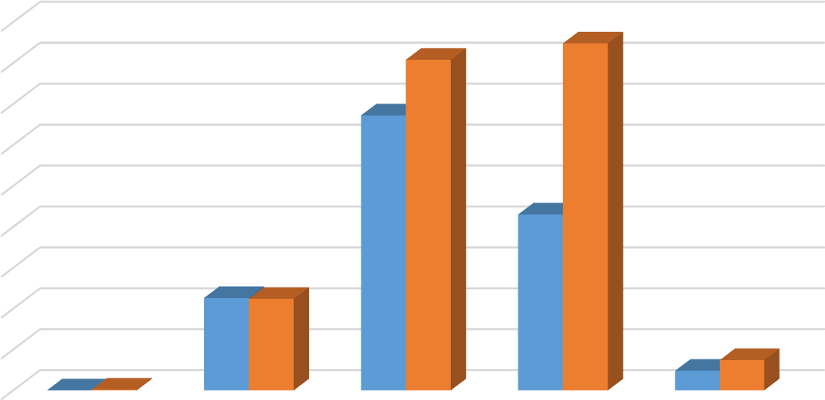

450

400

350

300

250

200

150

100

50

0

No Formal

Education

Primary

Education

Lower Secondary Upper Secondary QQI Level 6 and

Above

Male Female

|  |  |  |  |  |  |  |
| --- | --- | --- | --- | --- | --- | --- |
|  | **Waterford County** | | **Waterford City** | | **Wexford** | |
|  | **Male** | **Female** | **Male** | **Female** | **Male** | **Female** |
| **No formal education** | 0 | 1 | 0 | 0 | 0 | 0 |
| **Primary Education** | 18 | 25 | 37 | 19 | 58 | 68 |
| **Lower Secondary** | 111 | 170 | 115 | 97 | 110 | 137 |
| **Upper Secondary** | 63 | 162 | 56 | 67 | 96 | 195 |
| **QQI Level 6 and above** | 5 | 8 | 9 | 6 | 10 | 23 |

* + 44% have an entry level of Junior Certificate or lower on starting a BTEI Programme
  + This informs the QQI levels we need to offer
  + Cross reference with the age brackets (35-44) people have potentially left school 20 years or more and this will impact on the participation in learning

### Certification Achieved

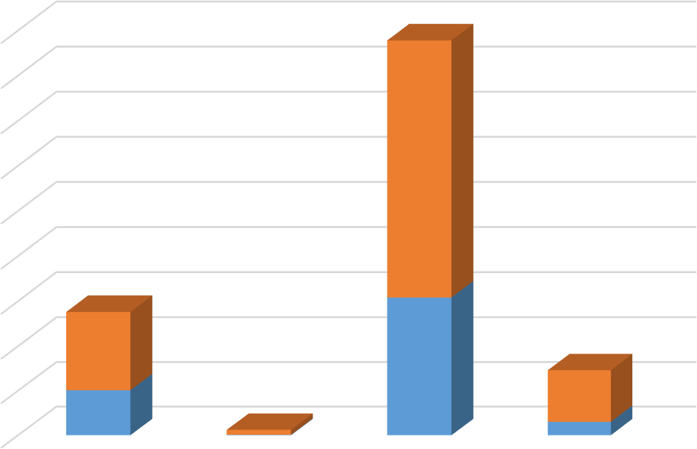

900

800

700

600

500

Female

Male

400

300

200

100

0

Minor Award 1-3 Major Award 3 Minor Award 4-6 Major Award 4-6

|  |  |  |  |  |  |  |
| --- | --- | --- | --- | --- | --- | --- |
|  | **Waterford County** | | **Waterford City** | | **Wexford** | |
| **Certification**  **Achieved** | **Male** | **Female** | **Male** | **Female** | **Male** | **Female** |
| **Minor Award 1 – 3** | 1 | 5 | 5 | 12 | 95 | 158 |
| **Major Award 3** | 0 | 0 | 0 | 0 | 1 | 11 |
| **Minor Award 4 – 6** | 51 | 123 | 35 | 39 | 222 | 408 |
| **Major Award 4 – 6** | 10 | 42 | 3 | 31 | 17 | 43 |

* + 67% of learners are achieving a minor award Level 4-6

### Waterford County Highlights

* + Programmes delivered in 2015 were based on the needs in a particular area and took into account the positive outcomes for learners who completed awards in the previous year, in particular in regard to employment.
  + Review of the South East Action plan for Jobs supported the rationale for the programmes on offer.
  + Consultation took place with the Chamber of Commerce to ensure that the needs of employers were met and a leaning towards retail, tourism, IT, Customer Service and Communications across the region.
  + The value of team working was highlighted as important and so was introduced across Co Waterford.
  + Building relationships with CE Supervisors was seen as important and regular updates were provided as to provision across the area. As a result an increased number of CE participants availed of courses delivered as part of BTEI. The Supervisors were encouraged to combine the requests identified and bring a cohesive plan to WWETB, this is ongoing work.
  + Regular updates were provided to DSP on programme provision and attendance at the Education Training Network Meeting where sharing of information across programmes occurs.
  + Work took pace with TREO Portlairge in providing support to service users, primarily young men many of whom experience social isolation due to drug use and previous criminal activity. This is a new initiative in Dungarvan and seen as hugely important for the town. The success of TREO in Waterford city is hoped will be replicated in the town.
  + Working with TREO LTI and Community Employment Scheme in Dungarvan is targeting those most at risk of long term unemployment whom are furthest from the labour market. The significance of the interaction with client users has an impact within families and creates an awareness of the service and programmes offered by BTEI. It is hoped to develop courses for the families in 2016.
  + Becoming an active member of Tramore Volunteers has raised the profile of the Tramore Centre in the town. Along with participation in the Promenande Festival brought the work of the centre into the community. This involved the making of props for display in the town.
  + Offering Japanese in Tramore was exciting as the learners became more informed of Japanese culture, food and the story of Lafcadio Hearn. The gardens created to reflect his life were opened to the public in June 2015.
  + A new centre was opened in Cappoquin, this small town would have experienced lack of programme provision for many years. This new centre and its facilities are of the highest standard and allow BTEI to work closely with Adult Literacy and Community Education.
  + Tutors of BTEI have attended training in Integrating Literacy which was facilitated by the Adult Literacy Service. This is ongoing work.
  + Progression rates to higher education is low but the numbers attaining employment in particular in the healthcare sector is still occurring.
  + Membership of the AFET Forum provides the coordinator with the opportunity to liaise with other FET Services on a national basis. Being part of the organising committee for the first FET Conference was very significant and worthwhile experience.
  + An overview of the work carried out in Tramore was submitted as a short piece to the ETBI Newsletter and was published in the Autumn edition.

### Waterford City Highlights

* + Due to high demand in the healthcare area we plan to offer Health Service Skills as well as Healthcare Support at Level 5. This course has the highest level of progression to employment with some learners gaining employment while they are still on the course.
  + Due to the national shortage of chefs we offer an ‘introduction to catering’ at Level 4 for learners who would otherwise not have access to this type of training. Part of the course is a one day introduction to the Hospitality Department in WIT which facilitates progression to their Level 6 Professional Cookery course.
  + In conjunction with the Traditional Skills LTI we offered extra tuition to participants in Ceramics. The aim is to develop skills for self-employment in the art and craft area.
  + Presentations were made to case officers in INTREO early in 2015 to inform them of course progression.
  + All courses available are notified to contacts in Social Welfare/Intreo on a regular basis.
  + We worked with the Mens Shed in Waterford city on developing skills for self- employment in carpentry/woodcraft. They are also being supported to create longer term plans for individuals and the group.
  + ESOL classes are provided for unemployed migrants/refugees to enable them to access the labour market or progress to further education. In 2015 about 50% did not complete the course due to work commitments.
  + We ran two courses under the Youth Development Initiative in conjunction with Social Welfare. This was a five day (over two weeks) work preparation programme that was supposed to be followed by an ‘internship’ with an employer. There were not placements for all participants. There was to be follow up as to progression for participants.
  + We continue our work with TREO (young people at risk offending) and Ceim Eile (people recovering from addiction). The programme is under constant review and components/supports are provided to meet the needs of the participants. This work relies on having good working relationships with the project workers and being flexible with hours/modules available.
  + In Waterford City we provide a Foundation course for adults returning to education. The focus of this year long course is confidence building, career planning and building skills for progression. It particularly suits those most removed from the labour market who are not sure what direction their career should take. The aim is that each learner will have a

plan for their own progression by year end. In 2015 100% of the learners progressed to further education form this group.

* + We provided extra supports in IT skills and English language to learners on a variety of BTEI courses to enable them to have the best chance of success.
  + We continue to support Ceim Eile (people recovering from addiction) with a flexible programme focused on preparing participants for re-entry to the labour market or progression to further/higher education. In 2015, 18 participants completed a total of 46 components at Level 4/5.
  + The literacy service assisted in initial assessment of learners on the Youth Development Initiative.
  + We work closely with the ESOL coordinator in assessing the needs of learners and referring them to appropriate provision
  + Extra supports in IT skills and literacy are provided to BTEI learners as required in ‘Study Support Groups’.
  + Skillnet – healthcare training for HSE home-helps – is managed in Waterford City by the BTEI coordinator. Two modules were completed in 2015 with 15 workers and other modules are being planned for 2016
  + AHEAD training was completed by BTEI coordinator – with the aim of understanding strategies to accommodate students with disabilities. A presentation was then prepared and given to the BETEIA
  + Conferences attended
    - WIT Colloquium February 18 on professionalism in FET
    - NAPD Conference April 15
    - Inaugural FET Conference Nov 26

### Wexford County

* + All of the participants on the Level 5 Healthcare Group in Gorey have found employment with the employers they began their voluntary work experience with. This ensures the employers have employees with relevant up to date legislatively required qualifications.
  + BTEI Wexford started to build links with the Local Enterprise Office to look at options of sharing information and working together in the future.
  + BTEI Wexford visited local Investments Company, BNY Mellon, to research what skills and qualifications they require in the current economic climate. Finds from this meeting lead to linking with Carlow IT to develop a programme leading to possible employment opportunities or further education.
  + Working in partnership with Sports Active Wexford to deliver their Community Training Programme.
  + BTEI Wexford delivered the Level 6 QQI Supervisor in Childcare award to local community childcare service workers to ensure their training levels met employer’s needs.
  + BTEI Wexford delivered a number of Private Security courses within the county and a large number of participants gained employment in the area.
  + BTEI Wexford Co-ordinator attended a Tourism Information Session for Wexford and is now part of the network and receiving up to date information on progress.
  + BTEI Wexford worked in conjunction with the FAI (Football Association of Ireland) on the delivery of a number of Sports and Recreation Programmes.
  + BTEI Wexford has developed a model of working with CE Supervisors to deliver relevant education and training programmes to a large number of participants from various schemes.
  + BTEI Wexford Co-ordinator consulted with the Wexford Training Centre Apprenticeship Manager around possibility of working together on programmes.
  + BTEI Wexford, along with colleagues, has commenced conversations with Wexford Local Development and the SICAP programme to develop a system of possibly working together.
  + BTEI Wexford Co-ordinator is part of the New Ross Network and the Enniscorthy Network. An informal network of various agency staff working together to engage the long term unemployed in education and training programmes.
  + BTEI Wexford delivered two first steps programmes in conjunction with the DSP to young people within the county.
  + BTEI also worked with Gorey Youth Needs and other agencies working with Youths at Risk, to deliver a QQI Level 3 programme to youths in the Gorey Area.
  + BTEI Co-ordinator met with a local committee, Educare Learning, and developed a programme for youths at risk, particularly youths with learning disabilities, in the New Ross Area.
  + In 2015 almost 10% of the total number attending BTEI programmes in Wexford classed themselves as a person with a disability.
  + BTEI Wexford works together with the Cornmarket Project to deliver programmes in Gorey and New Ross to substance mis-users within these geographical areas.
  + BTEI Wexford works with the mental health agency in Enniscorthy to deliver certified training to the clients attending the centre.
  + BTEI Wexford Co-ordinator attended the Roma Community session in Enniscorthy to research educational and training needs.
  + BTEI Wexford supports the Community Strand Programme delivered through the rural South West Wexford Community Development Project.
  + As part of an all-inclusive information session, BTEI delivered a training session to a number of staff members within CUMAS (formerly New Ross Community Workshop) on programme delivery within the New Ross Adult Education Centre.
  + Participants from REHAB have been supported to attend BTEI programmes in Wexford Town and Enniscorthy.
  + BTEI programmes are offered in dedicated Adult Education Centres and in community locations.
  + BTEI and Adult Literacy staff within the Adult Education Centres worked as part of a team within the centre to ensure the best possible learning experience for the learners.
  + Assessment tool for BTEI developed in consultation with Adult Literacy Service.
  + As part of the Hairdressing Level 5 Programme, BTEI Wexford offered the Start your Own Business Module to all learners attending the programme.
  + Local Business Personnel delivered talks to the Customer Service Group in Wexford Town.
  + As is the nature and level of the BTEI programme delivery being levels 3 to five, the majority of BTEI learners progress onto further FET courses or employment.
  + In 2015 a year long professional development programme was devised for BTEI, Community Education and Adult Literacy tutors to attend.
  + Wexford BTEI staff were encouraged to complete the FET Skills Profile, Investing in Your Future Questionnaire.
  + In September a BTEI Wexford training session was delivered entitled “Tutor Start Back”.
  + Feedback is issued to all BTEI Wexford tutors following QQI Assessment Periods.
  + BTEI staff attended the learning wellbeing and FET environment training session delivered by FESS.
  + BTEI Wexford Co-ordinator attended the inaugural FET National Conference.

## Community Education

### Community Education Facilitator: Fran Kennedy

The Community Education Programme supports local communities and community based groups in County Waterford, Waterford City and County Wexford.

Community Education is informal learning that contributes to the development of the local community. Grants and Tutor Hours are available to community groups. Each application is individually assessed.

Due to the volume of applications, priority is given to groups who organise community education programmes for people who may face acute barriers to taking part in education: Older people, women experiencing disadvantage, people with disabilities, travellers, ethnic minority groups, unemployed, lone parents, men experiencing disadvantage, carers, ex- offenders.

### County Waterford Community Education

Community Education Facilitator: Aine Whelan

Address: Unit F13, Dungarvan Shopping Centre, Dungarvan, Co Waterford Tel: 058 51405

Email: [ainewhelan@wwetb.ie](mailto:ainewhelan@wwetb.ie)

### Waterford City Community Education

Community Education Facilitator: Helen Rafferty

Address: Education and Training Centre, Ozanam Street, Waterford Tel: 051 873195

Email: [helenrafferty@wwetb.ie](mailto:helenrafferty@wwetb.ie)

### Wexford Community Education

Community Education Facilitator: Anne McDonnell

Address: Waterford & Wexford ETB, Ardcavan Business Park, Ardcavan, Wexford Tel: 053 9123799

Email: [annemcdonnelle@wwetb.ie](mailto:annemcdonnelle@wwetb.ie)

### Community Education Age Profile

500

450

400

350

300

250

200

150

100

50

0

16 - 17

18 -20

21 - 24

25 - 34 35 - 44

45 - 54

55 - 64

65 +

Male Female

|  |  |  |  |  |  |  |
| --- | --- | --- | --- | --- | --- | --- |
| **Age Bracket** | **Waterford County** | | **Waterford City** | | **Wexford** | |
|  | **Male** | **Female** | **Male** | **Female** | **Male** | **Female** |
| **16 -17** | 2 | 0 | 0 | 0 | 0 | 1 |
| **18 – 20** | 2 | 8 | 10 | 3 | 4 | 5 |
| **21 – 24** | 9 | 9 | 19 | 8 | 8 | 7 |
| **25 – 34** | 30 | 21 | 40 | 26 | 23 | 33 |
| **35 – 44** | 23 | 69 | 22 | 28 | 22 | 108 |
| **45 – 54** | 27 | 74 | 34 | 50 | 63 | 168 |
| **55 – 64** | 12 | 72 | 25 | 57 | 72 | 130 |
| **65 +** | 16 | 138 | 53 | 126 | 95 | 200 |
| **TOTAL** | **121** | **391** | **203** | **298** | **287** | **652** |

* + One third of learners are 65 years and over
  + There is an underrepresentation with under 25 years of age

### Employment Status of Learners

1200

1000

800

600

400

200

0

Long Term Unemployed Unemployed <1 year

Employed

Not in the Labour Market

Male Female

|  |  |  |  |  |  |  |
| --- | --- | --- | --- | --- | --- | --- |
|  | **Waterford County** | | **Waterford City** | | **Wexford** | |
| **Employment Status** | **Male** | **Female** | **Male** | **Female** | **Male** | **Female** |
| **Long Term Unemployed** | 18 | 27 | 77 | 117 | 26 | 23 |
| **Unemployed <1 Year** | 25 | 42 | 15 | 13 | 103 | 93 |
| **Employed** | 20 | 83 | 12 | 17 | 21 | 151 |
| **Not in the Labour Market** | 58 | 239 | 98 | 156 | 137 | 385 |

* + 55% of our learners identify themselves as not in the labour market, this would include carers, people with disabilities, people working in the home and not on the live register, state employment participants, people in receipt of a pension

### Certification Achieved

100%

90%

80%

70%

60%

50%

40%

30%

20%

10%

0%

Minor Award 1-3

Minor Award 4-6

Major Award 4-6

Major Award Level 7

Male Female

|  |  |  |  |  |  |  |
| --- | --- | --- | --- | --- | --- | --- |
|  | **Waterford County** | | **Waterford City** | | **Wexford** | |
| **Certification**  **Achieved** | **Male** | **Female** | **Male** | **Female** | **Male** | **Female** |
| **Minor Award 1 – 3** | 4 | 7 | 0 | 0 | 0 | 11 |
| **Minor Award 4 – 6** | 0 | 0 | 0 | 0 | 9 | 114 |
| **Major Award 4 – 6** | 0 | 0 | 0 | 0 | 1 | 6 |
| **Major Award Level 7** | 2 | 7 | 2 | 7 | 0 | 0 |

* + Community Education is in the main non accredited
  + If a group wishes for certification, where possible, the group is referred to BTEI
  + There is a difference in accreditation levels between Counties

### Waterford County Highlights

#### SkillETB

* + - 18 HSE Care Workers participated in 4 QQI Level 5 Healthcare modules aimed at raising the skills of support staff. This programme is run in conjunction with the HSE.

#### BA Community Education and Development

* + - In 2015 the Community Education programme co-funded nine voluntary community workers from Co Waterford to access a QQI level 7 degree in Community Education and Development thus improving their ability to gain employment. At least 2 of the group have gained employment to date.

### Men’s Shed

* + - The Community Education Programme supports The Men’s shed in Dungarvan, Portlaw and Tramore. The shed provides a place where men can come together and undertake a variety of agreed activities. In Dungarvan and Tramore the

Men’s Shed premises is provided by WWETB. Six members of the Dungarvan

Men’s Shed attended the Aontas Star Awards in Dublin, as they were short listed for a regional award. Although they were not the winners on the day, the group really enjoyed the experience and they had the opportunity to network with other community group around the country.

### QQI Level 5 Youth work

* + - The Community Education Programme supports Waterford and South Tipperary Youth Service with QQI Level 5 training for Volunteers. The programme is aimed at those working in the youth sector with no formal qualifications.

### Portlaw Community Activation.

* + - The CEF is working with TUSLA, Foróige, Waterford Council and SICAP to support and promote community groups in Portlaw. A history of high unemployment and rural isolation has impacted on the town resulting in a lack of community activity. Clodaigh House is now a Community and Family Resource Hub with 7 community groups working from the centre: Clodaigh House Women’s Group, Clodaigh House Knitting Group, Portlaw Men’s Shed, Foróige, Scouts, Civil Defence, Portlaw Task Force and the Parent and Toddler Group.

### English for Asylum Seekers and Migrant Workers

* + - There are 2 direct provision houses for Asylum Seekers in Tramore with approximately 100 residents. In order to promote inclusion into Irish society the Community Education Programme, in conjunction with the Literacy Service, provides English classes for asylum seekers. In addition to provision for asylum seekers, the Community Education Service also supports migrant workers and their families who experience isolation and exclusion due to language and cultural barriers. The Community Education programme provides English classes in Tramore, Dungarvan and Cappoquin. There are three English Classes in

Dungarvan and two in Cappoquin. The programme facilitated 70 ESOL learners in 2015.

### Benefit 4

* + - The main objective of the BenefIT Programme is to get more people online. We focus on key target groups like older people, jobseekers and the disadvantaged. Participation on the Benefit4 Programme promotes new skills and encourages people to stay better connected thus reducing isolation. To date Co Waterford has trained in excess of 100 people under the Benefit4 Programme.

### Women’s Groups

* + - The Community Education Programme supports 10 women groups throughout Co Waterford combating rural isolation and promoting active inclusion in local communities. The Community Education Resource Worker supported the establishment of a Community Education group in Cappoquin Education Centre, promoting activity and progression in the Centre. 120 women participated on Community Education Programmes in 2015

### Ranganna Gaeilge

* + - Beginner, intermediate and advanced Irish classes took place in An Rinn in conjunction with Údarás Na Gealtachta promoting the integration of those living in Gaeltacht areas and also promoting the Irish Language.
  + The Community Education Programme works closely with the Literacy Service providing predevelopment programmes and offering progression routes where appropriate.

### Waterford Traveler Support Group

* + - A 10 week pre-develop Programme was offered to traveller women in Dungarvan who have progressed to the Literacy Service.

### WIT degree in Community Education and Development

* + - Community volunteers were supported access a QQI level 7 degree in Community Education and Development and 18 learners are currently being supported on a QQI level 6 certificate in Community Development
  + WIT Community Education Students hosted a seminar on the engagement of non- traditional students into Third Level. The seminar showcased the way the WIT Community Education Programme works, highlighting the engagement and outreach process and the effectiveness of collective learning.

### Training Attended

* + - Managing Risk Seminar
    - Child Protection Training
    - Global Awareness Training - Irish Aid and Crawford College facilitated Global Awareness Training at Tramore Education Centre. The programme looked at creative ways for trainers to explore global issues with groups.
    - First Aid Training
    - Data Protection Training

### Waterford City Highlights

* + 9 voluntary community workers from Waterford City were supported to participate in the Ordinary Degree in Community Education and Development.

### Wexford County Highlights

* + 16 HSE Care Workers participated in SkillETB under Community Education programme. In 2015 one full group progressed to Health Care Major Award under BTEI with support from Resource Worker.
  + In 2015, WWETB Community Education Programme participation rates indicate that 247 of our participants were unemployed (27.9%), with 198 being unemployed for a year or more (22.3%).
  + Community Education Wexford has very good working relationships with Family Resource Centres, local libraries and Wexford Local Development. These relationships inform our programmes and ensure we are targeting those most in need.
  + We worked with Taghmon FRC to develop a Youth engagement programme to be funded under Dormant Accounts. Unfortunately the application was unsuccessful but we will part fund internally in 2016.
  + Work continues with young traveller women in the Bunclody area.
  + WWETB Community Education Programme provides Tutor Hours to local community education providers, such as FRC’s, Men’s Sheds, and other community/voluntary groups, so that local needs are responded to effectively. With this approach, WWETB

Community Education Programme supports local groups who are especially successful in targeting those most hard to reach to engage in education. The range of supports available to adult learners in community setting is particularly effective and has the capacity to support people to become involved and stay involved.

* + Acquired Brain Injury (Wexford) – 7 adult learners completed QQI Level 4 Painting (Minor Award) through a needs-based community arts programme delivered by ABI and WWETB Community Education Programme.
  + 9 adult learners completed QQI Level 4 Stable and Yard Routine, through a needs-based programme engaging adults with intellectual disabilities, delivered by Windmill TTU and WWETB Community Education Programme, together with Ragtree EAL. All learners are progressing to further modules to work towards QQI Level Horsemanship (Major Award).
  + 5 adult learners completed QQI Level 4 Short Order Cookery, delivered by DeafHear and WWETB Community Education programme for adults who are deaf.
  + Delivery of a Personal Development and Lifeskills Programme for homeless men, together with Ozanam House, Wexford, through which over 25 men took part in 2015. This programme involves non-accredited learning and practical skills for personal/social development such as cookery, and health/personal development activities.
  + Co. Wexford based on its population receives 57% of funding for Benefit 4. In 2015 we trained 383 learners in our own Adult Education Centres, Wexford Library, Gorey Library, Enniscorthy Library, Raheen Family Resource Cente, Taghmon Family Resource

Centre, St Aidans Intellectual Disability Services, Ard Aoibhinn Disability Services, St. Margaret’s Day Care Centre and Respond Housing Association.

* + All groups being supported by the Community Education Programme are visited by the WWETB Adult Guidance Service each year.
  + 7 people received Major Awards in 2015, one person progressed to WIT to complete a Higher Education course.
  + Adult and Community Education Tutor Support Programme 2014/15-
    - Irish Sign Language
    - Basic Facilitation Skills
    - Advanced Facilitation Skills
    - Creative Facilitation
    - Working with People Interculturally
    - Adult Guidance Workshop
    - First Aid
    - Working with Men

## ESOL (English for Speakers of Other Languages)

### Adult Education Officer: Michael Kirwan

English Languages are available throughout the ETB in our adult education and training centres for migrant workers, the unemployed and asylum seekers.

Priority is given to those in need of Basic English language skills to a level of functional competency (A2 on the Common European Framework of Reference for Languages or NFQ Level 3).

Accreditation at NFQ Levels 4 and 5 and/or IELTS preparation may be offered in some centres for a fee.

## Vocational Training Opportunities Scheme (VTOS)

### Adult Education Officer: Mary Walsh

There are nine Further Education and Training Centres that offer VTOS in Waterford & Wexford ETB across the Counties of Waterford and Wexford.

The Vocational Training Opportunities Scheme is an educational opportunities scheme for unemployed persons which is funded by the Department of Education and Skills. The Scheme is operated through the 16 Education & Training Boards countrywide and provides a special range of courses designed to meet the education and training needs of unemployed people.

### VTOS BunclodyBunclody Adult Education Centre

Co-Ordinator: Ms Mary Waters

Address: Ryland Road, Bunclody, Co Wexford Tel: 053-9377326 Website: [www.waterfordwexford.etb.ie](http://www.waterfordwexford.etb.ie/)

### Introduction:

The Adult Education Centre in Bunclody is a 20 place centre delivering QQI Level 4 Major Modules in Employment Skills and General Studies.

### Major Modules Offered:

Employment Skills QQI 4 and General Studies QQI 4. Subjects Delivered include:

At Level 3: French

At Level 4: Communications, ESOL, Teamworking, Work Experience, Information Technology, Customer Service, Career Planning, Understanding Interculturalism, Digital Photography.

At Level 5: Word Processing, Work Experience

### Highlights of 2015 include:

* + The students, as part of Teamworking QQI Level 4, produced a book entitled “Recipes for Life” which contained local recipes from all their different countries and stories associated with these recipes and the occasions where this food was eaten.

The book was produced and sold with the proceeds going to the HOPE centre in Enniscorthy.

* + As part of Understanding Interculturalism, the students produced a booklet on Folklore relevant to their own culture.
  + As part of Understanding Interculturalism, the student hosted a guest speaker.
  + As part of Digital Photography, the students held a photography exhibition in the Bunclody Library.
  + The students took an educational trip to Kilmainham Goal and IMMA.

### Front of BuildingDungarvan Adult Education Centre (VTOS)

Coordinator: Ms Aileen O’Connor

Address: Wolfe Tone Road, Dungarvan, Co Waterford Tel: 058 45757

Email: [aileenoconnor@wwetb.ie](mailto:aileenoconnor@wwetb.ie) Website: [www.waterfordwexford.etb.ie](http://www.waterfordwexford.etb.ie/)

### Introduction:

The Dungarvan Adult Education VTOS Centre at Wolfe Tone Road, Dungarvan, offers full time courses

### Courses Offered:

Courses offered include General Learning (QQI Level 4), eBusiness (QQI Level 5), Tourism with Business (QQI Level 5), Office Administration (QQI Level 5), Retail Practice (QQI Level 5), Business Administration (QQI Level 5) and Art (QQI Level 5).

The Business courses will provide students with a broad range of business and computing skills to work in the modern business and financial sector. Many subjects in year 1 start at level 4, progressing to level 5 in year 2.

Work experience will be undertaken 2 weeks in Year 1 and 2 weeks in year 2. The students will achieve a Level 4 General Learning Award (4M2010) in Year 1 and all or a combination of Level 5 awards in Year 2.

The Art course is a 2 year course that covers all the essential areas within Art, practice. Many subjects in year 1 start at level 4, progressing to level 5 in the second year. Subjects covered are Painting, Drawing, Batik, Weaving and Sculpture.

**Duration:** 2 years, full-time.

### Highlights of 2015 include:

Annual Awards night in The Park Hotel Dungarvan was well supported again and we had a large number of students receiving awards.

The Annual Art Exhibition was held in the Dungarvan Shopping Centre. The exhibition was opened by the past VTOS student and now established Artist Dave Minehan. The exhibition was open for three weeks and many students sold some of their work.

### outside2Enniscorthy VTOS

VTOS Co-Ordinator: Ms Eithne Agar

Address: Bellefield GAA Complex, Bellefield, Enniscorthy, Co Wexford Tel: 053-9237224 Email: [enniscorthyvtos@wwetb.ie](mailto:enniscorthyvtos@wwetb.ie) Website: [www.waterfordwexford.etb.ie](http://www.waterfordwexford.etb.ie/)

### Introduction:

The policy and ethos of the Enniscorthy VTOS Centre is of “an open and accessible programme of learning structures around the needs of the learner”.

### Courses Offered:

General Studies (QQI Level 5), this programme of learning is aimed at those who wish to progress to Third Level or further education at Level 6 and offers a broad range of knowledge and key skills development.

Business Administration (QQI Level 5), the overall aim of this programme is to provide the learner with the opportunity to build the knowledge, skills and competence required for participation in higher education, including acquiring a broad range of knowledge for an academic discipline, and key skills for academic research and enquiry.

General Learning (QQI Level 3), basic skills development for those who may have left school early, who are considering progression to a PLC or employment and are capable of learning at level 3.

Employability Skills (QQI Level 3), basic skills development for those who may have left school early and who are considering progression to employment and are capable of learning at level 3.

### Photo At the Awards ceremony of Enniscorthy VTOS Students with our new AEO Mary Walsh Dec 2015Highlights of 2015 include:

At the Awards ceremony of Enniscorthy VTOS Students with our new AEO Mary Walsh Dec 2015

Nicola Kirwan, Eithne Agar, Mary Walsh AEO and Karen O Brien

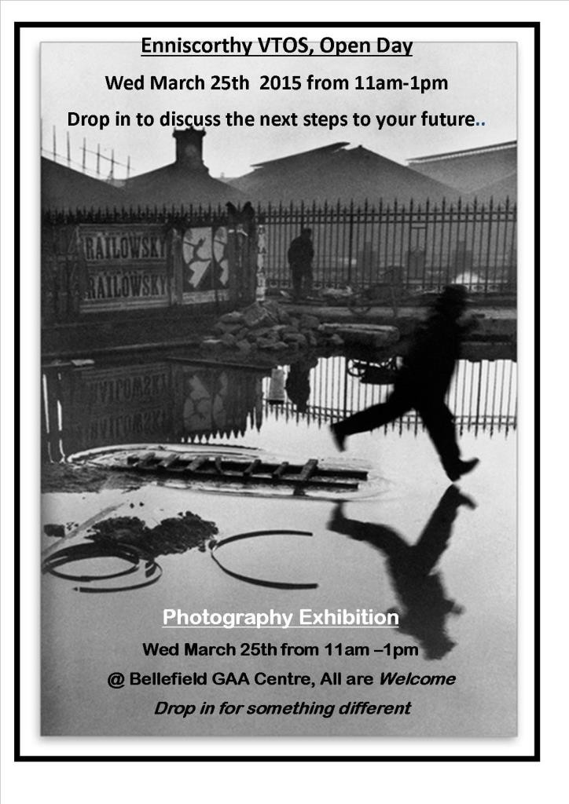

Our annual Photography Exhibition under the tutelage of James Quirke is always a landmark event and draws many students to our programme.

Identifiable trends and considerations for the future.

* + A decrease in progression to college and an increase in progression to other training including Community Employment, PLC, and Internships.
  + A higher than usual return to original status.
  + A further increase in those with Junior Certificate standard or lower on entry.
  + A repeated pattern with 2:1 female to male ratio.
  + Number of students 40

# Progression of VTOS 2015 Students

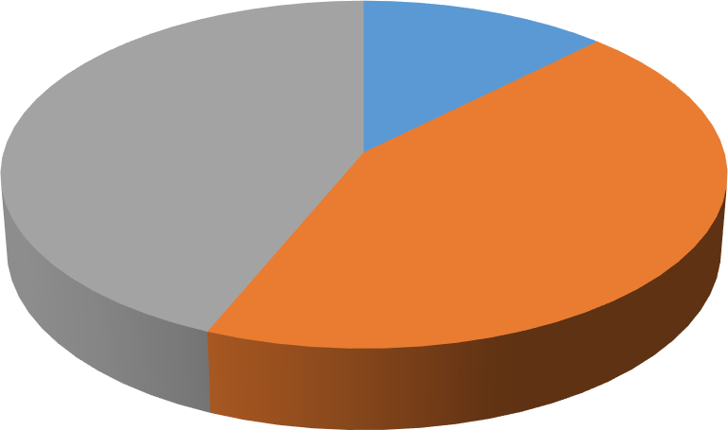

0%

12%

44%

44%

College Employment Original Status Other Training

# Current Students Prior Education

20

18

16

14

12

10

8

6

4

2

0

No Formal Education Primary Junior Cert. Leaving Cert.

### 20161121_104810Gorey Adult Education Centre

Centre Co-Ordinator: Mr James O’Hanlon

Address: Gorey Civic Centre, The Avenue, Gorey, Co Wexford Tel: 053 9421791 Email: [goreyvtos@wwetb.ie](mailto:goreyvtos@wwetb.ie) Website: [www.waterfordwexford.etb.ie](http://www.waterfordwexford.etb.ie/)

### Introduction:

VTOS is a return to learning programme which allows adult learners to explore and develop their skills and interests in a general learning course where they can build their confidence and identify opportunities for building a career. Twenty students will get an opportunity to return to full time education and achieve qualifications in a wide range of skills for employment or to progress to third level education.

VTOS is geared for those who may not have experienced success in their previous time in education but are now interested in getting a quality qualification across a broad range of subjects.

### Courses Offered:

The course can last for two years, after successfully completing first year and is full time. The first year is designed to build a solid foundation of up to date skills, to access employment in today’s economy. In the second year there is the opportunity to acquire a QQI Level 5 qualification in Business or General Studies which will help students to progress to third level education or employment depending on the persons plan.

### IMG_0013Kilmacthomas Adult Education Centre

Centre Co-Ordinator: Mr Frank McQuillan

Address: Union Road, Kilmacthomas, Co Waterford Tel: 051 294680

Email: [frankmcquillan@wwetb.ie](mailto:frankmcquillan@wwetb.ie) Website: [www.waterfordwexford.etb.ie](http://www.waterfordwexford.etb.ie/)

### Courses Offered:

Courses offered include: Start Your Own Business, Business Studies, Information and Communication Technology Skills, Retail Skills and Horticulture.

### Highlights of 2015 include:

The progression of learners who completed the VTOS Start-Your-Own-Business course in June 2015 is outlined in the table and chart below.

Progression 2015

Employment

Third Level QQI Level 5

Self Employment

Live Register

|  |  |  |  |
| --- | --- | --- | --- |
| **Progression** | **Male** | **Female** | **Total** |
| **Employment** | 1 | 1 | 2 |
| **Self-Employment** | 5 | 5 | 10 |
| **Higher Level**  **Education** | 1 | 2 | 3 |
| **ETB Training** | 1 | - | 1 |
| **Live Register** | 3 | 2 | 5 |

### VTOS Cover PictureNew Ross Adult Education Centre

Co-Ordinator: Ms Miranda Ó Bolguidhir

Address: Butlersland, New Ross, Co Wexford Tel: 051 425034

Email: [newrossvtos@wwetb.ie](mailto:newrossvtos@wwetb.ie) Website: [www.waterfordwexford.etb.ie](http://www.waterfordwexford.etb.ie/)

### Introduction:

VTOS aims to give unemployed people education and training opportunities which will develop their employability. By completing a VTOS course, participants will gain recognised national qualifications up to QQI Level 5.

The centre provides a supportive environment for learners who wish to return to education at any stage of their adult lives. You will have the chance to update your education and skills and will be prepared to engage in further education or to gain paid employment.

### Courses Offered:

Courses Offered include Employability Skills (QQI Level 3) with subjects including Communications, Career Preparation, Mathematics, Art & Design, Work Processing, Personal Effectiveness.

Office Skills (QQI Level 4) with subjects including Communications, General Office Skills, Business English, Business Calculations, Information Technology Skills, Customer Service, Bookkeeping and Accounts, Work Experience.

Culinary Skills (QQI Level 4) with subjects including Culinary Techniques, Pastry, Baking & Desserts, Menu Planning, Catering Operations & Systems, Team Working, Personal Effectiveness, Work Experience, Work Processing, Functional Maths.

Professional Cookery (QQI Level 5) with subjects including Culinary Techniques, Pastry, Baking & Desserts, Menu Planning & Applied Nutrition, International Cuisines, Meal Service, Food Science & Technology, Personal Effectiveness, Work Practice, Work Processing.

### Highlights for 2015

* + A former learner who completed in 2013 and since graduated from Culinary Arts Level 6 in WIT gave an inspiring talk and held a Q&A session with our Professional Cookery learners.
  + QQI awards were presented to 2014 graduates in Employability Skills, Office Skills, Culinary Skills and Professional Cookery.
  + Learners were presented with certificates in HACCP, Basic First Aid and Manual Handling.
  + The Coordinator attended the NAVC conference.
  + An Open Day was held for the recruitment of new learners. Existing Culinary Skills learners coordinated the organisation and catering for this event as part of their Teamworking module assignment.
  + A former learner, who completed in 2012 and was last employed in 2008, secured fulltime employment.
  + A former learner, who completed in 2011, showed his work at Wexford Campus School of Art and Design’s exhibition on completion of an Art degree.
  + A former learner, who completed in 2010, passed his Leaving Certificate History with flying colours (an A1) from New Ross Vocational College.
  + A former learner, who completed in June 2015, commenced a JobBridge placement in the Centre operating the canteen.
  + A former learner, who completed in June 2015, commenced a JobBridge placement in Youthreach New Ross as a kitchen assistant.
  + The Coordinator commenced a TEG (Irish language) one year, part time course.
  + The Coordinator attended the ETBI conference.
  + Learners attended WIT Open Day.
  + Professional Cookery learners cooked and served a Christmas meal to all in the Centre.

### thumbnail_IMG_1408Adult Access VTOS

**Waterford College of Further Education**

Address: Waterford College of Further Education, Parnell Street, Waterford

Tel: 051 874053

Email: [vtos@wcfe.ie](mailto:vtos@wcfe.ie) Website: [www.wcfe.ie](http://www.wcfe.ie/)

### Introduction:

Adult Access VTOS WCFE which is a core Vocational Opportunities Training Scheme (VTOS) provision is unique in this area as it is part of a larger college giving the students all the advantages of the larger college. Adult Access delivers interesting, worthwhile and relevant courses to adults. There are 100 places available for these two years courses.

Special attention is given to supporting those who have been out of the education system for some time with individually designed tutorials. In addition, extensive provision of English language lessons are integral parts of the course for those for whom English is not their first language.

Courses are delivered in groups dedicated to adults as part of a larger college and give students access to a broad range of facilities including, canteen, gym, library, common room, student cards and open access computer rooms. Importance is given to fun and enjoyment with student activates throughout the year. Along with the main components learners can participate in workshops that enhance their college experience such as study skills, career planning, health related activities, entrepreneurship, customer facing skills, interview preparation, personal care, presentation skills, team working, conflict resolution, occupational first aid, manual and patient handling, drama, complementary therapies, and hair care for carers.

Some students come to the course to improve their existing qualification but many choose to change career direction. Many graduates move directly into employment and many more move on to further education, both within the college and to third level. Graduates achieve worthwhile level 5 FETAC QQI certifications, on courses that are constantly evolving and changing to meet the needs of students and employers.

### Courses Offered:

Courses offered include: Social and Health Care Studies, Childcare and Business Studies.

### Highlights of 2015 include:

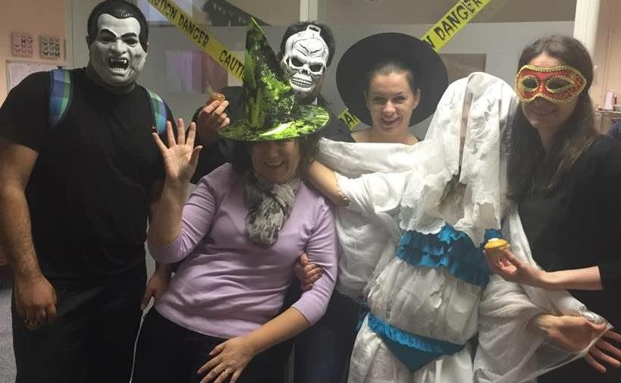The usual fun activities included these scary students at Halloween as well as activities at Christmas and health week.

Statistics at the end of 2015:

* + There were 95 students
    - 28 male and 67 female students

Course Statistics:

* + 19 in the business studies area
  + 76 in the social, community, health and child care areas
  + 57 students were in first year of the course
  + 38 students were in second year of the course
  + The majority of the second years graduated with a full level 5 QQI major award while all the first years achieved component awards. Most graduates progressed to employment or to further or higher education.

### Waterford VTOS

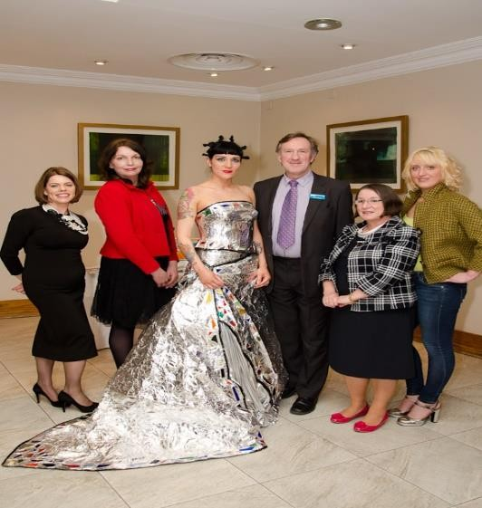

Centre Co-Ordinator: Ms Helena Finlay

Address: Durand’s Court, Parnell Street, Waterford Tel: 051 852803

Email: [info@adulteducationcentre.ie](mailto:info@adulteducationcentre.ie) Website: [www.adulteducationcentre.ie](http://www.adulteducationcentre.ie/)

### Introduction:

Waterford VTOS (formerly Waterford Adult Education Centre) has been offering courses to adults under the Vocational Training Opportunities Scheme since 1994. A range of full-time educational and training courses are available to adults who are aged 21 years or over and in receipt of eligible Social Protection payments.

The emphasis is on providing quality education in a friendly, supportive environment enabling our graduates to progress on to employment, self- employment or to further education. Our courses are accredited by Quality and Qualifications Ireland (QQI) (formerly FETAC) which testifies to the standard and professionalism of the education and training being offered.

Ancillary services, such as a student canteen and access to the internet, English language, literacy and numeracy support classes further enhances the learning environment of our students. There are no college fees and affordable childcare assistance is provided through the Childcare Education and Training Support (CETS) .Waterford VTOS is located near the city centre and is well serviced by bus routes.

### Programme’s Offered:

#### Information Technology & Business Administration. Accreditation: QQI Level 5 Award in Business Administration 5M2468 and Information Processing 5M2067

Subjects: Word Processing, Database Methods, Spreadsheet Methods, Work Experience, Communications, Business Administration, Payroll; Manual & Computerised, Accounts; Manual & Computerised, Marketing, Desktop Publishing, Web Authoring and Medical Terminology.

#### Art, Craft & Design. Accreditation: QQI Level 5 Creative Craft 5M1981

Subjects: Stained Glass/Decorative Glass Design, Drawing, Design Skills, Ceramics, Art Metal- craft, Wood Finishing, Combined Materials, Appreciation of Art, Craft & Design, Painting, Communications, Work Experience, Introduction to Computers.

***Interior Design & Decoration. Accreditation: QQI Level 5 Interior Design 5M5054.*** Subjects: Architectural Drawing, Appreciation of Art, Craft & Design, Ceramics, Furniture & Fittings, Design Skills, Combined Materials, Communications, Work Experience, Materials &

Finishes, Drawing, Colour & Light, Computer Illustrated Graphics, Introduction to Computers & CAD.

#### Fashion Design & Accessories. Accreditation: QQI Level 5 Award 5M3865.

Subjects: Garment Construction, Fashion Industry & Design Studies, Pattern Drafting, Drawing, Textiles, Embroidery, Ceramics, Combined Materials, Communications, Work Experience and Introduction to Computers.

### Highlights of 2015 include:

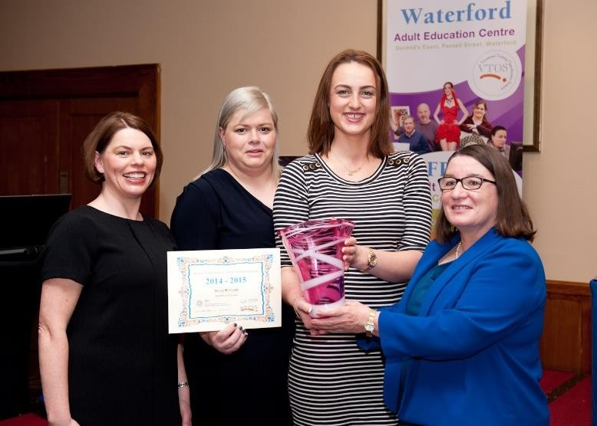

**Waterford VTOS Awards Ceremony**

**March 2015**

Sylivia McGrath, Second Year Graduate, Information Technology & Bus. Admin. Student being presented with the Student of the Year Certificate and Presentation Bowl by Mary Walsh, AEO.



**Fashion Show:** Pictured: Model Ciara Kavanagh wearing Avante Garde design as part of the Second Year Fashion Design Show, QQI Level 5.



**Craft Exhibition:** Second Year Craft, Art and Design hosting their annual exhibition

(QQI Level 5) in the Municipal Library, Waterford City.



Interior Design Exhibition: Second Year Interior Design & Decoration Ceramic Piece (QQI Level 5) in the Municipal Library, Waterford City.

### Wexford-VTOS-300x199Wexford VTOS

Centre Co-Ordinator: Ms Ann Slaven

Address: Wexford Adult Education Centre, Westgate, Wexford Tel: 053 9146188 Email: [wexfordvtos@wwetb.ie](mailto:wexfordvtos@wwetb.ie) Website: [www.waterfordwexford.etb.ie](http://www.waterfordwexford.etb.ie/)

### Introduction:

The Wexford Adult Education Centre is located at Westgate in Wexford. The centre caters for 80 full time VTOS students. Courses on offer may vary from year to year depending on the needs and interests of incoming students. All courses offer nationally and internationally recognised qualifications.

The centre provides a supportive environment for learners who wish to return to education at any stage of their adult lives. All levels are catered for and you will be welcomed regardless of age, sex, educational background, or ability. You will have the chance to update your education and skills and will be assisted on to further education or into employment. Maybe you want to help your children with their homework. Maybe you want to meet like-minded adults.

Whatever your motivations, VTOS might be your solution.

### Courses Offered:

*Business Administration*

* + Business and Administration Skills
  + Word Processing
  + Text Production
  + Bookkeeping Manual and Computerised
  + Database Methods
  + Business Calculations
  + Communications
  + Work Experience

*Information Processing*

* + Information and Communication Systems
  + Spreadsheet Methods
  + Accounting Manual and Computerised
  + Payroll Manual and Computerised
  + Database Methods
  + eBusiness Studies
  + Digital Marketing
  + Communications
  + Work Experience

*Leaving Certificate for Adults*

* + English
  + Mathematics
  + History
  + Accounting
  + Business
  + French

*Microsoft Office Specialist*

* + Access Core
  + Excel Core
  + Word Core
  + Powerpoint Core
  + Excel Expert
  + Word Expert

*Sports Coaching /General learning*

* + Research and Study Skills
  + Teamworking
  + Work Experience
  + Safety and health in the Workplace
  + Occupational First Aid
  + Hurling Coaching
  + Gaelic Football Coaching
  + Anatomy and Physiology

#### Office Skills

* + Communications
  + General office Skills
  + Business English
  + Functional Mathematics
  + Information Technology Skills
  + Computer Applications
  + Customer Service
  + Work Experience
  + Bookkeping and Accounts

### Highlights of 2015 include:

* + Number Enrolled: 80
  + Links forged with local employers through work experience programme
  + All staff trained in Occupational First Aid
  + Sport students provided sports training in local primary and secondary school and organised Fun and Fitness days in Primary schools
  + Coaching students acted as coaches for Easter and Summer Camps run by GAA
  + Charity and fundraising events organised by class groups as part of Teamworking project
  + 14 students progressed to full time employment, 12 to 3rd level Education,2 to self- employment and 6 to CE
  + 5 Students were involved in radio broadcast about adults returning to education

**Youth Work**

Waterford and Wexford Education and Training Board as part of ETB Act 2013 supports the coordination, provision, assessment and administration of Youth Work.

Youth Work is defined in the Youth Work Act 2001 and in the ETB Act 2013 as:

A planned programme of education designed for the purpose of aiding and enhancing the personal and social development of young persons through their voluntary participation, and which is

1. complementary to their formal, academic or vocational education and training; and
2. provided primarily by voluntary youth work organisations.

The ETB have 2 Officers working in Youth Affairs:

Youth Development Officer: Joe Gough

Address: WWETB Youth Affairs, Ozanam Street, Waterford

Tel: 051 878254

Email: [joegough@wwetb.ie](mailto:joegough@wwetb.ie)

### Area of responsibility: Waterford city

Youth Officer: Martin Fitzgerald

Address: Administrative office, Dungarvan Shopping Centre, Dungarvan, Co Waterford

Tel: 058 51433

Email: [martinfitzgerald@wwetb.ie](mailto:martinfitzgerald@wwetb.ie)

### Area of responsibility: Waterford (excluding the city of Waterford) and Wexford Counties

**Youth Work Committee for Waterford and Wexford**

In 2015 Waterford and Wexford ETB has established the Youth Work Committee to advise on its functions in relation to Youth Work. The Committee are looking to develop a Youth Work Plan. The aim of consultation is:

1. To identify areas where the Youth Work Committee can add value to the provision of Youth work services in Counties Waterford and Wexford.
2. To identify gaps that exist currently in terms of needs of the young people where a Youth Work response would make significant impact on improved outcomes for young people.
3. To identify thematic and geographical areas that stakeholders identify as priority areas for Youth Work responses.

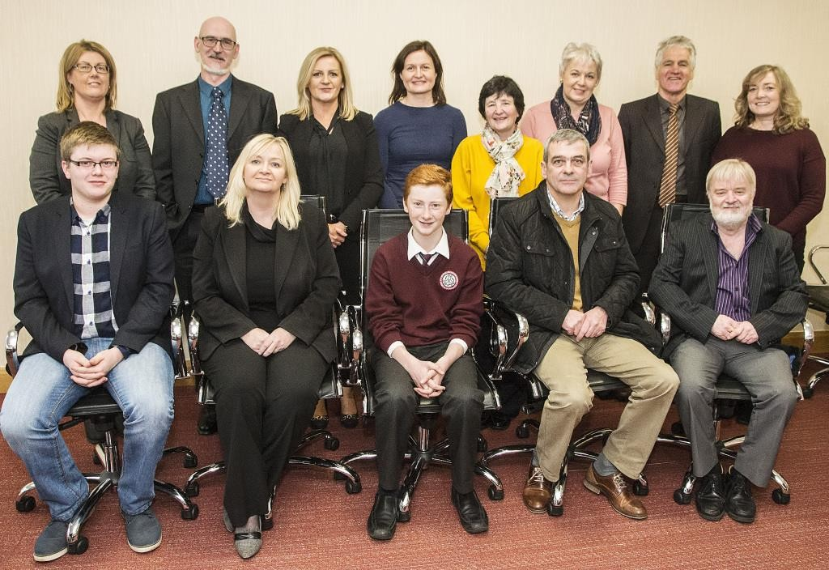

**Back row (L to R**): Claire McNamara (TUSLA), David Doyle (WWETB committee member), Cathy Drohan (WWETB Administration), Gail Sullivan (Foroige), Mary Halligan (Independent projects), Alison Parle (uniformed groups), Joe Gough (WWETB Youth Development Officer), Cris Fogarty (Youth Work Ireland)

**Front row (L to R):** Gavin Mooney (Comhairle na nOg: Wexford), Cllr. Mary Roche (WWETB committee member), Ríain O’Donoghue (Comhairle na nOg: Waterford), Peter Culleton (Gardaí), Martin Fitzgerald (WWETB, Youth Officer).

Waterford and Wexford Education and Training Board (WWETB) confirmed that the first full meeting of the Youth Work Committee took place in Dungarvan. The Committee will have responsibility for advising Waterford and Wexford Education and Training Board on its Youth Work functions as outline in the ETB Act 2013. The Youth Work Committee will oversee the support, co-ordination, administration and assessment of youth work services provided in Waterford and Wexford Counties. The Committee will be made up of nominees of the key Youth Work stakeholders and replaces the Youth committees of the former City of Waterford VEC, County Waterford VEC and County Wexford VEC.

The Committee will be chaired by Cllr. Mary Roche and will have members from WWETB, Foroige, Youth Work Ireland, the uniformed youth groups, independent youth projects, Comhairle na nÓg, TUSLA and the Gardaí. The core function of the Committee will be to promote Youth Work as a non-formal educational process and over the next few months will begin the process of developing a Youth Work Plan for the area.

The Youth Work Committee will be supported in its work by the ETB Youth work staff, Martin Fitzgerald and Joe Gough. “Youth Work as a process of non-formal education is recognised at national and European level as complementary to their formal, academic or vocational

education and training. It is provided by trained staff and volunteers in communities across Waterford and Wexford” says Martin Fitzgerald, Youth Officer for Waterford and Wexford

Counties. He added that “Youth Work provision ranges from one night a week youth groups to fully staffed Youth Projects dealing with the personal and social development of young people as well as equipping young people to deal with a range of issues that they face such as progression in education, developing a sense of community, substance misuse or mental health. It is intended that the Committee will act as a space to promote and develop the

practice of Youth Work”.

## Local Youth Club Grant Scheme 2015 Allocations

The Waterford and Wexford Education and Training Board allocated the annual grants to volunteer led youth clubs and groups. The purpose of the grant is to support local community based groups to provide Youth Work services in their locality. A total of 57 groups received

€46,839.17

These grants are key to the clubs involved and can be seen as support to young people from across all areas of need and location to achieve their full potential.

|  |  |
| --- | --- |
| **Club Name** | **Amount** |
| 12th Wexford Scouts | €800.67 |
| 1st Wexford (New Ross) Sea Scouts | €1,120.94 |
| 25th Wexford (Piercestown) Scouting Ireland Group | €800.67 |
| 2nd Port Waterford Dunmore East Sea Scouts | €1,120.94 |
| 2nd Wexford Port of Wexford Sea Scouts | €1,120.94 |
| 2nd Wexford Scout Group | €800.67 |
| 31st Waterford Scout Group | €1,120.94 |
| 35th Waterford Copper Coast | €1,120.94 |
| 35th Wexford Kilmore Scout Group | €960.80 |
| 36th Ramsgrange Scout Troop | €800.67 |
| Abbeyside Girl Guides, Brownies & Ladybirds | €1,120.94 |
| Activ8 | €640.54 |
| Aglish and Villierstown Foroige | €720.60 |
| Askamore Foroige | €640.54 |

|  |  |
| --- | --- |
| Ballinroad Youth Club | €480.40 |
| Ballyduff Upper Foroige Club | €640.54 |
| Ballygarrett Youth Club | €800.67 |
| Boolavogue Foroige Club | €640.54 |
| Bree Macra na Feirme | €640.54 |
| Bree Youth Club | €960.80 |
| Bunclody Foroige Youth Club | €640.54 |
| Catholic Guides of Ireland | €1,120.94 |
| Clonard Guides CGI | €800.67 |
| Coderdojo Dungarvan | €1,120.94 |
| Cool Monday Club | €960.80 |
| Coolnasmear/Colligan Irish Girl Guides | €960.80 |
| Courtnacuddy Youth Club | €1,120.94 |
| Danescastle Music Group | €1,120.94 |
| Davidstown Foroige Club | €480.40 |
| Dungarvan No Name Club | €1,120.94 |
| Dungarvan Scouts 11th Waterford | €1,120.94 |
| Dungarvan Youth Club | €480.40 |
| Enniscorthy Brownies | €640.54 |
| Foroige Passage East | €720.60 |
| Fusion | €640.54 |
| Group 203, Irish Pilgrimage Trust | €480.40 |
| Irish Red Cross Portlaw Cadet Unit | €800.67 |
| Le cheile Youth Club | €560.47 |
| Lismore Foroige Club | €640.54 |
| Make a Difference Foroige Club | €480.40 |
| Monageer Foroige | €960.80 |
| Murrintown Youth Club | €1,120.94 |
| New Ross No Name Club | €1,120.94 |

|  |  |
| --- | --- |
| No Limits Youth Club, Clonea Power | €560.47 |
| No Name Club Ring of Hook | €800.67 |
| Our Lady's Island Youth Club | €960.80 |
| Oylegate Youth Club | €1,120.94 |
| Planet Youth | €880.74 |
| Raheen Youth Club | €640.54 |
| Seashell ladybirds, Brownies and Guides | €1,120.94 |
| St. Joseph's Youth Club | €640.54 |
| Tallow Foroige Club | €640.54 |
| The Ballagh Youth Club | €640.54 |
| The Wolf Pack | €640.54 |
| Wexford Chess | €800.67 |
| Wexford Town Unit C.G.I | €1,120.94 |
| **Total** | €46,839.17 |

**Other grants**

***Startup club grants***

|  |  |
| --- | --- |
| **Club** | **Allocation** |
| Clashmore/Kinsalebeg Foroige Club | **€640.54** |
| Total | **€640.54** |

***Capital grants: Type 1***

|  |  |
| --- | --- |
| **Project Name** | **Amount** |
| Edmund Rice Youth and Community Multiplex | €4,786.80 |
| Ferrybank Drug Prevention | €13,596.15 |
| Northern Suburban Community Youth Project | €1,759.92 |
|  | **€20,142.87** |

***Capital grants: type 1***

|  |  |  |  |
| --- | --- | --- | --- |
| SHY | Waterford: Johns Park/San  Herblain | Youth Work Ireland  (WSTCYS) | €24,999 |

**Highlights for 2015**

* + Establishment of Youth Work Committee
  + Introduction of certified Youth Worker training in New Ross and Wexford

## Youthreach

### Adult Education Officer: Mary Walsh

There are seven Youthreach Centres in Waterford and Wexford ETB across the Counties of Waterford and Wexford.

Youthreach is a programme of education, training and work experience for early school leavers provided in an out-of-school setting. Youthreach aims to give young people a second chance to gain education and training, a chance to develop new skills, a chance to gain national certification and progress to further education or training, a chance to find employment.

### ww centre photoDungarvan Youthreach

Co-Ordinator: Ms Maria Carney

Address: Rinnasillogue Place, Dungarvan, Co Waterford Tel: 058 44997 Email: [dungarvanyouthreach@wwetb.ie](mailto:dungarvanyouthreach@wwetb.ie) Website: [www.waterfordwexford.etb.ie](http://www.waterfordwexford.etb.ie/)

### Introduction:

The aim of Dungarvan Youthreach is to provide a second chance programme of education and development to young people in a safe, supportive and holistic environment.

### Courses Offered:

In total, 35 young people engaged with the programme during 2015. The programmes offered were

### Formal Certified Learning

* + The Leaving Certificate Applied course.
  + QQI level 3 General Learning Certificate

### Informal Learning

* + Work Experience
  + Summer Programme
  + Independent living skills & Leisure activities that promote growth & development

### Highlights of 2015 include:

* + Through the Quality Framework Initiative (QFI), the centre engaged with an Internal Centre Evaluation (ICE) process and completed a review of 2013 / 2014 in 2015.
  + Resource Staff member Sonia Young and Co-Ordinator Maria Carney completed the Instructional Leadership course through ETBI.
  + Certification rates 2015: 5 completed the Leaving Certificate Applied. 10 achieved QQI level 3 component certificates. 10 completed certificates in Safe Food and First Aid. 2 were awarded an Equine Transport Certificate.

### IMG_4727Enniscorthy Youthreach

Co-Ordinator: Mr John Brennan

Address: Spring Valley, Enniscorthy, Co Wexford Tel: 053 9234982

Email: [enniscorthyyouthreach@wwetb.ie](mailto:enniscorthyyouthreach@wwetb.ie) Website: [www.enniscorthyyouthreach.ie](http://www.enniscorthyyouthreach.ie/)

### Introduction:

Enniscorthy Youthreach Centre strives to provide a caring and learning environment for all our learners where mutual respect and fairness is the key in allowing individuals to achieve their full potential. The aim of Youthreach is to provide education, training and certification for early school leavers, to provide a structured programme to help the individual learner

### Programmes Offered:

Gateway. This programme is introduced to cater for learners who need help with literacy and numeracy. It also consists of practical classes such as Home Economics, Information Technology and Woodwork. Literacy and numeracy is provided on a one to one basis.

Foundation Level. This one year programme gives learners an opportunity to become familiar with on-going assessment and doing task work.

Leaving Certificate Applied. This is an option revised Senior Cycle structure and was introduced in Summer 1995, subjects offered in this are: Art, Craft & Design, English & Communications, French, Gaeilge, Hair & Beauty, Hotel, Catering & Tourism, Information Technology, ECDL, Leisure & Recreation, Mathematical Applications, Social Education, Vocational Preparation & Guidance, Woodwork & Construction, Digital Media, SPHE.

Other Programmes Delivered include ECDL, Steer Clear, First Aid and Manual Handling

### Highlights of 2015 include:

|  |  |  |
| --- | --- | --- |
| **Number of Learners in the Centre on 31 December 2015** | | |
| **Male** | **Female** | **Total** |
| 22 | 16 | 38 |

|  |  |  |  |
| --- | --- | --- | --- |
| **The Age of the Learners** | | | |
| ***Age*** | ***Male*** | ***Female*** | ***Total*** |
| *15* | *0* | *1* | *1* |
| *16* | *4* | *3* | *7* |
| *17* | *10* | *7* | *17* |
| *18* | *6* | *4* | *10* |
| *19* | *1* | *1* | *2* |
| *20* | *1* | *0* | *1* |
| **TOTAL** | **22** | **16** | **38** |
|  | | | |
| ***The number of learners who left the programme*** | | | |
|  | *Male* | *Female* | *Total* |
| ***Family Commitment*** | *1* | *0* | *1* |
| ***Moved Location*** | *0* | *1* | *1* |
| ***Total*** | ***1*** | ***1*** | ***2*** |

|  |  |  |
| --- | --- | --- |
| ***The numbers who completed Certified/Non Certified Courses*** | | |
|  | ***Male*** | ***Female*** |
| ***LCA*** | *7* | *6* |
| ***QQI Level 3*** | *1* | *3* |
| ***ECDL*** | *17* | *13* |
| ***Basic First Aid*** | *10* | *8* |
| ***Steer Clear*** | *9* | *5* |
| ***Manual Handling*** | *10* | *7* |
| ***SPHE/RSE*** | *22* | *16* |
| ***Summer Programme*** | *10* | *8* |
| ***TOTAL*** | ***86*** | ***66*** |

|  |  |  |
| --- | --- | --- |
| ***Destination of those completing the programme*** | | |
|  | ***Male*** | ***Female*** |
| ***Employement*** | *3* | *0* |
| ***PLC*** | *2* | *3* |
| ***Other Training*** | *1* | *0* |
| ***Unemployment*** | *1* | *3* |
| ***TOTAL*** | ***7*** | ***6*** |

**Enniscorthy Youthreach Winners of the X-Hale Youth Awards Film Competition 2015**

The Annual Irish Cancer Society Annual X-Hale Awards took place on Thursday 2 July 2015 in The Light House Cinema in Smithfield, Dublin 7 with Enniscorthy Youthreach taking two top awards. They won the overall at Senior Level and also the awards for most hits on Youtube with over 72,000 views. There were 41 entries in this years competition from all over the Country.

The Irish Cancer Society through the X-Hale Youth Awards want Youth Organisations to play their part in helping to prevent young people in our community from starting to smoke.

Currently in Ireland about 12% of school aged young people are reported to smoke with rates as high as 25% of 15 - 17 year old girls in some areas.

Enniscorthy Youthreach students with assistance from their teacher Mr Hugh John Dunne set about creating an anti-smoking video which they entered into the competition. The script was written, the sets made and the overall production took place and it depicts a young girl being pressurised into smoking. This was achieved by introducing some similar scenes from horror movies acted out by the cast from Youthreach.

When this video was put on Youtube by the Irish Cancer Society, within hours it went viral. The message being portrayed by this short film is to prevent young people from starting to smoke.

Digital Media was introduced as an extra-curricular module at Enniscorthy Youthreach in 2014/2015. The students had to carry out a lot of research regarding the topic and then make sure they had the correct equipment.

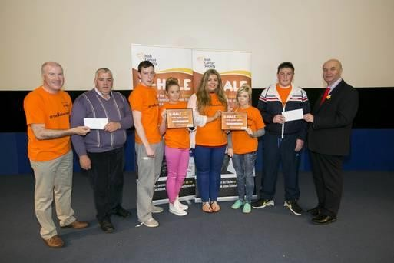

### VTOS Cover PictureNew Ross Youthreach

Centre Co-Ordinator: Mr James O’ Hanlon/

Ms Michelle Keating

Address: Butlersland Industrial Estate, Butlersland, New Ross, Co Wexford Tel: 051 440307 Email: [newrossyouthreach@wwetb.ie](mailto:newrossyouthreach@wwetb.ie)

Website: [www.waterfordwexford.etb.ie](http://www.waterfordwexford.etb.ie/)

### Introduction:

New Ross Youthreach is committed to maintaining a welcoming, caring and safe learning environment where learners can progress at their own pace to achieve their individual potential in an atmosphere of mutual respect.

The aims of New Ross Youthreach are to provide a caring, secure and disciplined environment where learners learn and teacher teach, to provide a broad-based curriculum which seeks to meet the varying needs and abilities of individual learners, to foster the development of each learners skills, knowledge and self-esteem as well as his/her enthusiasm for learning, to help learners to develop skills for future life and for responsible citizenship, to promote moral values, self-discipline and self-respect for themselves and respect for others.

### Programmes Offered:

The programmes on offer include; Leaving Certificate Applied, QQI – Levels 3 and 4, Special Educational Needs Initiative (SENI), Guidance and Counselling Service, Learning Support Programme, Literacy/Numeracy Provision and Home School Community Liaison.

### Highlights of 2015 include:

* + NAYC Conference
  + RSA talk
  + DLP Training
  + Trip to Cobh (Titanic)
  + FOI Training
  + FARR Training
  + Practical and Oral Examinations were held in the centre and assessed by the State Examinations Commissioner.
  + Learners went on a cinema trip.
  + A Summer Programme was held which included:
* First Aid training for Learners
* Safe Pass
* Outdoor pursuits
* Fishing
* Sporting Activities
* Student inductions and assessments was carried out with all new learners to the centre.
  + SEN ICE was carried out in the centre with Mary Gordon in attendance.
  + Occupational First Aid refresher training was delivered to all first aid staff in the centre.
  + A Learner Council was established with one/two representatives from each class voted on by the learners.
  + Learners held a “Paint it Pink” morning in aid of Cancer research and raised €175.
  + The centre launched its Facebook page – which now has 180 followers. The page is used to report and promote the good work of our learners in the centre.
  + Road Safety Authority attended the centre and gave a talk to the learners.
  + Learners went on a rewards trip (bowling) for those with good attendance, timekeeping and behaviour.
  + Male learners attended a workshop with Stuart Wilson, learner support practitioner, on overcoming difficulties and healthy coping mechanisms.
  + Co-ordinator, resource staff and some teachers were trained in WRAT 4 testing. WRAT 4 is an assessment tool conducted with learners to establish their existing competencies. Training was delivered by Dr. Mary Gordon.
  + Some staff received training in Wellbeing in the Further Education and Training Environment delivered by FESS.
  + We held an awards evening for those who achieved QQI Level 3 awards.
  + Winners of the Christmas card competition selected and cards printed and sold in aid of Childline which raised €100.
  + Michelle attended the NAYC regional meeting in Citywest.
  + Michelle attended the FET seminar in Kilashee House.
  + Michelle attended a PLSS briefing in Waterford.
  + Female learners attended a workshop with Stuart Wilson, learner support practitioner, on overcoming difficulties and healthy coping mechanisms.
  + The Harmony Programme attended the centre for a half day drugs intervention.
  + The enterprise group sold their Christmas cards and donated all money raised to Childline. They raised €100.
  + Christmas dinner was held in the centre for all learners and staff. This was followed by a whole centre quiz and prizes for the winners.
  + Staff attended the Cornmarket open day. Cornmarket is a local drugs initiative. The Cornmarket Project is an inter-agency community based treatment and rehabilitation project under the auspices of Wexford Local Development.
  + LCA 1 Hotel, Catering & Tourism group held a bake sale in the centre with proceeds raised going to St. Vincent de Paul. They raised €70.
  + Michelle attended the NAYC regional meeting in Citywest.
  + Michelle attended Child Protection training with PDST.

### tramore1Tramore Youthreach

Centre Co-Ordinator: Mr Gerard McManus

Address: Tramore Further Education & Training Centre, Unit 2, Seapoint Business Park, Riverstown, Tramore, Co Waterford. Tel: 051 338447

Email: [tyouthreach@wwetb.ie](mailto:tyouthreach@wwetb.ie) Website: [www.waterfordwexford.etb.ie](http://www.waterfordwexford.etb.ie/)

### Introduction:

Youthreach is part of a national programme that offers second chance education and training to 16-20 year olds. It is aimed at early school leavers and is designed to give young people the opportunity to gain confidence and engage in the formal certification process in an ‘out of school’ setting. It is a full-time year round course where learners receive a weekly training and travel allowance.

### Courses Offered:

Courses offered include: Leaving Certification Applied and QQI Level 3. In addition to formal learning, the following services are provided: Work Experience, Sports & Recreation, Mentoring and Support, Careers Information, Personal & Social Development and Literacy & Numeracy Development.

### Learners in the Centre:

There were 20 learners in the Centre

* + 2 Female
  + 18 Male

### Exam Results 2015

* + 1 Distinction and 7 Merits

### Michael Sweetman Trust Trip to Strasburg:

* + We had two Learners go to the European Parliament for 2015

### Staff Training:

* Instructional Leadership
* Restorative Practice
* Web- wheel Training (mentoring with Learners)
* Soft Skills

### Trips Out:

* Ploughing Championship
* Trip to the Cinema
* Active Connections
* Amber Flag (Community Walk)

### Extra Programs:

* + Safe Food (Certified)
  + First Aid (Certified)

### Waterford Youthreach

Centre Co-Ordinator: Mr Jim D’Arcy

Address: 66 O’Connell Street, Waterford Tel: 051 877241 Website: [www.waterfordwexfordetb.ie](http://www.waterfordwexfordetb.ie/)

### Introduction:

While working with early school leavers, our aims are to provide education and vocational guidance to early school leaver sin order to improve future employment and training prospects, to provide a caring, effective and safe environment where education can take place, to provide educational programmes which are learner-focused and reflect their vocational, social and health needs, to encourage the development of life-skills in a respectful and caring manner, to support all early school leavers equally and fairly

### Courses Offered:

Courses offered include: Leaving Certificate (1 Year), Leaving Certificate Applied (2 years), Horticulture, Sports Performance. The Leaving Certificate and Leaving Certificate Applied courses are open to any young person who has an active interest in learning that would like to return to education. Literacy and numeracy are a constant focus as part of all courses offered within the centre and there is a dedicated literacy team who supports students one-to-one.

Literacy and numeracy are a fundamental part of our centres ethos. Pupils are encourage to return to education and to take an active interest in their progression to third level courses, vocational apprenticeships and/or job application.

### Wexford Youthreach

Centre Co-Ordinator: Ms Phil O’Mahoney

Address: Whitemill Industrial Estate, Wexford Tel: 053 9146448

Email: [wexfordyouthreach@wwetb.ie](mailto:wexfordyouthreach@wwetb.ie) Website: [www.waterfordwexford.etb.ie](http://www.waterfordwexford.etb.ie/)

### Introduction:

Youthreach Wexford provides education, training and personal development. We encourage students to realise their full potential in a caring, respectful and safe environment.

The aims of Youthreach are

* to provide the opportunity for students to engage in education and training,
* to integrate language, literacy and numeracy throughout all aspects of the programme,
* to develop the students personal and social skills,
* to instill a sense of personal, environmental and community responsibility in the individual student,
* to establish links and network with relevant agencies, organisations and stakeholders,
* staff adopt a collaborative approach to fulfil the mission statement in a dignified and mutually respectful workplace, to create a caring, respectful, safe and suitable learning environment in the centre and to provide students with the knowledge and skills required to make the transition from Youthreach to Further and Higher Education, training, work and adult life.

### Programmes Offered:

Programmes offered include; Leaving Certificate Applied, QQI Level 2 and Level 3, Literacy & Numeracy Provision, SPHE and RSE.

### Highlights of 2015 include:

* Anger Management Programme for students – February/March 2015.
* Staff training.
* Planning application lodged to Wexford Co. Council with regard to new premises.
* Visiting speakers to the centre; i.e. A.I.B. Bank for students, Manager of Access.
* Various meetings with manager of Youthtrain regarding new premises.
* Moved into new premises in September, 2015.
* Exhibition of FLIGHT summer programme during Wexford Opera Festival October 2015.
* Car Safety Programme for students.
* Stand at Business Expo. – Clayton Whites Hotel.

### Youthreach Subla Centre

Centre Co-Ordinator: Mr Mark O’Sullivan

Address: Unit 3, Block 1, Lacken Road Business Park, Waterford

Tel: 051 373833 Email: [info@ysc.ie](mailto:info@ysc.ie) Website: [www.ysc.ie](http://www.ysc.ie/)

### Introduction

Youthreach Subla Centre is an education centre for young people who are aged between 15 and 20 years, have left the mainstream school system, do not attend other existing educational or training provision and have not secured fulltime employment.

The centre encourages a culture of educational attainment for young people in a safe, secure, supportive and caring environment.

We provide a genuinely integrated holistic education and support network for early school leavers while maintaining our strong links with the Traveller Community.

### Programmes offered

*Leaving Certificate Applied*

This course aims to provide young people with the abilities and skills to enable them to complete a Leaving Cert Applied. It runs across two years on a full-time basis and subjects studied include English & Communications, Mathematical Applications, Social Education, Vocational Preparation and Guidance, Information and Communications Technology, Active Leisure Studies and Leisure & Recreation.

### Highlights 2015:

* The beginning of new LCA Year 2 class in September 2015.
* Regular attendance at the city library and city events throughout the year including the Christmas market, historical, photography and art exhibitions, drama plays and music concerts. These events were great ways to integrate LCA subject learning with the city we live in.
* Centre outings and trips included:
  + An educational exploration of Cork city
  + The National Ploughing Championships in Laois
  + Shielbeggan Outdoor Activity centre in Wexford
  + Quadding in Clonroche
  + Go-karting in Kilkenny
  + Surfing in Tramore
  + Climbing in the Comeragh mountains
* Visitors and outside educators to the centre included
  + Drug Awareness programme
  + Squashy Couch sexual health programme
  + Traveller CDP healthy eating programme

## Training Services

Waterford and Wexford Training Services are dedicated to ensuring your learning experience is enjoyable and successful. Our experienced team provide a very high standard of training and support to assist you in your journey towards a brighter future.

At our purpose built facilities we offer a variety of courses that are suitable for many different learners – jobseekers, people entering the workforce for the first time, early school leavers, people with disabilities, those wishing to change careers and people looking to refresh their knowledge or gain new skills.

Waterford and Wexford ETB have two Training Centres, one in Waterford City and one in Wexford Town.

### Waterford Training Centre

Address: Waterford Industrial Park, Cork Road, Waterford Tel: 051 301500

Email: [infotraining@wwetb.ie](mailto:infotraining@wwetb.ie)

Website: [www.wwetbtraining.ie](http://www.wwetbtraining.ie/)

### Wexford Training Centre

Address: Whitemills North Industrial Estate, Wexford

Tel: 053 9143602

Email: [infotraining@wwetb.ie](mailto:infotraining@wwetb.ie)

Website: [www.wwetbtraining.ie](http://www.wwetbtraining.ie/)

## Programme Managers

***Apprenticeships*** Marius Cassidy John Cassidy

Eamonn McGettigan

#### Quality Assurance

John Cassidy

***Traineeships*** John Cassidy Nichola Long PJ McAuliffe Joe Maher

Jacqueline Sweeney



Training

Courses

Specialist

Training Programme

Apprenticeships

Local Training

Initiative

Traineeships

Training

Centre

Community

Training Centre

Construction

Studies Certification Scheme

E-Learning at

the Library

Quarry Skills

Certification Scheme

**Training Course**

These courses provide learners with essential and valuable skills to make them potential valuable employees. On successful completion of these courses, learners will gain formal qualifications. These courses are delivered on a full-time, part-time, blended or evening basis.

* Day courses are usually full-time and provide you with essential and valuable skills that aim to make you more employable. Our day courses offer formal qualifications recognised by Industry to help you enter the workforce. If you are a jobseeker, looking to refresh your knowledge, gain new skills or enter the workforce for the first time we may have a suitable day course for you.
* Evening courses are delivered by night and are aimed at people who may want to learn new skills or want to be build on their current skills but may not be available for training during the day. The courses on offer can provide you with essential and valuable skills that make you more employable. Evening courses offer formal qualifications recognised by Industry. If you are looking to refresh your current skills, gain new skills or enter the workforce for the first time we may have a suitable evening course for you.
* These courses are designed to improve the skills of people who may need additional support to obtain a job or progress to higher-level training. If you have been unemployed for a long time, are an early school leaver or have a disability these courses may be suitable for you. Training is provided by Community Training Centres, Specialist Training Providers and Local Training Initiatives.

### Apprenticeships

Apprenticeship is the recognised means by which people are trained to become craftspeople in Ireland. Apprenticeship involves a combination of learning in the classroom and on-the-job training and aims to develop the skills of the apprentice to meet the needs of industry and the labour market.

### Traineeships

Traineeships are job specific and industry endorsed training programmes. A traineeship combines learning at the training centre with on-the-job training. Traineeships are specific to jobs that are not taught as apprenticeships but do require skills that are best learnt through on- the-job training.

### Construction Skills Certification Scheme

The Construction Skills Certification Scheme (CSCS) is for people who are interested in working in the construction industry in a non-craft job. The scheme trains, assesses, certifies and registers people to work in the construction industry.

### Quarry Skills Certification Scheme

The Quarry Skills Certification Scheme (QSCS) is for people who are interested in working in the quarrying sector in a non-craft job. The scheme trains, assesses, certifies and registers people to work in the quarrying sector.

**E-Learning at the Library**

This is a foundation programme for people who are interested in learning the basics of information technology. The programme is open to anyone and is delivered by ETB in partnership with the Library Council of Ireland.

**Community Training Centre (CTC)**

Training programmes run by CTCs are for early school leavers under the age of 21 who have left school with minimal or no formal qualifications. These programmes offer training, guidance and individual support to help each learner achieve qualifications and employment

**Local Training Initiative (LTI)**

Local Training Initiatives are provided by independent community organisations such as Youth Services or Family Resources Centres. The training is aimed at people aged between 18-35 years old who have most difficulty getting a job because they have no formal qualifications, or qualifications that are no longer relevant and have been out of work for a long time. Learners are provided with training, guidance and individual support to help them get qualifications and enter the workforce.

**Specialist Training Programme (STP)**

Specialist Training Providers provide flexible training courses that are designed for learners who have a disability. Learners in STPs are provided with personal, social and vocational skills training and development leading to qualifications and assistance to obtain employment.

## Human Resources

The Human Resources Department of Waterford and Wexford Education and Training Board provides support to over 2,000 staff delivering education services in our schools and centres throughout Counties Waterford and Wexford. Our aim of this Department is to attract and retain staff and support them in their employment by developing and maintaining best practice HR structures, policies and procedures.

The main areas of responsibility for the Human Resource Department include: pay administration, staffing levels, management of staff leave entitlements and superannuation and retirement benefits.

Staff vacancies are advertised on our website [www.wwetb.ie](http://www.wwetb.ie/) and applications are received by hard copy. New appointees are subject to Garda Vetting procedures.

## Corporate Services

### Third Level Grant Scheme 2014/15

Waterford and Wexford ETB administers grants/scholarship schemes for students attending courses in further and higher education approved by the Department of Education and Skills. There is also an additional payment called the Special Rate of Maintenance Grant which is available to students whose income includes an eligible Social Welfare payment and whose total income is below a specific band.

Payments are made by Waterford & Wexford ETB to students awarded under the VEC Scholarship Scheme and to students who have been awarded under the PLC Maintenance Grant Scheme who are attending courses at PLC centres. Payments under the TLT Scheme are made directly by the college.

The following table illustrates the levels of financial support provided in 2014/15

|  |  |  |  |  |
| --- | --- | --- | --- | --- |
| **Scheme** | **PLC** | **TLT** | **VEC** | **Total** |
| **Renewal Awards** | 0 | 12 | 111 | 123 |

### Health & Safety

In 2015, 22 employees of Waterford & Wexford ETB took part in Occupational First Aid (OFA) Training.

Occupational First Aid courses are designed to provide the learner with the knowledge and practical skills to give effective life support, diagnose and treat injuries or illness within the workplace. It also aims to give the understanding required to comply with the requirements of the Safety, Health and Welfare at Work regulations.

Refresher training in OFA will be provided annually.

A Safety Representative is an employee elected by their fellow employees, whose main role is to represent them to management on all health and safety issues. Section 25 of Safety, Health and Welfare at Work Act 2005 outlines the rights and role of a Safety Representative

One employee attended Safety Representative Training.

### Buildings Section

Waterford and Wexford ETB continued, in 2015, to improve the physical teaching and learning environment in all its schools, colleges and centres through a comprehensive Capital Development Programme.

The following projects were developed under Emergency Works Grants:

* Kennedy College fire related works
* Bridgetown College fire related works

The following projects were developed under the Summer Work Scheme:

* St Declans roofworks
* Selskar College roofworks

The following projects were also developed during 2015:

* Bunclody extension
* Bridgetown College ASD unit
* Irishtown building demolition

The following leases were signed/renewed in 2015:

* Wexford Youthreach, Whitemill Industrial Estate, Wexford
* Cappoquin AEC

## Appendix 1

### Abbreviations

|  |  |
| --- | --- |
| **ASD** | Autistic Spectrum Disorder |
| **BNS** | Boys National School |
| **BTEI** | Back to Education Initiative |
| **C & AG** | Comptroller and Auditor General |
| **CAD** | Computer Aided Design |
| **CC** | Community College |
| **CCTV** | Closed Circuit Television |
| **CE** | Community Employment |
| **CIT** | Cork Institute of Technology |
| **COSI** | Community of Social Innovators |
| **CPD** | Continuous Professional Development |
| **CSCS** | Construction Skills Certification Scheme |
| **CSPE** | Civic, Social and Political Education |
| **CTC** | Community Training Centre |
| **DCG** | Design and Communication Graphics |
| **DSP** | Department of Social Protection |
| **ECDL** | European Computer Driving Licence |
| **ESOL** | English for Speakers of Other Languages |
| **ETB** | Education and Training Board |
| **EU** | European Union |
| **FÁS** | Foras Áiseanna Saothair |
| **FET** | Further Education and Training |
| **FETAC** | Further Education and Training Awards Council |
| **FRC** | Family Resource Centre |
| **GAA** | Gaelic Athletic Association |
| **HSCL** | Home School Community Liaison |
| **ICT** | Information Communications Technology |
| **IMMA** | Irish Museum of Modern Art |
| **JCSP** | Junior Certificate School Programme |
| **LCAP** | Leaving Certificate Applied Programme |
| **LCVP** | Leaving Certificate Vocational Programme |
| **LGBT** | Lesbian, Gay, Bisexual and Transgender |
| **LTI** | Local Training Initiative |
| **MEP** | Member of the European Parliament |

|  |  |
| --- | --- |
| **MOS** | Microsoft Office Specialist |
| **NBSS** | National Behaviour Support Service |
| **NFQ** | National Framework of Qualifications |
| **OFA** | Occupational Firs Aid |
| **PDST** | Professional Development Service for Teachers |
| **PE** | Physical Education |
| **PLC** | Post Leaving Certificate |
| **PPP** | Public Private Partnership |
| **PRO** | Public Relations Officer |
| **QQI** | Quality and Qualifications Ireland |
| **QSCS** | Quarry Skills Certification Scheme |
| **SENI** | Special Educational Needs Initiative |
| **SHY** | Sacred Heart Youth Project |
| **SICAP** | Social Inclusion and Community Activation Programme |
| **SIP** | School Improvement Plan |
| **SOLAS** | Seirbhísí Oideachais Leanunaigh Agus Scileanna |
| **SPHE** | Social, Personal and Health Education |
| **SPY** | Special Projects for Youth |
| **STP** | Specialist Training Programme |
| **SUSI** | Student Universal Support Ireland |
| **TLT** | Third Level Maintenance Grant Scheme for Trainees |
| **TY** | Transition Year |
| **TYP** | Transition Year Programme |
| **UCC** | University College Cork |
| **UCD** | University College Dublin |
| **VEC** | Vocational Education Committee |
| **VTOS** | Vocational Training and Opportunities Scheme |
| **WCFE** | Waterford College of Further Education |
| **WIT** | Waterford Institute of Technology |
| **WSE** | Whole School Evaluation |
| **WSTCYS** | Waterford and South Tipperary Community Youth Service |
| **WWETB** | Waterford and Wexford Education and Training Board |
| **YSI** | Young Social Innovators |

