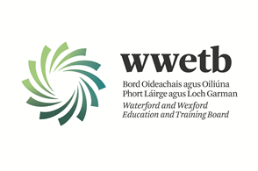

Applications are invited from suitably qualified persons to fill the following vacancy:

PERSONAL ASSISTANT & PANEL
WATERFORD COLLEGE OF FURTHER EDUCATION
TEMPORARY PART-TIME POST
12-15 HOURS PER WEEK

*A panel will be created for positions that may arise during the 2025/2026 academic year.

Application form and full details may be obtained from Other Vacancies - Waterford and Wexford Education and Training Board (wwetb.ie).

Completed applications should be returned to vacancies@wwetb.ie by 4:00pm on 14/07/2025.

Shortlisting may apply.
Canvassing by or on behalf of the candidate will automatically disqualify.
Late applications will not be accepted.
All appointments are subject to the sanction of the Minister for Education.

WWETB is an equal opportunities employer.

